UNITED STATES

SECURITIES AND EXCHANGE COMMISSION
WASHINGTON, D.C. 20549

FORM 8-K

CURRENT REPORT

Pursuant to Section 13 or 15(d)
of the Securities Exchange Act of 1934

Date of Report (Date of earliest event reported): January 8, 2024

Solid Biosciences Inc.

(Exact Name of Registrant as Specified in its Charter)

Delaware

001-38360

90-0943402

(State or Other Jurisdiction
of Incorporation)

(Commission
File Number)

(IRS Employer
Identification No.)

500 Rutherford Avenue, Third Floor

Charlestown, Massachusetts 02129
(Address of Principal Executive Offices) (Zip Code)

Registrant’s telephone number, including area code: (617) 337-4680

(Former Name or Former Address, if Changed Since Last Report)

Check the appropriate box below if the Form 8-K filing is intended to simultaneously satisfy the filing obligation of the registrant under any of the following provisions (see General Instruction A.2. below):

- Written communications pursuant to Rule 425 under the Securities Act (17 CFR 230.425)

- Soliciting material pursuant to Rule 14a-12 under the Exchange Act (17 CFR 240.14a-12)

- Pre-commencement communications pursuant to Rule 14d-2(b) under the Exchange Act (17 CFR 240.14d-2(b))

- Pre-commencement communications pursuant to Rule 13e-4(c) under the Exchange Act (17 CFR 240.13e-4(c)) Securities registered pursuant to Section 12(b) of the Act:
Title of each class |  | Trading |  | Name of each exchange
 |  | Symbol |  | on which registered
Common Stock $0.001 par value per share |  | SLDB |  | The Nasdaq Global Select Market

Indicate by check mark whether the registrant is an emerging growth company as defined in Rule 405 of the Securities Act of 1933 (§230.405 of this chapter) or Rule 12b-2 of the Securities Exchange Act of 1934 (§240.12b-2 of this chapter).

Emerging growth company ☐

If an emerging growth company, indicate by check mark if the registrant has elected not to use the extended transition period for complying with any new or revised financial accounting standards provided pursuant to Section 13(a) of the Exchange Act. ☐

Item 1.01 Entry into a Material Definitive Agreement.

Securities Purchase Agreement

On January 8, 2024, Solid Biosciences Inc., a Delaware corporation (the “Company”), entered into a securities purchase agreement (the “Securities Purchase Agreement”) with certain institutional accredited investors (the “Investors”), pursuant to which the Company agreed to issue and sell to the Investors in a private placement an aggregate of 16,973,103 shares of the Company’s common stock, par value $0.001 per share (the “Shares”), at a price of $5.53 per share, and, to one Investor in lieu of Shares, pre-funded warrants to purchase 2,712,478 shares of the Company’s common stock (the “Pre-Funded Warrants”), at a price of $5.529 per Pre-Funded Warrant (the “Private Placement”).

The Private Placement is expected to close on or about January 11, 2024, subject to the satisfaction of certain customary closing conditions. The Company expects to receive aggregate gross proceeds from the Private Placement of approximately $108.9 million, before deducting placement agent fees and offering expenses, and aggregate net proceeds from the Private Placement of approximately $104.1 million, after deducting placement agent fees.

Citigroup Global Markets Inc. and Cantor Fitzgerald & Co. acted as joint lead placement agents for the Private Placement.

The Company has granted the Investors indemnification rights with respect to its representations, warranties, covenants and agreements under the Securities Purchase Agreement.

The Private Placement includes new and existing investors, including Perceptive Advisors, Adage Capital Partners LP, Deerfield Management Company, Invus, Janus Henderson Investors, Vestal Point Capital, LP, Bain Capital Life Sciences, RA Capital Management and an undisclosed life sciences investor, among others.

Pre-Funded Warrants

Each Pre-Funded Warrant to be issued in the Private Placement will have an exercise price of $0.001 per share, will be exercisable immediately and will be exercisable until the Pre-Funded Warrant is exercised in full.

Under the terms of the Pre-Funded Warrants, the Company may not effect the exercise of any such warrant, and a holder will not be entitled to exercise any portion of any such warrant, if, upon giving effect to such exercise, the aggregate number of shares of common stock beneficially owned by the holder (together with its affiliates, any other persons acting as a group together with the holder or any of the holder’s affiliates, and any other persons whose beneficial ownership of common stock would or could be aggregated with the holder’s for purposes of Section 13(d) or Section 16 of the Securities Exchange Act of 1934, as amended (the “Exchange Act”)) would exceed 4.99% of the number of shares of common stock outstanding immediately after giving effect to the exercise, as such percentage ownership is determined in accordance with the terms of such warrant, which percentage may be increased or decreased at the holder’s election upon 61 days’ notice to the Company subject to the terms of such warrants, provided that such percentage may in no event exceed 19.99%.

Registration Rights Agreement

Also on January 8, 2024, the Company entered into a registration rights agreement (the “Registration Rights Agreement”) with the Investors, pursuant to which the Company agreed to register for resale the Shares and the shares of the Company’s common stock issuable upon exercise of the Pre-Funded Warrants (the “Pre-Funded Warrant Shares” and, together with the Shares, the “Registrable Securities”). Under the Registration Rights Agreement, the Company has agreed to file a registration statement covering the resale by the Investors of their Registrable Securities no later than 30 days following the closing of the Private Placement (the “Filing Date”). The Company has agreed to use commercially reasonable efforts to cause such registration statement to be declared effective as soon as reasonably practicable and to keep such registration statement effective until the date that all Registrable Securities covered by such registration statement have been sold or can be sold without restriction pursuant to Rule 144 and without the requirement to be in compliance with Rule 144(c)(1) (or any successor thereof) promulgated under the Securities Act of 1933, as amended (the “Securities Act”). The Company has agreed to be responsible for all fees and expenses incurred in connection with the registration of the Registrable Securities.

In the event (i) the registration statement has not been filed by the Filing Date, (ii) the registration statement is not declared effective prior to the earlier of (a) five business days after the date on which the Company is notified by the Securities and Exchange Commission (the “SEC”) that the registration statement will not be reviewed by the SEC staff or is not subject to further comment by the SEC staff or (b) the 15th day after the Filing Date (or the 60th day after the closing of the Private Placement, if the SEC staff determines to review the registration statement), or (iii) after the registration statement has been declared effective by the SEC, sales cannot be made pursuant to the registration statement for any reason, subject to certain limited exceptions, then the Company has agreed to make pro rata payments to each Investor as liquidated damages and not as a penalty in an amount equal to one percent (1.0%) of the aggregate amount invested by such Investor for the Registrable Securities per 30-day period or pro rata for any portion thereof for each such month during which such event continues, subject to certain caps set forth in the Registration Rights Agreement.

The Company has granted the Investors customary indemnification rights in connection with the registration statement. The Investors have also granted the Company customary indemnification rights in connection with the registration statement.

The foregoing descriptions of the Securities Purchase Agreement, the Pre-Funded Warrants and the Registration Rights Agreement do not purport to be complete and are qualified in their entirety by reference to the full text of the forms of Securities Purchase Agreement, Pre-Funded Warrant and Registration Rights Agreement, copies of which are filed as Exhibits 10.1, 4.1 and 10.2 to this Current Report on Form 8-K, respectively, and incorporated by reference herein.

The representations, warranties and covenants contained in the Securities Purchase Agreement and the Registration Rights Agreement were made solely for the benefit of the parties thereto and the placement agents expressly named as third-party beneficiaries thereto and may be subject to limitations agreed upon by the contracting parties. Accordingly, the Securities Purchase Agreement and the Registration Rights Agreement are incorporated herein by reference only to provide investors with information regarding the terms thereof and not to provide investors with any other factual information regarding the Company or its business, and should be read in conjunction with the disclosures in the Company’s periodic reports and other filings with the SEC.

Item 2.02. Results of Operations and Financial Condition.

Spokespersons of the Company plan to present the information in the presentation attached hereto as Exhibit 99.1 (the “Presentation”) at various meetings beginning on January 8, 2024, including investor and analyst meetings in connection with the J.P. Morgan Healthcare Conference. A copy of the presentation is attached as Exhibit 99.1 to this Current Report on Form 8-K and is incorporated herein by reference.

Although the Company has not finalized its full financial results for the fourth quarter and fiscal year ended December 31, 2023, the Company disclosed in the Presentation that it expects to report cash, cash equivalents and available-for-sale securities of approximately $123.9 million as of December 31, 2023.

The estimated cash, cash equivalents and available-for-sale securities figure is preliminary and unaudited, represents management’s estimate as of the date of this report, is subject to completion of the Company’s financial closing procedures for the fourth quarter and fiscal year ended December 31, 2023, and does not present all necessary information for a complete understanding of the Company’s financial condition as of December 31, 2023, or the Company’s results of operations for the year ended December 31, 2023. The actual financial results may differ materially from the preliminary estimated financial information.

The information provided under Item 2.02 of this Current Report on Form 8-K (including Exhibit 99.1) shall not be deemed “filed” for purposes of Section 18 of the Exchange Act or otherwise subject to the liabilities of that section, nor shall it be deemed incorporated by reference in any filing under the Securities Act or the Exchange Act, except as expressly set forth by specific reference in such a filing.

Item 3.02 Unregistered Sales of Equity Securities.

The information contained above in Item 1.01 is hereby incorporated by reference into this Item 3.02. Based in part upon the representations of the Investors in the Securities Purchase Agreement, the offering and sale of the Shares and the Pre-Funded Warrants will be exempt from registration under Section 4(a)(2) of the Securities Act. The Shares and Pre-Funded Warrants have not been registered under the Securities Act or any state securities laws, and the Shares and Pre-Funded Warrants may not be offered or sold in the United States absent registration with the SEC or an applicable exemption from the registration requirements. The sale of the securities will not involve a public offering and will be made without general solicitation or general advertising. The Investors represented that they are institutional “accredited investors” as defined in Rule 501(a)(1), (2), (3) or (7) under the Securities Act or “qualified institutional buyers” within the meaning of Rule 144A under the Securities Act, and that they are acquiring the Shares and Pre-Funded Warrants for investment purposes only and not with a view to any resale, distribution or other disposition of the Shares and Pre-Funded Warrants in violation of the United States federal securities laws.

Item 7.01 Regulation FD Disclosure.

The information contained above in Item 2.02 related to the Presentation is hereby incorporated by reference into this Item 7.01.

The information provided under Item 7.01 of this Current Report on Form 8-K (including Exhibit 99.1) shall not be deemed “filed” for purposes of Section 18 of the Exchange Act or otherwise subject to the liabilities of that section, nor shall it be deemed incorporated by reference in any filing under the Securities Act or the Exchange Act, except as expressly set forth by specific reference in such a filing.

By providing the information in Item 7.01 of this Current Report on Form 8-K (including Exhibit 99.1), the Company is not making an admission as to the materiality of any information herein. The information contained in Item 7.01 of this Current Report on Form 8-K is intended to be considered in the context of more complete information included in the Company’s filings with the SEC and other public announcements that the Company has made and may make from time to time by press release or otherwise. The Company undertakes no duty or obligation to update or revise the information contained in this Current Report on Form 8-K, although it may do so from time to time as its management believes is appropriate. Any such updating may be made through the filing of other reports or documents with the SEC, through press releases or through other public disclosures.

Item 8.01 Other Events.

On January 8, 2024, the Company issued a press release announcing the Private Placement. The full text of the press release issued in connection with this announcement is attached as Exhibit 99.2 to this Current Report on Form 8-K and incorporated herein by reference.

On January 8, 2024, the Company announced that it anticipates providing an initial safety update from cohort 1 of its Phase 1/2 clinical trial, SGT-003-101, a first in human, open-label, multicenter trial to determine the safety and tolerability of SGT-003 in pediatric patients with Duchenne muscular dystrophy, in mid-2024, subject to initiating patient dosing in mid-to-late first quarter of 2024, and anticipates providing initial data from cohort 1 of the Phase 1/2 clinical trial in the third quarter of 2024. The Company also announced that it anticipates submitting an investigational new drug application for SGT-501 in the first quarter of 2025.

Forward-Looking Statements

This Current Report on Form 8-K contains “forward-looking statements” within the meaning of the Private Securities Litigation Reform Act of 1995, including statements regarding the anticipated closing of the Private Placement; the anticipated proceeds from the Private Placement; the filing of a registration statement to register the resale of the Shares and Pre-Funded Warrants to be issued and sold in the Private Placement; future expectations, plans and prospects for the Company; the Company’s plans with respect to its Phase 1/2 clinical trial for SGT-003, including expectations with respect to dosing and presenting data; the Company’s plans for filing an investigational new drug application for SGT-501; the Company’s preliminary and unaudited estimated cash, cash equivalents and available-for-sale securities as of December 31, 2023; and other statements containing the words “anticipate,” “believe,” “continue,” “could,” “estimate,” “expect,” “intend,” “may,” “plan,” “potential,” “predict,” “project,”

“should,” “target,” “would,” “working” and similar expressions. Any forward-looking statements are based on management’s current expectations of future events and are subject to a number of risks and uncertainties that could cause actual results to differ materially and adversely from those set forth in, or implied by, such forward-looking statements. These risks and uncertainties include, but are not limited to: whether the conditions for the closing of the Private Placement will be satisfied; risks associated with the ability to recognize the anticipated benefits of the Company’s acquisition of AavantiBio; the Company’s ability to advance SGT-003, SGT-501, AVB-401, AVB-202-TT and other preclinical programs and capsid libraries on the timelines expected or at all; obtain and maintain necessary approvals from the FDA and other regulatory authorities; replicate in clinical trials positive results found in preclinical studies of the Company’s product candidates; uncertainties as to the Company’s preliminary and unaudited estimated cash, cash equivalents and available-for-sale securities as of December 31, 2023, which are estimates based on preliminary and unaudited information, subject to the completion of the Company’s financial closing procedures; obtain, maintain or protect intellectual property rights related to its product candidates; compete successfully with other companies that are seeking to develop Duchenne and other neuromuscular and cardiac treatments and gene therapies, manage expenses; and raise the substantial additional capital needed, on the timeline necessary, to continue development of SGT-003, SGT-501, AVB-401, AVB-202-TT and other candidates, achieve its other business objectives and continue as a going concern. For a discussion of other risks and uncertainties, and other important factors, any of which could cause the Company’s actual results to differ from those contained in the forward-looking statements, see the “Risk Factors” section, as well as discussions of potential risks, uncertainties and other important factors, in the Company’s most recent filings with the SEC. In addition, the forward-looking statements included in this Current Report on Form 8-K represent the Company’s views as of the date hereof and should not be relied upon as representing the Company’s views as of any date subsequent to the date hereof. The Company anticipates that subsequent events and developments will cause the Company’s views to change. However, while the Company may elect to update these forward-looking statements at some point in the future, the Company specifically disclaims any obligation to do so.

Item 9.01 Financial Statements and Exhibits.

(d) Exhibits:

Exhibit

No.

Description

4.1 Form of Pre-Funded Warrant.

10.1 Form of Securities Purchase Agreement, dated January 8, 2024, by and among the Company and the other parties thereto.

10.2 Form of Registration Rights Agreement, dated January 8, 2024, by and among the Company and the other parties thereto.

99.1 Solid Biosciences Inc. Presentation January 2024.

99.2 Press Release, dated January 8, 2024.

104 Cover Page Interactive Data File (formatted as Inline XBRL).

SIGNATURES

Pursuant to the requirements of the Securities Exchange Act of 1934, the registrant has duly caused this report to be signed on its behalf by the undersigned hereunto duly authorized.

 | SOLID BIOSCIENCES INC.
Date: January 8, 2024 | By: | /s/ Alexander Cumbo
 | Name: | Alexander Cumbo
 | Title: | Chief Executive Officer

Exhibit 4.1

NEITHER THIS SECURITY NOR THE SECURITIES FOR WHICH THIS SECURITY IS EXERCISABLE HAVE BEEN REGISTERED WITH THE SECURITIES AND EXCHANGE COMMISSION (THE “SEC”) OR THE SECURITIES COMMISSION OF ANY STATE IN RELIANCE UPON AN EXEMPTION FROM REGISTRATION UNDER THE SECURITIES ACT OF 1933, AS AMENDED (THE “SECURITIES ACT”), AND, ACCORDINGLY, MAY NOT BE OFFERED OR SOLD EXCEPT PURSUANT TO AN EFFECTIVE REGISTRATION STATEMENT UNDER THE SECURITIES ACT OR PURSUANT TO AN AVAILABLE EXEMPTION FROM, OR IN A TRANSACTION NOT SUBJECT TO, THE REGISTRATION REQUIREMENTS OF THE SECURITIES ACT AND IN ACCORDANCE WITH APPLICABLE STATE SECURITIES LAWS. THIS SECURITY AND THE SECURITIES ISSUABLE UPON EXERCISE OF THIS SECURITY MAY BE PLEDGED IN CONNECTION WITH A BONA FIDE MARGIN ACCOUNT OR OTHER LOAN SECURED BY SUCH SECURITIES.

PRE-FUNDED COMMON STOCK PURCHASE WARRANT

SOLID BIOSCIENCES INC.

Warrant Shares: |  | Initial Exercise Date: | , 2024
 |  | Issue Date: | , 2024

THIS PRE-FUNDED COMMON STOCK PURCHASE WARRANT (the “Warrant”) certifies that, for value received, _____________ or its

assigns (the “Holder”) is entitled, upon the terms and subject to the limitations on exercise and the conditions hereinafter set forth, at any time on or after the date hereof (the “Initial Exercise Date”) until exercised in full (the “Termination Date”) but not thereafter, to subscribe for and purchase from Solid Biosciences Inc., a Delaware corporation (the “Company”), up to ______ shares (as subject to adjustment hereunder, the “Warrant Shares”) of Common Stock. The purchase price of one share of Common Stock under this Warrant shall be equal to the Exercise Price, as defined in Section 2(b).

Section 1. Definitions. Capitalized terms used and not otherwise defined herein shall have the meanings set forth in that certain Securities Purchase Agreement (the “Purchase Agreement”), dated January 8, 2024, among the Company and the purchasers signatory thereto.

Section 2. Exercise.

- Exercise of Warrant. Exercise of the purchase rights represented by this Warrant may be made, in whole or in part, at any time or times on or after the Initial Exercise Date and on or before the Termination Date by delivery to the Company of a duly executed PDF copy submitted by e-mail (or e-mail attachment) of the Notice of Exercise in the form annexed hereto, and delivered in accordance with the notice requirements set forth in Section 5(h) (the “Notice of Exercise”). Within the earlier of (i) two (2) Trading Days and (ii) the number of Trading Days comprising the Standard Settlement Period (as defined in Section 2(d)(i) herein) following the date of exercise as aforesaid, the Holder shall deliver the aggregate Exercise Price (as defined below) for the Warrant Shares specified in the applicable Notice of Exercise by wire transfer or cashier’s check drawn on a United States bank unless the cashless exercise procedure specified in Section 2(c) below is applicable and specified in the applicable Notice of Exercise. No ink-original Notice

1

of Exercise shall be required, nor shall any medallion guarantee (or other type of guarantee or notarization) of any Notice of Exercise be required. Notwithstanding anything herein to the contrary, the Holder shall not be required to physically surrender this Warrant to the Company until the Holder has purchased all of the Warrant Shares available hereunder and the Warrant has been exercised in full, in which case, the Holder shall surrender this Warrant to the Company for cancellation within three (3) Trading Days of the date on which the final Notice of Exercise is delivered to the Company. Partial exercises of this Warrant resulting in purchases of a portion of the total number of Warrant Shares available hereunder shall have the effect of lowering the outstanding number of Warrant Shares purchasable hereunder in an amount equal to the applicable number of Warrant Shares purchased. The Holder and the Company shall maintain records showing the number of Warrant Shares purchased and the date of such purchases. The Company shall deliver any objection to any Notice of Exercise within one (1) Trading Day of receipt of such notice. The Holder and any assignee, by acceptance of this Warrant, acknowledge and agree that, by reason of the provisions of this paragraph, following the purchase of a portion of the Warrant Shares hereunder, the number of Warrant Shares available for purchase hereunder at any given time may be less than the amount stated on the face hereof.

- Exercise Price. The aggregate exercise price of this Warrant, except for a nominal exercise price of $0.001 per Warrant Share, was pre-funded to the Company on or prior to the Initial Exercise Date and, consequently, no additional consideration (other than the nominal exercise price of $0.001 per Warrant Share) shall be required to be paid by the Holder to any Person to effect any exercise of this Warrant. The Holder shall not be entitled to the return or refund of all, or any portion, of such pre-paid aggregate exercise price under any circumstance or for any reason whatsoever, including in the event this Warrant shall not have been exercised prior to the Termination Date. The remaining unpaid exercise price per share of Common Stock under this Warrant shall be $0.001, subject to adjustment hereunder (the “Exercise Price”).

- Cashless Exercise. This Warrant may also be exercised, in whole or in part, at such time by means of a “cashless exercise” in which the Holder shall be entitled to receive a number of Warrant Shares equal to the quotient obtained by dividing [(A-B) (X)] by (A), where:

  - = as applicable: (i) the VWAP (as defined below) on the Trading Day immediately preceding the date of the applicable Notice of Exercise if such Notice of Exercise is (1) both executed and delivered pursuant to Section 2(a) hereof on a day that is not a Trading Day or
(2) both executed and delivered pursuant to Section 2(a) hereof on a Trading Day prior to the opening of “regular trading hours” (as defined in Rule 600(b)(68) of Regulation NMS promulgated under the federal securities laws) on such Trading Day, (ii) at the option of the Holder, either (y) the VWAP on the Trading Day immediately preceding the date of the applicable Notice of Exercise or (z) the Bid Price (as defined below) of the Common Stock on the Principal Trading Market as reported by Bloomberg L.P. as of the time of the Holder’s execution of the applicable Notice of Exercise if such Notice of Exercise is executed during “regular trading hours” on a Trading Day and is delivered within two (2) hours thereafter (including until two (2) hours after the close of “regular

2

trading hours” on a Trading Day) pursuant to Section 2(a) hereof or (iii) the VWAP on the date of the applicable Notice of Exercise if the date of such Notice of Exercise is a Trading Day and such Notice of Exercise is both executed and delivered pursuant to Section 2(a) hereof after the close of “regular trading hours” on such Trading Day;

(B) = the Exercise Price of this Warrant, as adjusted hereunder; and

- = the number of Warrant Shares that would be issuable upon exercise of this Warrant in accordance with the terms of this Warrant if such exercise were by means of a cash exercise rather than a cashless exercise.

If Warrant Shares are issued in such a cashless exercise, the parties acknowledge and agree that in accordance with Section 3(a)(9) of the Securities Act, the Warrant Shares shall take on the characteristics of the Warrants being exercised, and for purposes of Rule 144 under the Securities Act, the holding period of the Warrant Shares being issued may be tacked on to the holding period of this Warrant. The Company agrees not to take any position contrary to this Section 2(c), except to the extent required by applicable law, rule or regulation.

“Bid Price” means, for any date, the price determined by the first of the following clauses that applies: (a) if the Common Stock is then listed or quoted on a Trading Market, the bid price of the Common Stock for the time in question (or the nearest preceding date) on the Trading Market on which the Common Stock is then listed or quoted as reported by Bloomberg L.P. (based on a Trading Day from 9:30 a.m. (New York City time) to 4:02 p.m. (New York City time)), (b) if OTCQB or OTCQX is not a Trading Market, the volume weighted average price of the Common Stock for such date (or the nearest preceding date) on OTCQB or OTCQX as applicable, (c) if the Common Stock is not then listed or quoted for trading on OTCQB or OTCQX and if prices for the Common Stock are then reported on The Pink Open Market (or a similar organization or agency succeeding to its functions of reporting prices), the most recent bid price per share of the Common Stock so reported, or (d) in all other cases, the fair market value of a share of Common Stock as determined in good faith by the Board of Directors of the Company.

“VWAP” means, for any date, the price determined by the first of the following clauses that applies: (a) if the Common Stock is then listed or quoted on a Trading Market, the daily volume weighted average price of the Common Stock for such date (or the nearest preceding date) on the Trading Market on which the Common Stock is then listed or quoted as reported by Bloomberg L.P. (based on a Trading Day from 9:30 a.m. (New York City time) to 4:02 p.m. (New York City time)), (b) if OTCQB or OTCQX is not a Trading Market, the volume weighted average price of the Common Stock for such date (or the nearest preceding date) on OTCQB or OTCQX as applicable, (c) if the Common Stock is not then listed or quoted for trading on OTCQB or OTCQX and if prices for the Common Stock are then reported on The Pink Open Market (or a similar organization or agency succeeding to its functions of reporting prices), the most recent bid price per share of the Common Stock so reported, or

- in all other cases, the fair market value of a share of Common Stock as determined by the Board of Directors of the Company and reasonably agreed to by the Purchasers of a majority in interest of the Warrants issued pursuant to the Purchase Agreement then outstanding.

3

- Mechanics of Exercise.

  - Delivery of Warrant Shares Upon Exercise. The Company shall cause the Warrant Shares purchased hereunder to be transmitted by the Transfer Agent to the Holder by crediting the account of the Holder’s or its designee’s balance account with The Depository Trust Company through its Deposit or Withdrawal at Custodian system (“DWAC”) if the Company’s transfer agent is then a participant in such system and either (A) there is an effective registration statement covering the resale of the Warrant Shares by the Holder or (B) in the case of a cashless exercise of the Warrant, the Warrant Shares are eligible for resale by the Holder without volume or manner-of-sale limitations pursuant to Rule 144, and in each case, at the request of the Holder, in electronic book entry form to the account of the Holder or by physical delivery of a certificate, registered in the Company’s share register in the name of the Holder or its designee, for the number of Warrant Shares to which the Holder is entitled pursuant to such exercise to the address specified by the Holder in the Notice of Exercise by the date that is the earliest of (i) two (2) Trading Days after the delivery to the Company of the Notice of Exercise, (ii) one (1) Trading Day after delivery of the aggregate Exercise Price to the Company and (iii) the number of Trading Days comprising the Standard Settlement Period after the delivery to the Company of the Notice of Exercise (such date, the “Warrant Share Delivery Date”).Upon delivery of the Notice of Exercise, the Holder shall be deemed for all corporate purposes to have become the holder of record of the Warrant Shares with respect to which this Warrant has been exercised, irrespective of the date of delivery of the Warrant Shares, provided that payment of the aggregate Exercise Price (other than in the case of a cashless exercise) is received within the earlier of (i) two (2) Trading Days and (ii) the number of Trading Days comprising the Standard Settlement Period following delivery to the Company of the Notice of Exercise. The Company agrees to maintain a transfer agent that is a participant in the FAST program so long as this Warrant remains outstanding and exercisable. As used herein, “Standard Settlement Period” means the standard settlement period, expressed in a number of Trading Days, on the Principal Trading Market with respect to the Common Stock as in effect on the date of delivery of the Notice of Exercise.

4

- Delivery of New Warrants Upon Exercise. If this Warrant shall have been exercised in part, the Company shall, at the request of a Holder and upon surrender of this Warrant, at the time of delivery of the Warrant Shares, deliver to the Holder a new Warrant evidencing the rights of the Holder to purchase the unpurchased Warrant Shares called for by this Warrant, which new Warrant shall in all other respects be identical with this Warrant.

- Compensation for Buy-In on Failure to Timely Deliver Warrant Shares Upon Exercise. In addition to any other rights available to the Holder, if the Company fails to cause the Transfer Agent to transmit to the Holder the Warrant Shares in accordance with the provisions of Section 2(d)(i) above pursuant to an exercise on or before the Warrant Share Delivery Date (other than a failure solely caused by incorrect or incomplete information provided by the Holder to the Company), and if after such date the Holder is required by its broker to purchase and does purchase (in an open market transaction or otherwise) or the Holder’s brokerage firm otherwise purchases on the Holder’s behalf, shares of Common Stock to deliver in satisfaction of a sale by the Holder of the Warrant Shares which the Holder anticipated receiving upon such exercise (a “Buy-In”), then the Company shall (A) pay in cash to the Holder the amount, if any, by which (x) the Holder’s total purchase price (including brokerage commissions, if any) for the shares of Common Stock so purchased exceeds (y) the amount obtained by multiplying (1) the number of Warrant Shares that the Company was required to deliver to the Holder in connection with the exercise at issue times (2) the price at which the sell order giving rise to such purchase obligation was executed, and (B) at the option of the Holder, either reinstate the portion of the Warrant and equivalent number of Warrant Shares for which such exercise was not honored (in which case such exercise shall be deemed rescinded) or deliver to the Holder the number of shares of Common Stock that would have been issued had the Company timely complied with its exercise and delivery obligations hereunder. For example, if the Holder purchases Common Stock having a total purchase price of $11,000 to cover a Buy-In with respect to an attempted exercise of shares of Common Stock with an aggregate sale price giving rise to such purchase obligation of $10,000, under clause (A) of the immediately preceding sentence the Company shall be required to pay the Holder $1,000. The Holder shall provide the Company written notice within two (2) Trading Days after the occurrence of a Buy-In indicating the amounts payable to the Holder in respect of the Buy-In and, upon request of the Company, evidence of the amount of such loss. Nothing herein shall limit a Holder’s right to pursue any other remedies available to it hereunder, at law or in equity including, without limitation, a decree of specific performance and/or injunctive relief with respect to the Company’s failure to timely deliver shares of Common Stock upon exercise of the Warrant as required pursuant to the terms hereof.

5

  - No Fractional Shares or Scrip. No fractional shares or scrip representing fractional shares shall be issued upon the exercise of this Warrant. As to any fraction of a share which the Holder would otherwise be entitled to purchase upon such exercise, the Company shall, at its election, either pay a cash adjustment in respect of such final fraction in an amount equal to such fraction multiplied by the Exercise Price or round up to the next whole share.

  - Charges, Taxes and Expenses. Issuance of Warrant Shares shall be made without charge to the Holder for any issue or transfer tax or other incidental expense in respect of the issuance of such Warrant Shares, all of which taxes and expenses shall be paid by the Company, and such Warrant Shares shall be issued in the name of the Holder or in such name or names as may be directed by the Holder; provided, however, that, in the event that Warrant Shares are to be issued in a name other than the name of the Holder, this Warrant when surrendered for exercise shall be accompanied by the Assignment Form attached hereto duly executed by the Holder and the Company may require, as a condition thereto, the payment of a sum sufficient to reimburse it for any transfer tax incidental thereto. The Company shall, to the extent applicable, pay all Transfer Agent fees required for processing of any Notice of Exercise and all fees to the Depository Trust Company (or another established clearing corporation performing similar functions) required for electronic delivery of the Warrant Shares.

- Holder’s Exercise Limitations. The Company shall not effect any exercise of this Warrant, and a Holder shall not have the right to exercise any portion of this Warrant, pursuant to Section 2 or otherwise, to the extent that after giving effect to such issuance after exercise as set forth on the applicable Notice of Exercise, the Holder (together with (i) the Holder’s Affiliates, (ii) any other Persons acting as a group together with the Holder or any of the Holder’s Affiliates, and (iii) any other Persons whose beneficial ownership of the Common Stock would or could be aggregated with the Holder’s for purposes of Section 13(d) or Section 16 of the Securities Exchange Act of 1934, as amended (the “Exchange Act”) (such Persons set forth in clause (i) through (iii) above, “Attribution Parties”)), would beneficially own in excess of the Beneficial Ownership Limitation (as defined below). For purposes of the foregoing sentence, the number of shares of Common Stock beneficially owned by the Holder and its Attribution Parties shall include the number of shares of Common Stock issuable upon exercise of this Warrant with respect to which such determination is being made, but shall exclude the number of shares of Common Stock which would be issuable upon (i) exercise of the remaining, nonexercised portion of this Warrant beneficially owned by the Holder or any of its Attribution Parties and (ii) exercise or conversion of the unexercised or nonconverted portion of any other securities of the Company (including, without limitation, any other Common Stock Equivalents) subject to a limitation on conversion or exercise analogous to the limitation contained herein beneficially owned by the Holder or any of its Attribution Parties. Except as set forth in the preceding sentence, for purposes

6

of this Section 2(e), beneficial ownership shall be calculated in accordance with Section 13(d) of the Exchange Act and the rules and regulations promulgated thereunder, it being acknowledged by the Holder that the Company is not representing to the Holder that such calculation is in compliance with Section 13(d) of the Exchange Act and the Holder is solely responsible for any schedules or forms required to be filed in accordance therewith. A determination as to any group status as contemplated above shall be determined in accordance with Section 13(d) of the Exchange Act and the rules and regulations promulgated thereunder. For purposes of this Section 2(e), in determining the number of outstanding shares of Common Stock, a Holder may rely on the number of outstanding shares of Common Stock as reflected in (A) the Company’s most recent periodic or annual report filed with the SEC, as the case may be, (B) a more recent public announcement by the Company or (C) a more recent written notice from the Company or the Transfer Agent to the Holder setting forth the number of shares of Common Stock outstanding. Upon the written or oral request of a Holder, the Company shall within one (1) Trading Day confirm in writing to the Holder the number of shares of Common Stock then outstanding. In any case, the number of outstanding shares of Common Stock shall be determined after giving effect to the conversion or exercise of securities of the Company, including this Warrant, by the Holder or its Attribution Parties since the date as of which such number of outstanding shares of Common Stock was reported. The “Beneficial Ownership Limitation” shall be 4.99% of the number of shares of the Common Stock outstanding immediately after giving effect to the issuance of shares of Common Stock issuable upon exercise of this Warrant. The Holder, upon notice to the Company, may increase or decrease the Beneficial Ownership Limitation provisions of this Section 2(e), provided that the revised Beneficial Ownership Limitation in no event exceeds 19.99% of the number of shares of the Common Stock outstanding immediately after giving effect to the issuance of shares of Common Stock upon exercise of this Warrant held by the Holder and the provisions of this Section 2(e) shall continue to apply. Any increase or decrease in the Beneficial Ownership Limitation will not be effective until the 61st day after such notice is delivered to the Company. The provisions of this paragraph shall be construed and implemented in a manner otherwise than in strict conformity with the terms of this Section 2(e) to correct this paragraph (or any portion hereof) which may be defective or inconsistent with the intended Beneficial Ownership Limitation herein contained or to make changes or supplements necessary or desirable to properly give effect to such limitation. The limitations contained in this paragraph shall apply to a successor holder of this Warrant.

Notwithstanding anything to the contrary contained herein, the Company shall not effect any exercise of this Warrant, and the Holder shall not be entitled to exercise this Warrant for a number of Warrant Shares in excess of that number of Warrant Shares which, upon giving effect to such exercise, would cause (i) the aggregate number of shares of Common Stock beneficially owned by the Holder and its Attribution Parties to exceed 19.99% of the total number of issued and outstanding shares of Common Stock of the Company following such exercise, or (ii) the combined voting power of the securities of the Company beneficially owned by the Holder and its Attribution Parties to exceed 19.99% of the combined voting power of all of the securities of the Company then outstanding following such exercise. For purposes of this Section 2(e), the aggregate number of shares of Common Stock or voting securities beneficially owned by the Holder and its Attribution Parties shall include the shares of Common Stock issuable upon the

7

exercise of this Warrant with respect to which such determination is being made, but shall exclude the number of shares of Common Stock which would be issuable upon (x) exercise of the remaining unexercised and non-cancelled portion of this Warrant by the Holder and (y) exercise or conversion of the unexercised, non-converted or non-cancelled portion of any other securities of the Company that do not have voting power (including without limitation any securities of the Company which would entitle the holder thereof to acquire at any time Common Stock, including without limitation any debt, preferred stock, right, option, warrant or other instrument that is at any time convertible into or exercisable or exchangeable for, or otherwise entitles the holder thereof to receive, Common Stock), is subject to a limitation on conversion or exercise analogous to the limitation contained herein and is beneficially owned by the Holder or any of its Attribution Parties.

Section 3. Certain Adjustments.

- Stock Dividends and Splits. If the Company, at any time while this Warrant is outstanding: (i) pays a stock dividend or otherwise makes a distribution or distributions on shares of its Common Stock or any other equity or equity equivalent securities payable in shares of Common Stock (which, for avoidance of doubt, shall not include any shares of Common Stock issued by the Company upon exercise of this Warrant), (ii) subdivides outstanding shares of Common Stock into a larger number of shares, (iii) combines (including by way of reverse stock split) outstanding shares of Common Stock into a smaller number of shares of Common Stock, or (iv) issues by reclassification of shares of the Common Stock any shares of capital stock of the Company, then in each case the Exercise Price shall be multiplied by a fraction of which the numerator shall be the number of shares of Common Stock (excluding treasury shares, if any) outstanding immediately before such event and of which the denominator shall be the number of shares of Common Stock outstanding immediately after such event, and the number of shares issuable upon exercise of this Warrant shall be proportionately adjusted such that the aggregate Exercise Price of this Warrant shall remain unchanged. Any adjustment made pursuant to this Section 3(a) shall become effective immediately after the record date for the determination of stockholders entitled to receive such dividend or distribution and shall become effective immediately after the effective date in the case of a subdivision, combination or re-classification.

- Pro Rata Distributions. During such time as this Warrant is outstanding, if the Company shall declare or make any dividend or other distribution of its assets (or rights to acquire its assets) to holders of shares of Common Stock, by way of return of capital or otherwise (including, without limitation, any distribution of cash, stock or other securities, property or options by way of a dividend, spin off, reclassification, corporate rearrangement, scheme of arrangement or other similar transaction) (a “Distribution”), at any time after the issuance of this Warrant, then, in each such case, the Holder shall be entitled to participate in such Distribution to the same extent that the Holder would have participated therein if the Holder had held the number of shares of Common Stock acquirable upon complete exercise of this Warrant (without regard to any limitations on exercise hereof, including without limitation, the Beneficial Ownership Limitation) immediately before the date of which a record is taken for such Distribution, or, if no such record is taken, the date as of which the record holders of shares of Common Stock are to be

8

determined for the participation in such Distribution; provided, however, that, to the extent that the Holder’s right to participate in any such Distribution would result in the Holder exceeding the Beneficial Ownership Limitation, then the Holder shall not be entitled to participate in such Distribution to such extent (or in the beneficial ownership of any shares of Common Stock as a result of such Distribution to such extent) and the portion of such Distribution shall be held in abeyance for the benefit of the Holder until such time, if ever, as its right thereto would not result in the Holder exceeding the Beneficial Ownership Limitation.

  - Fundamental Transaction. If, at any time while this Warrant is outstanding, (i) the Company, directly or indirectly, in one or more related transactions effects any merger or consolidation of the Company with or into another Person, (ii) the Company, directly or indirectly, effects any sale, lease, license, assignment, transfer, conveyance or other disposition of all or substantially all of its assets in one or a series of related transactions,
- any, direct or indirect, purchase offer, tender offer or exchange offer (whether by the Company or another Person) is completed pursuant to which holders of Common Stock are permitted to sell, tender or exchange their shares for other securities, cash or property and has been accepted by the holders of more than 50% the outstanding Common Stock, (iv) the Company, directly or indirectly, in one or more related transactions effects any reclassification, reorganization or recapitalization of the Common Stock or any compulsory share exchange pursuant to which the Common Stock is effectively converted into or exchanged for other securities, cash or property, or (v) the Company, directly or indirectly, in one or more related transactions consummates a stock or share purchase agreement or other business combination (including, without limitation, a reorganization, recapitalization, spin-off, merger or scheme of arrangement) with another Person or group of Persons whereby such other Person or group acquires more than 50% of the outstanding shares of Common Stock (not including any shares of Common Stock held by the other Person or other Persons making or party to, or associated or affiliated with the other Persons making or party to, such stock or share purchase agreement or other business combination) and in connection with such transaction the Common Stock is converted into or exchanged for other securities, cash or property (each a “Fundamental Transaction”), then, upon any subsequent exercise of this Warrant, the Holder shall have the right to receive, for each Warrant Share that would have been issuable upon such exercise immediately prior to the occurrence of such Fundamental Transaction, at the option of the Holder (without regard to any limitation in Section 2(e) on the exercise of this Warrant), the securities, cash and other property of the successor or acquiring corporation (or ultimate parent thereof) or of the Company, if it is the surviving corporation, as applicable, (the “Alternate Consideration”) receivable as a result of such Fundamental Transaction by a holder of the number of shares of Common Stock for which this Warrant is exercisable immediately prior to such Fundamental Transaction (without regard to any limitation in Section 2(e) on the exercise of this Warrant). For purposes of any such exercise, the determination of the Exercise Price shall be appropriately adjusted to apply to such Alternate Consideration based on the amount of Alternate Consideration issuable in respect of one share of Common Stock in such Fundamental Transaction, and the Company shall apportion the Exercise Price among the Alternate Consideration in a reasonable manner reflecting the relative value of any different components of the Alternate Consideration. If holders of Common Stock are given any choice as to the securities, cash or property to be received in a Fundamental Transaction, then the Holder shall be given the

9

same choice as to the Alternate Consideration it receives upon any exercise of this Warrant following such Fundamental Transaction. Notwithstanding the foregoing, in the event the Alternate Consideration consists solely of cash (a “Fundamental Cash Transaction”), then Holder shall exercise its conversion or purchase right under this Warrant and such exercise will be deemed effective immediately prior to the consummation of such Fundamental Cash Transaction. If Holder does not so exercise this Warrant, this Warrant shall automatically be exercised pursuant to Section 2(c) hereof, without any action by Holder and without regard to any ownership limitation in Section 2(e) immediately prior to the consummation of such Fundamental Cash Transaction and in such event Holder shall not be required to pay the exercise price for the shares of Common Stock and may in the alternative elect to receive the cash consideration upon consummation, less the exercise price for the shares of Common Stock for which this Warrant has been exercised. The Company shall provide the Holder with written notice of the Fundamental Cash Transaction (together with such reasonable information as the Holder may request in connection with such contemplated Acquisition giving rise to such notice), which is to be delivered to Holder not less than ten

- days prior to the closing of the proposed Fundamental Cash Transaction. To the extent necessary to effectuate the foregoing provisions, any successor to the Company or surviving entity in such Fundamental Transaction shall issue to the Holder a new warrant consistent with the foregoing provisions and evidencing the Holder’s right to exercise such warrant for the Alternate Consideration. The terms of any agreement pursuant to which a Fundamental Transaction is effected shall include terms requiring any such successor or surviving entity to comply with the provisions of this Section 3(c) and insuring that this Warrant (or any such replacement security) will be similarly adjusted upon any subsequent transaction analogous to a Fundamental Transaction.

  - Calculations. All calculations under this Section 3 shall be made to the nearest cent or the nearest 1/100th of a share, as the case may be. For purposes of this Section 3, the number of shares of Common Stock deemed to be issued and outstanding as of a given date shall be the sum of the number of shares of Common Stock (excluding treasury shares, if any) issued and outstanding.

  - Notice to Holder.

    - Adjustment to Exercise Price. Whenever the Exercise Price is adjusted pursuant to any provision of this Section 3, the Company shall promptly deliver to the Holder by email a notice setting forth the Exercise Price after such adjustment and any resulting adjustment to the number of Warrant Shares and setting forth a brief statement of the facts requiring such adjustment.

    - Notice to Allow Exercise by Holder. If (A) the Company shall declare a dividend (or any other distribution) on the Common Stock,

(B) the Company shall declare a special nonrecurring cash dividend on or a redemption of the Common Stock, (C) the Company shall authorize the granting to all holders of the Common Stock rights or warrants to subscribe

10

for or purchase any shares of capital stock of any class or of any rights, (D) the approval of any stockholders of the Company shall be required in connection with any reclassification of the Common Stock, any consolidation or merger to which the Company (and all of its subsidiaries, taken as a whole) is a party, any sale or transfer of all or substantially all of the assets of the Company, or any compulsory share exchange whereby the Common Stock is converted into other securities, cash or property, or (E) the Company shall authorize the voluntary or involuntary dissolution, liquidation or winding up of the affairs of the Company, then, in each case, the Company shall cause to be delivered by email to the Holder at its last email address as it shall appear upon the Warrant Register (as defined below), at least 10 calendar days prior to the applicable record or effective date hereinafter specified, a notice stating

- the date on which a record is to be taken for the purpose of such dividend, distribution, redemption, rights or warrants, or if a record is not to be taken, the date as of which the holders of the Common Stock of record to be entitled to such dividend, distributions, redemption, rights or warrants are to be determined or (y) the date on which such reclassification, consolidation, merger, sale, transfer or share exchange is expected to become effective or close, and the date as of which it is expected that holders of the Common Stock of record shall be entitled to exchange their shares of the Common Stock for securities, cash or other property deliverable upon such reclassification, consolidation, merger, sale, transfer or share exchange; provided that the failure to deliver such notice or any defect therein or in the delivery thereof shall not affect the validity of the corporate action required to be specified in such notice. The Holder shall remain entitled to exercise this Warrant during the period commencing on the date of such notice to the effective date of the event triggering such notice except as may otherwise be expressly set forth herein.

Section 4. Transfer of Warrant.

- Transferability. Subject to compliance with any applicable securities laws and the conditions set forth in Section 4(d) hereof, this Warrant and all rights hereunder (including, without limitation, any registration rights) are transferable, in whole or in part, upon surrender of this Warrant at the principal office of the Company or its designated agent, together with a written assignment of this Warrant substantially in the form attached hereto duly executed by the Holder or its agent or attorney and funds sufficient to pay any transfer taxes payable upon the making of such transfer. Upon such surrender and, if required, such payment, the Company shall execute and deliver a new Warrant or Warrants in the name of the assignee or assignees, as applicable, and in the denomination or denominations specified in such instrument of assignment, and shall issue to the assignor a new Warrant evidencing the portion of this Warrant not so assigned, and this Warrant shall promptly be cancelled. The Holder shall surrender this Warrant to the Company within three (3) Trading Days of the date on which the Holder delivers an assignment form to the Company assigning this Warrant in full. The Warrant, if properly assigned in accordance herewith, may be exercised by a new holder for the purchase of Warrant Shares without having a new Warrant issued.

11

- New Warrants. This Warrant may be divided or combined with other Warrants upon presentation hereof at the aforesaid office of the Company, together with a written notice specifying the names and denominations in which new Warrants are to be issued, signed by the Holder or its agent or attorney. Subject to compliance with Section 4(a), as to any transfer which may be involved in such division or combination, the Company shall execute and deliver a new Warrant or Warrants in exchange for the Warrant or Warrants to be divided or combined in accordance with such notice.

- Warrant Register. The Company shall register this Warrant, upon records to be maintained by the Company for that purpose (the “Warrant Register”), in the name of the record Holder hereof from time to time. The Company may deem and treat the registered Holder of this Warrant as the absolute owner hereof for the purpose of any exercise hereof or any distribution to the Holder, and for all other purposes, absent actual notice to the contrary.

- Transfer Restrictions. If, at the time of the surrender of this Warrant in connection with any transfer of this Warrant, the transfer of this Warrant shall not be either (i) registered pursuant to an effective registration statement under the Securities Act and under applicable state securities or blue sky laws or (ii) eligible for resale without volume or manner-of-sale restrictions or current public information requirements pursuant to Rule 144, the Company may require, as a condition of allowing such transfer, that the Holder or transferee of this Warrant, as the case may be, comply with the provisions of Section 9.1 of the Purchase Agreement.

- Representation by the Holder. The Holder, by the acceptance hereof, represents and warrants that it is acquiring this Warrant and, upon any exercise hereof, will acquire the Warrant Shares issuable upon such exercise, for its own account and not with a view to or for distributing or reselling such Warrant Shares or any part thereof in violation of the Securities Act or any applicable state securities law, except pursuant to sales registered or exempted under the Securities Act.

Section 5. Miscellaneous.

- No Rights as Stockholder Until Exercise; No Settlement in Cash. This Warrant does not entitle the Holder to any voting rights, dividends or other rights as a stockholder of the Company prior to the exercise hereof as set forth in Section 2(d)(i), except as expressly set forth in Section 3. Without limiting any rights of a Holder to receive Warrant Shares on a “cashless exercise” pursuant to Section 2(c) or to receive cash payments pursuant to Section 2(d)(iv) herein, in no event shall the Company be required to net cash settle an exercise of this Warrant.

- Loss, Theft, Destruction or Mutilation of Warrant. The Company covenants that upon receipt by the Company of evidence reasonably satisfactory to it of the loss, theft, destruction or mutilation of this Warrant or any stock certificate relating to the Warrant Shares, and in case of loss, theft or destruction, of indemnity or security reasonably satisfactory to

12

it (which, in the case of the Warrant, shall not include the posting of any bond), and upon surrender and cancellation of such Warrant or stock certificate, if mutilated, the Company will make and deliver a new Warrant or stock certificate of like tenor and dated as of such cancellation, in lieu of such Warrant or stock certificate.

- Saturdays, Sundays, Holidays, etc. If the last or appointed day for the taking of any action or the expiration of any right required or granted herein shall not be a Trading Day, then, such action may be taken or such right may be exercised on the next succeeding Trading Day.

- Authorized Shares.

The Company covenants that, during the period the Warrant is outstanding, it will reserve from its authorized and unissued Common Stock a sufficient number of shares to provide for the issuance of the Warrant Shares upon the exercise of any purchase rights under this Warrant. The Company further covenants that its issuance of this Warrant shall constitute full authority to its officers who are charged with the duty of issuing the necessary Warrant Shares upon the exercise of the purchase rights under this Warrant. The Company will take all such reasonable action as may be necessary to assure that such Warrant Shares may be issued as provided herein without violation of any applicable law or regulation, or of any requirements of the Trading Market upon which the Common Stock may be listed. The Company covenants that all Warrant Shares which may be issued upon the exercise of the purchase rights represented by this Warrant will, upon exercise of the purchase rights represented by this Warrant and payment for such Warrant Shares in accordance herewith, be duly authorized, validly issued, fully paid and nonassessable and free from all taxes, liens and charges created by the Company in respect of the issue thereof (other than taxes in respect of any transfer occurring contemporaneously with such issue).

Except and to the extent as waived or consented to by the Holder, the Company shall not by any action, including, without limitation, amending its certificate of incorporation or through any reorganization, transfer of assets, consolidation, merger, dissolution, issue or sale of securities or any other voluntary action, avoid or seek to avoid the observance or performance of any of the terms of this Warrant, but will at all times in good faith assist in the carrying out of all such terms and in the taking of all such actions as may be necessary or appropriate to protect the rights of Holder as set forth in this Warrant against impairment. Without limiting the generality of the foregoing, the Company will (i) not increase the par value of any Warrant Shares above the amount payable therefor upon such exercise immediately prior to such increase in par value and (ii) take all such action as may be necessary or appropriate in order that the Company may validly and legally issue fully paid and nonassessable Warrant Shares upon the exercise of this Warrant.

- Governing Law. All questions concerning the construction, validity, enforcement and interpretation of this Warrant shall be governed by and construed and enforced in accordance with the internal laws of the State of New York, without regard to the principles of conflicts of law thereof. Each party agrees that all legal proceedings concerning the interpretations, enforcement and defense of the transactions contemplated by this Warrant shall be commenced

13

exclusively in the state and federal courts sitting in the City of New York. Each party hereby irrevocably submits to the exclusive jurisdiction of the state and federal courts sitting in the City of New York, Borough of Manhattan for the adjudication of any dispute hereunder or in connection herewith or with any transaction contemplated hereby or discussed herein, and hereby irrevocably waives, and agrees not to assert in any suit, action or proceeding, any claim that it is not personally subject to the jurisdiction of any such court, that such suit, action or proceeding is improper or is an inconvenient venue for such proceeding. Each party hereby irrevocably waives personal service of process and consents to process being served in any such suit, action or proceeding by mailing a copy thereof via registered or certified mail or overnight delivery (with evidence of delivery) to such party at the address in effect for notices to it under this Warrant and agrees that such service shall constitute good and sufficient service of process and notice thereof. Nothing contained herein shall be deemed to limit in any way any right to serve process in any other manner permitted by law. If either party shall commence an action, suit or proceeding to enforce any provisions of this Warrant, the prevailing party in such action, suit or proceeding shall be reimbursed by the other party for their reasonable attorneys’ fees and other costs and expenses incurred with the investigation, preparation and prosecution of such action or proceeding.

- Restrictions. The Holder acknowledges that the Warrant Shares acquired upon the exercise of this Warrant, if not registered, and the Holder does not utilize cashless exercise, will have restrictions upon resale imposed by state and federal securities laws.

- Nonwaiver and Expenses. No course of dealing or any delay or failure to exercise any right hereunder on the part of Holder shall operate as a waiver of such right or otherwise prejudice the Holder’s rights, powers or remedies (notwithstanding the fact that the right to exercise this Warrant terminates on the Termination Date). Without limiting any other provision of this Warrant, if the Company willfully and knowingly fails to comply with any provision of this Warrant, which results in any material damages to the Holder, the Company shall pay to the Holder such amounts as shall be sufficient to cover any costs and expenses including, but not limited to, reasonable attorneys’ fees, including those of appellate proceedings, incurred by the Holder in collecting any amounts due pursuant hereto or in otherwise enforcing any of its rights, powers or remedies hereunder.

- Notices. Any and all notices or other communications or deliveries to be provided by the Holders hereunder including, without limitation, any Notice of Exercise, shall be in writing and delivered personally, by e-mail, or sent by a nationally recognized overnight courier service, addressed to the Company, at 500 Rutherford Avenue, Third Floor, Charlestown, Massachusetts 02129, Attn: Chief Executive Officer, [**], or such other email address or address as the Company may specify for such purposes by notice to the Holders. Any and all notices or other communications or deliveries to be provided by the Company hereunder shall be in writing and delivered personally, by e-mail, or sent by a nationally recognized overnight courier service addressed to each Holder at the e-mail address or address of such Holder appearing on the books of the Company. Any notice or other communication or deliveries hereunder shall be deemed given and effective on the earliest of (i) the time of transmission, if such notice or communication is delivered via e-mail at the e-mail address set forth in this Section prior to 5:30 p.m. (New York

14

City time) on any date, (ii) the next Trading Day after the time of transmission, if such notice or communication is delivered via e-mail at the e-mail address set forth in this Section on a day that is not a Trading Day or later than 5:30 p.m. (New York City time) on any Trading Day, (iii) the second Trading Day following the date of mailing, if sent by U.S. nationally recognized overnight courier service, or (iv) upon actual receipt by the party to whom such notice is required to be given.

- Limitation of Liability. No provision hereof, in the absence of any affirmative action by the Holder to exercise this Warrant to purchase Warrant Shares, and no enumeration herein of the rights or privileges of the Holder, shall give rise to any liability of the Holder for the purchase price of any Common Stock or as a stockholder of the Company, whether such liability is asserted by the Company or by creditors of the Company.

- Remedies. The Holder, in addition to being entitled to exercise all rights granted by law, including recovery of damages, will be entitled to specific performance of its rights under this Warrant. The Company agrees that monetary damages would not be adequate compensation for any loss incurred by reason of a breach by it of the provisions of this Warrant and hereby agrees to waive and not to assert the defense in any action for specific performance that a remedy at law would be adequate.

- Successors and Assigns. Subject to applicable securities laws, this Warrant and the rights and obligations evidenced hereby shall inure to the benefit of and be binding upon the successors and permitted assigns of the Company and the successors and permitted assigns of Holder. The provisions of this Warrant are intended to be for the benefit of any Holder from time to time of this Warrant and shall be enforceable by the Holder or holder of Warrant Shares.

- Amendment. This Warrant may be modified or amended or the provisions hereof waived with the written consent of the Company, on the one hand, and the Holder, on the other hand.

- Severability. Wherever possible, each provision of this Warrant shall be interpreted in such manner as to be effective and valid under applicable law, but if any provision of this Warrant shall be prohibited by or invalid under applicable law, such provision shall be ineffective to the extent of such prohibition or invalidity, without invalidating the remainder of such provisions or the remaining provisions of this Warrant.

- Headings. The headings used in this Warrant are for the convenience of reference only and shall not, for any purpose, be deemed a part of this

Warrant.

********************

(Signature Page Follows)

15

IN WITNESS WHEREOF, the Company has caused this Warrant to be executed by its officer thereunto duly authorized as of the date first above indicated.

SOLID BIOSCIENCES INC.

By:

Name:

Title:

[Signature Page to Pre-Funded Warrant]

 | NOTICE OF EXERCISE
TO: SOLID BIOSCIENCES INC.
(1) The undersigned hereby elects to purchase |  | Warrant Shares of the Company pursuant to the terms of the attached Warrant
(only if exercised in full), and tenders herewith payment of the exercise price in full, together with all applicable transfer taxes, if any.

(2) Payment shall take the form of (check applicable box):

[ ] in lawful money of the United States; or

  - ] if permitted, the cancellation of such number of Warrant Shares as is necessary, in accordance with the formula set forth in subsection 2(c), to exercise this Warrant with respect to the maximum number of Warrant Shares purchasable pursuant to the cashless exercise procedure set forth in subsection 2(c).

- Please issue said Warrant Shares in the name of the undersigned or in such other name as is specified below:

- By its delivery of this Notice of Exercise, the undersigned represents and warrants to the Company that (a) in giving effect to the exercise evidenced hereby the Holder will not beneficially own in excess of the number of shares of Common Stock (as determined in accordance with Section 13(d) of the Exchange Act) permitted to be owned under Section 2(e) of the Warrant to which this notice relates and (b) the undersigned is an “accredited investor” as defined in Regulation D promulgated under the Securities Act of 1933, as amended.

The Warrant Shares shall be delivered to the following DWAC Account Number:

[SIGNATURE OF HOLDER]

Name of Investing Entity:

Signature of Authorized Signatory of Investing Entity:

Name of Authorized Signatory:

Title of Authorized Signatory:

Date:

ASSIGNMENT FORM

(To assign the foregoing Warrant, execute this form and supply required information. Do not use this form to purchase shares.)

FOR VALUE RECEIVED, the foregoing Warrant and all rights evidenced thereby are hereby assigned to

Name:

(Please Print)

Address:

(Please Print)

Phone Number:

Email Address:

Dated: ,

Holder’s Signature:

Holder’s Address:

Exhibit 10.1

SECURITIES PURCHASE AGREEMENT

This SECURITIES PURCHASE AGREEMENT (this “Agreement”) is made and entered into as of January 8, 2024 by and among Solid Biosciences Inc., a Delaware corporation (the “Company”), and the Investors identified on Exhibit A attached hereto (each an “Investor” and collectively the “Investors”).

RECITALS

A. The Company and the Investors are executing and delivering this Agreement in reliance upon the exemption from securities registration afforded by the provisions of Section 4(a)(2) of the 1933 Act (as defined below);

B. The Investors wish to purchase from the Company, and the Company wishes to sell and issue to the Investors, upon the terms and subject to the conditions stated in this Agreement, (1) an aggregate of 16,973,103 shares (the “Shares”) of the Company’s Common Stock, par value $0.001 per share (the “Common Stock”), and (2) pre-funded warrants in the form attached hereto as Exhibit B to purchase an aggregate of 2,712,478 shares of Common Stock (each, a “Pre-Funded Warrant” and collectively, the “Pre-Funded Warrants”); and

C. Contemporaneously with the sale of the Shares and Pre-Funded Warrants, the parties hereto will execute and deliver a Registration Rights Agreement, in the form attached hereto as Exhibit C (the “Registration Rights Agreement”), pursuant to which the Company will agree to provide certain registration rights in respect of the Shares and the Warrant Shares (as defined below) under the 1933 Act and applicable state securities laws.

In consideration of the mutual promises made herein and for other good and valuable consideration, the receipt and sufficiency of which are hereby acknowledged, the parties hereto agree as follows:

1. Definitions. For the purposes of this Agreement, the following terms shall have the meanings set forth below:

“Affiliate” means, with respect to any Person, any other Person which directly or indirectly through one or more intermediaries Controls, is controlled by, or is under common Control with such Person.

“Business Day” means a day, other than a Saturday or Sunday, on which banks in New York City are open for the general transaction of business.

“Closing” has the meaning set forth in Section 3.1.

“Closing Date” has the meaning set forth in Section 3.1.

“Common Stock” has the meaning set forth in the recitals to this Agreement.

“Common Stock Equivalents” means any securities of the Company which would entitle the holder thereof to acquire at any time Common Stock, including, without limitation, any debt, preferred stock, rights, options, warrants or other instrument that is at any time convertible into or exchangeable for, or otherwise entitles the holder thereof to receive, Common Stock.

“Company’s Knowledge” means the actual knowledge of the executive officers (as defined in Rule 405 under the 1933 Act) of the Company.

“Control” (including the terms “controlling,” “controlled by” or “under common control with”) means the possession, direct or indirect, of the power to direct or cause the direction of the management and policies of a Person, whether through the ownership of voting securities, by contract or otherwise.

“Disclosure Time” means, (i) if this Agreement is signed on a day that is not a Trading Day or after 9:00 a.m. (New York City time) and before midnight (New York City time) on any Trading Day, 9:01 a.m. (New York City time) on the Trading Day immediately following the date hereof, unless otherwise instructed as to an earlier time by the Placement Agents, and (ii) if this Agreement is signed between midnight (New York City time) and 9:00 a.m. (New York City time) on any Trading Day, no later than 9:01 a.m. (New York City time) on the date hereof, unless otherwise instructed as to an earlier time by the Placement Agents.

“DTC” means Depository Trust Company.

“EDGAR system” has the meaning set forth in Section 4.9.

“Environmental Laws” has the meaning set forth in Section 4.15.

“GAAP” has the meaning set forth in Section 4.17.

“Intellectual Property” has the meaning set forth in Section 4.14.

“Material Adverse Effect” means a material adverse effect on (i) the assets, liabilities, results of operations, financial condition or business of the Company and its subsidiaries taken as a whole, (ii) the legality or enforceability of any of the Transaction Documents or (iii) the ability of the Company to perform its obligations under the Transaction Documents, except that for purposes of Section 6.1(i) of this Agreement, in no event shall a change in the market price of the Common Stock alone constitute a “Material Adverse Effect”.

“Material Contract” means any contract, instrument or other agreement to which the Company is a party or by which it is bound that has been filed or was required to have been filed as an exhibit to the SEC Filings pursuant to Item 601(b)(4) or Item 601(b)(10) of Regulation S-K.

“Nasdaq” means the Nasdaq Global Select Market.

“Person” means an individual, corporation, partnership, limited liability company, trust, business trust, association, joint stock company, joint venture, sole proprietorship, unincorporated organization, governmental authority or any other form of entity not specifically listed herein.

2

“Placement Agents” means Citigroup Global Markets Inc. and Cantor Fitzgerald & Co.

“Placement Securities” means the Shares and the Pre-Funded Warrants.

“Pre-Funded Warrants” has the meaning set forth in the recitals to this Agreement.

“Principal Trading Market” means the Trading Market on which the Common Stock is primarily listed on and quoted for trading, which, as of the date of this Agreement and the Closing Date, shall be the Nasdaq Global Select Market.

“Registration Rights Agreement” has the meaning set forth in the recitals to this Agreement.

“Regulation D” means Regulation D as promulgated by the SEC under the 1933 Act.

“Regulatory Authorities” has the meaning set forth in Section 4.29.

“Required Investors” has the meaning set forth in the Registration Rights Agreement.

“SEC” means the U.S. Securities and Exchange Commission.

“SEC Filings” has the meaning set forth in Section 4.8.

“Securities” means the Placement Securities and the Warrant Shares.

“Shares” has the meaning set forth in the recitals to this Agreement.

“Short Sales” means all “short sales” as defined in Rule 200 of Regulation SHO under the 1934 Act (but shall not be deemed to include the location and/or reservation of borrowable shares of Common Stock).

“Trading Day” means (i) a day on which the Common Stock is listed or quoted and traded on its Principal Trading Market or (ii) if the Common Stock is not quoted on any Trading Market, a day on which the Common Stock is quoted in the over-the-counter market as reported in the “pink sheets” by OTC Markets Group Inc. (or any similar organization or agency succeeding to its functions of reporting prices); provided, that in the event that the Common Stock is not listed or quoted as set forth in (i) or (ii) hereof, then Trading Day shall mean a Business Day.

“Trading Market” means whichever of the New York Stock Exchange, the NYSE American, the Nasdaq Global Select Market, the Nasdaq Global Market or the Nasdaq Capital Market on which the Common Stock is listed or quoted for trading on the date in question.

“Transfer Agent” has the meaning set forth in Section 7.1(a).

“Transaction Documents” means this Agreement, the Pre-Funded Warrants and the Registration Rights Agreement.

3

“Warrant Shares” means the shares of Common Stock issuable upon exercise of the Pre-Funded Warrants.

“1933 Act” means the Securities Act of 1933, as amended, or any successor statute, and the rules and regulations promulgated thereunder.

“1934 Act” means the Securities Exchange Act of 1934, as amended, or any successor statute, and the rules and regulations promulgated thereunder.

- Purchase and Sale of the Placement Securities. On the Closing Date, upon the terms and subject to the conditions set forth herein, the Company will issue and sell, and each Investor will purchase, severally and not jointly, (a) the number of Shares set forth opposite the name of such Investor under the heading “Number of Shares to be Purchased” on Exhibit A attached hereto and (b) a Pre-Funded Warrant to purchase the number of Warrant Shares set forth opposite the name of such Investor under the heading “Number of Warrant Shares Underlying Pre-Funded Warrant Purchased” on Exhibit A attached hereto, if any. The purchase price per Share shall be $5.53. The purchase price for the Pre-Funded Warrants shall be $5.529 per Warrant Share. The Pre-Funded Warrants shall have an exercise price equal to $0.001 per Warrant Share.

- Closing.

3.1. Upon the satisfaction or waiver of the conditions set forth in Section 6, the completion of the purchase and sale of the Placement Securities (the “Closing”) shall occur remotely via exchange of documents and signatures at a time (the “Closing Date”) to be agreed to by the Company and the Investors but (i) in no event earlier than the second Trading Day after the date hereof and (ii) in no event later than the fifth Trading Day after the date hereof, and of which the Investors will be notified at least two Trading Days in advance by the Placement Agents.

3.2. On or before the Closing Date, each Investor shall deliver or cause to be delivered to the Company, via wire transfer of immediately available funds pursuant to the wire instructions delivered to such Investor by the Company at least two Trading Days prior to the Closing Date, an amount equal to the purchase price to be paid by the Investor for the Placement Securities to be acquired by it as set forth opposite the name of such Investor under the heading “Aggregate Purchase Price of Placement Securities” on Exhibit A attached hereto. If the Closing has not occurred for any reason on or prior to the fifth Trading Day after the date hereof and the Agreement has been terminated by the Investor pursuant to Section 6.3, the applicable purchase price shall be promptly (but no later than two Business Days thereafter) returned to the applicable Investor.

3.3. At the Closing, the Company shall deliver or cause to be delivered to each Investor (i) a number of Shares, registered in the name of the Investor (or its nominee in accordance with its delivery instructions), equal to the number of Shares set forth opposite the name of such Investor under the heading “Number of Shares to be Purchased” on Exhibit A attached hereto and (ii) a Pre-Funded Warrant, registered in the name of the Investor (or its nominee in accordance with its delivery instructions), to purchase up to the number of Warrant

4

Shares set forth opposite the name of such Investor under the heading “Number of Warrant Shares Underlying Pre-Funded Warrant Purchased” on Exhibit A attached hereto, if any. The Shares shall be delivered via a book-entry record through the Company’s transfer agent and the Company shall provide to each Investor evidence in form reasonably satisfactory to the Investor from the Transfer Agent evidencing the issuance of such Shares. Unless the Company and an Investor otherwise mutually agree with respect to such Investor’s Shares, at Closing settlement shall occur on a “delivery versus payment” basis.

- Representations and Warranties of the Company. The Company hereby represents and warrants to the Investors that, except (a) as described in the Company’s SEC Filings (as defined below) (excluding any disclosures set forth under the headings “Risk Factors” or disclosure of risks set forth in any “forward-looking statements” disclaimer; it being understood that any factual information contained within such headings or disclosure shall not be excluded) or (b) as set forth on the disclosure schedule delivered herewith (which is arranged in numbered and lettered sections corresponding to the numbered and lettered sections contained in this Section 4) (the “Disclosure Schedule”), each of which qualify these representations and warranties in their entirety:

4.1. Organization, Good Standing and Qualification. The Company is a corporation duly organized, validly existing and in good standing under the laws of the jurisdiction of its incorporation and has all requisite corporate power and authority to carry on its business as now conducted and to own or lease its properties. The Company is duly qualified to do business as a foreign corporation and is in good standing in each jurisdiction in which the conduct of its business or its ownership or leasing of property makes such qualification or leasing necessary unless the failure to so qualify has not had and would not reasonably be expected to have a Material Adverse Effect. The Company’s subsidiaries are set forth on Exhibit 21.1 to its most recent Annual Report on Form 10-K, and the Company owns, directly or indirectly, 100% of the outstanding equity securities of such subsidiaries. The Company’s subsidiaries are duly organized, validly existing and in good standing under the laws of their jurisdiction of incorporation and have all requisite power and authority to carry on their business as now conducted and to own or lease their properties. The Company’s subsidiaries are duly qualified to do business as foreign corporations and are in good standing in each jurisdiction in which the conduct of their business or their ownership or leasing of property makes such qualification or leasing necessary unless the failure to so qualify has not had and would not reasonably be expected to have a Material Adverse Effect.

4.2. Authorization. The Company has the requisite corporate power and authority and has taken all requisite corporate action necessary for, and no further action on the part of the Company, its officers, directors and stockholders is necessary for, (i) the authorization, execution and delivery of the Transaction Documents, (ii) the authorization of the performance of all obligations of the Company hereunder or thereunder, and (iii) the authorization, issuance (or reservation for issuance) and delivery of the Securities to each Investor. The Transaction Documents constitute the legal, valid and binding obligations of the Company, enforceable against the Company in accordance with their terms, subject to bankruptcy, insolvency, fraudulent transfer, reorganization, moratorium and similar laws of general applicability, relating to or affecting creditors’ rights generally and to general equitable principles.

5

4.3. Capitalization. The Company is authorized under its Certificate of Incorporation to issue 300,000,000 shares of Common Stock. The Company’s disclosure of its issued and outstanding capital stock in its most recent SEC Filing containing such disclosure was accurate in all material respects as of the date indicated in such SEC Filing. All of the issued and outstanding shares of the Company’s capital stock have been duly authorized and validly issued and are fully paid and nonassessable; none of such shares were issued in violation of any preemptive rights; and such shares were issued in compliance in all material respects with applicable state and federal securities law and any rights of third parties. No Person is entitled to preemptive or similar statutory or contractual rights with respect to the issuance by the Company of any securities of the Company, including, without limitation, the Securities. Except for (a) stock options and restricted stock units approved pursuant to Company stock-based compensation plans described in the SEC Filings and (b) warrants disclosed in the SEC Filings, there are no outstanding warrants, options, convertible securities or other rights, agreements or arrangements of any character under which the Company is or may be obligated to issue any equity securities of any kind, except as contemplated by this Agreement. There are no voting agreements, buy-sell agreements, option or right of first purchase agreements or other similar agreements among the Company and any of the securityholders of the Company relating to the securities of the Company held by them. Except as provided in (i) the Registration Rights Agreement, (ii) that certain Registration Rights Agreement, dated September 29, 2022, by and among the Company and certain investors signatory thereto, (iii) that certain Amended and Restated Registration Rights Agreement, dated as of March 29, 2017, by and among the Company and certain investors signatory thereto, and (iv) that certain Investor Agreement, dated as of October 22, 2020, by and between the Company and Ultragenyx Pharmaceutical Inc., no Person has the right to (a) require the Company to register any securities of the Company under the 1933 Act, whether on a demand basis or in connection with the registration of securities of the Company for its own account or for the account of any other Person or (b) prohibit the Company from filing a registration statement under the 1933 Act.

The issuance and sale of the Securities hereunder will not obligate the Company to issue shares of Common Stock or other securities to any other Person (other than the Investors) and will not result in the adjustment of the exercise, conversion, exchange or reset price of any outstanding security.

The Company does not have outstanding stockholder purchase rights or a “poison pill” or any similar arrangement in effect giving any Person the right to purchase any equity interest in the Company upon the occurrence of certain events.

4.4. Valid Issuance. The Shares have been duly and validly authorized and, when issued and paid for pursuant to this Agreement, will be validly issued, fully paid and nonassessable, and shall be free and clear of all encumbrances and restrictions (other than those created by any Investor with respect to Shares purchased by such Investor), except for restrictions on transfer set forth in the Transaction Documents or imposed by applicable securities laws. The Warrant Shares have been duly and validly authorized and reserved for issuance and, upon exercise of the Pre-Funded Warrants in accordance with their terms, including the payment of any exercise price therefor, will be validly issued, fully paid and nonassessable, and shall be free and clear of all encumbrances and restrictions (other than those created by any Investor with respect to Warrant Shares purchased by such Investor), except for restrictions on transfer set forth in the Transaction Documents or imposed by applicable securities laws.

6

4.5. Consents. Subject to the accuracy of the representations and warranties of each Investor set forth in Section 5 hereof, the execution, delivery and performance by the Company of the Transaction Documents and the offer, issuance and sale of the Securities require no consent of, action by or in respect of, or filing with, any Person, governmental body, agency, or official other than (a) filings that have been made pursuant to applicable state securities laws, (b) post-sale filings pursuant to applicable state and federal securities laws, (c) filings pursuant to the rules and regulations of Nasdaq and (d) filing of the registration statement required to be filed by the Registration Rights Agreement, each of which the Company has filed or undertakes to file within the applicable time. Subject to the accuracy of the representations and warranties of each Investor set forth in Section 5 hereof, the Company has taken all action necessary to exempt (i) the issuance and sale of the Securities and (ii) the other transactions contemplated by the Transaction Documents from the provisions of any stockholder rights plan or other “poison pill” arrangement, any anti-takeover, business combination or control share law or statute binding on the Company or to which the Company or any of its assets and properties is subject that is or could reasonably be expected to become applicable to the Investors as a result of the transactions contemplated hereby, including without limitation, the issuance of the Securities and the ownership, disposition or voting of the Shares or the Warrant Shares by the Investors or the exercise of any right granted to the Investors pursuant to this Agreement or the other Transaction Documents.

4.6. Use of Proceeds. The net proceeds of the sale of the Placement Securities hereunder shall be used by the Company for working capital and general corporate purposes.

4.7. No Material Adverse Change. Since September 30, 2023, there has not been:

- any Material Adverse Effect;

- any declaration or payment by the Company of any dividend, or any authorization or payment by the Company of any distribution, on any of the capital stock of the Company, or any redemption or repurchase by the Company of any securities of the Company; or

- any material transaction entered into by the Company other than in the ordinary course of business.

4.8. SEC Filings. The Company has filed all reports, schedules, forms, statements and other documents required to be filed by the Company under the 1933 Act and the 1934 Act, including pursuant to Section 13(a) or 15(d) thereof, for the one year period preceding the date hereof (collectively, the “SEC Filings”). At the time of filing thereof, the SEC Filings complied as to form in all material respects with the requirements of the 1933 Act or the 1934 Act, as applicable, and the rules and regulations of the SEC thereunder, and none of the SEC Filings, when filed or furnished, contained any untrue statement of a material fact or omitted to state a material fact required to be stated therein or necessary in order to make the statements therein, in light of the circumstances under which they were made, not misleading.

7

4.9. No Conflict, Breach, Violation or Default. The execution, delivery and performance of the Transaction Documents by the Company and the issuance and sale of the Securities in accordance with the provisions thereof will not, except (solely in the case of clauses (i)(b) and (ii)) for such violations, conflicts or defaults as would not reasonably be expected, individually or in the aggregate, to have a Material Adverse Effect, (i) conflict with or result in a breach or violation of (a) any of the terms and provisions of, or constitute a default under, the Company’s Certificate of Incorporation or the Company’s Bylaws, both as in effect on the date hereof (true and complete copies of which have been made available to the Investors through the Electronic Data Gathering, Analysis, and Retrieval system (the “EDGAR system”)), or (b) assuming the accuracy of the representations and warranties in Section 5, any applicable statute, rule, regulation or order of any governmental agency or body or any court, domestic or foreign, having jurisdiction over the Company or its subsidiaries, or any of their assets or properties, or (ii) conflict with, or constitute a default (or an event that with notice or lapse of time or both would become a default) under, result in the creation of any lien, encumbrance or other adverse claim upon any of the properties or assets of the Company or its subsidiaries or give to others any rights of termination, amendment, acceleration or cancellation (with or without notice, lapse of time or both) of, any Material Contract. This Section 4.9 does not relate to matters with respect to tax status, which are the subject of

Section 4.10, employee relations and labor matters, which are the subject of Section 4.13, intellectual property matters, which are the subject of Section 4.14, or environmental matters, which are the subject of Section 4.15.

4.10. Tax Matters. The Company and its subsidiaries have timely prepared and filed all material tax returns required to have been filed by them with all appropriate governmental agencies and timely paid all material taxes shown thereon or otherwise owed by them. There are no material unpaid assessments against the Company nor, to the Company’s Knowledge, any audits by any federal, state or local taxing authority. All material taxes that the Company is required to withhold or to collect for payment have been duly withheld and collected and paid to the proper governmental entity or third party when due. There are no tax liens pending or, to the Company’s Knowledge, threatened against the Company or any of its assets or property. With the exception of agreements or other arrangements that are not primarily related to taxes entered into in the ordinary course of business, there are no outstanding tax sharing agreements or other such arrangements between the Company and any other corporation or entity (other than a subsidiary of the Company).

4.11. Title to Properties. The Company and its subsidiaries have good and marketable title to all real properties and all other material properties and assets owned by them, in each case free from liens, encumbrances and defects, except such as would not reasonably be expected, individually or in the aggregate, to have a Material Adverse Effect; and the Company and its subsidiaries hold any leased real or personal property under valid and enforceable leases with no exceptions, except such as would not reasonably be expected, individually or in the aggregate, to have a Material Adverse Effect.

8

4.12. Certificates, Authorities and Permits. The Company possesses adequate certificates, authorities or permits issued by appropriate governmental agencies or bodies necessary to conduct the business now operated by it, except where failure to so possess would not reasonably be expected, individually or in the aggregate, to result in a Material Adverse Effect. The Company has not received any written notice of proceedings relating to the revocation or modification of any such certificate, authority or permit that would reasonably be expected to have a Material Adverse Effect, individually or in the aggregate, on the Company.

4.13. Labor Matters.

- The Company is not party to or bound by any collective bargaining agreements or other agreements with labor organizations. The Company has not violated any laws, regulations, orders or contract terms affecting the collective bargaining rights of employees or labor organizations, or any laws, regulations or orders affecting employment discrimination, equal opportunity employment, or employees’ health, safety, welfare, wages and hours, except for any such violations that would not reasonably be expected to have a Material Adverse Effect, individually or in the aggregate, on the Company.

- No material labor dispute with the employees of the Company, or with the employees of any principal supplier, manufacturer, customer or contractor of the Company, exists or, to the Company’s Knowledge, is threatened or imminent.

4.14. Intellectual Property. Except as would not, individually or in the aggregate, have or reasonably be expected to have a Material Adverse Effect:

  - The Company and its subsidiaries own, possess, license or have other rights to use, all patents, patent applications, trade and service marks, trade and service mark registrations, trade names, copyrights, licenses, inventions, trade secrets, technology, know-how and other intellectual property (collectively, the “Intellectual Property”) necessary for the conduct of the Company’s business as now conducted or as proposed in the SEC Filings to be conducted.

  - (i) There are no rights of third parties to any such Intellectual Property, including no liens, security interests or other encumbrances;

- to the Company’s Knowledge, there is no infringement by third parties of any such Intellectual Property; (iii) there is no pending or, to the Company’s Knowledge, threatened action, suit, proceeding or claim by others challenging the Company’s rights in or to any such Intellectual Property;
- such Intellectual Property that is described in the SEC Filings has not been adjudged by a court of competent jurisdiction invalid or unenforceable, in whole or in part; (v) there is no pending or, to the Company’s Knowledge, threatened action, suit, proceeding or claim by others challenging the validity or scope of any such Intellectual Property that is owned or licensed by the Company, including interferences, oppositions, reexaminations or government proceedings; and (vi) there is no pending or, to the Company’s Knowledge, threatened action, suit, proceeding or claim by others that the Company infringes, misappropriates, or otherwise violates any patent, trademark, copyright, trade secret or other proprietary rights of others.

4.15. Environmental Matters. The Company is not in violation of any statute, rule, regulation, decision or order of any governmental agency or body or any court, domestic or foreign, relating to the use, disposal or release of hazardous or toxic substances or relating to the protection or restoration of the environment or human exposure to hazardous or toxic substances

9

(collectively, “Environmental Laws”), has not released any hazardous substances regulated by Environmental Laws onto any real property that it owns or operates and has not received any written notice or claim that it is liable for any off-site disposal or contamination pursuant to any Environmental Laws, which violation, release, notice, claim, or liability would reasonably be expected, individually or in the aggregate, to have a Material Adverse Effect, and to the Company’s Knowledge, there is no pending or threatened investigation that would reasonably be expected to lead to such a claim.

4.16. Legal Proceedings. There are no legal, governmental or regulatory investigations, actions, suits or proceedings pending to which the Company or its subsidiaries are or may reasonably be expected to become a party or to which any property of the Company or its subsidiaries are or may reasonably be expected to become the subject that, individually or in the aggregate, would reasonably be expected to have a Material Adverse Effect.

4.17. Financial Statements. The financial statements included in each SEC Filing comply in all material respects with applicable accounting requirements and the rules and regulations of the SEC with respect thereto as in effect at the time of filing (or to the extent corrected by a subsequent restatement) and present fairly, in all material respects, the consolidated financial position of the Company as of the dates shown and its consolidated results of operations and cash flows for the periods shown, subject in the case of unaudited financial statements to normal, immaterial year-end audit adjustments, and such consolidated financial statements have been prepared in conformity with United States generally accepted accounting principles applied on a consistent basis during the periods involved (“GAAP”) (except as may be disclosed therein or in the notes thereto, and except that the unaudited financial statements may not contain all footnotes required by GAAP, and, in the case of quarterly financial statements, except as permitted by Form 10-Q under the 1934 Act). Except as set forth in the financial statements of the Company included in the SEC Filings filed prior to the date hereof, the Company has not incurred any liabilities, contingent or otherwise, except those incurred in the ordinary course of business, consistent (as to amount and nature) with past practices since the date of such financial statements, none of which, individually or in the aggregate, have had or would reasonably be expected to have a Material Adverse Effect.

4.18. Compliance with Nasdaq Continued Listing Requirements. The Company is in compliance with applicable Nasdaq continued listing requirements. There are no proceedings pending or, to the Company’s Knowledge, threatened against the Company relating to the continued listing of the Common Stock on Nasdaq and the Company has not received any notice of, nor to the Company’s Knowledge is there any reasonable basis for, the delisting of the Common Stock from Nasdaq.

4.19. Brokers and Finders. Other than the Placement Agents, no Person will have, as a result of the transactions contemplated by the Transaction Documents, any valid right, interest or claim against or upon the Company or an Investor for any commission, fee or other compensation pursuant to any agreement, arrangement or understanding entered into by or on behalf of the Company. No Investor shall have any obligation with respect to any fees, or with respect to any claims made by or on behalf of other Persons for fees, in each case of the type contemplated by this Section 4.19 that may be due in connection with the transactions contemplated by this Agreement or the other Transaction Documents.

10

4.20. No Directed Selling Efforts or General Solicitation. Neither the Company nor any Person acting on its behalf has conducted any general solicitation or general advertising (as those terms are used in Regulation D) in connection with the offer or sale of any of the Securities.

4.21. No Integrated Offering. Neither the Company nor its subsidiaries nor any Person acting on their behalf has, directly or indirectly, made any offers or sales of any Company security or solicited any offers to buy any Company security, under circumstances that would adversely affect reliance by the Company on Section 4(a)(2) for the exemption from registration for the transactions contemplated hereby or would require registration of the Securities under the 1933 Act.

4.22. Private Placement. Assuming the accuracy of the representations and warranties of the Investors set forth in Section 5, the offer and sale of the Placement Securities to the Investors and the exercise of the Pre-Funded Warrants as contemplated hereby is exempt from the registration requirements of the 1933 Act. The issuance and sale of the Placement Securities and the exercise of the Pre-Funded Warrants does not contravene the rules and regulations of Nasdaq.

4.23. Questionable Payments. Neither the Company nor its subsidiaries nor, to the Company’s Knowledge, any of their current or former directors, officers, employees, agents or other Persons acting on behalf of the Company or its subsidiaries, has on behalf of the Company or its subsidiaries in connection with their business: (a) used any corporate funds for unlawful contributions, gifts, entertainment or other unlawful expenses relating to political activity; (b) made any direct or indirect unlawful payments to any governmental officials or employees from corporate funds;

- established or maintained any unlawful or unrecorded fund of corporate monies or other assets which is in violation of law; (d) made any false or fictitious entries on the books and records of the Company; or (e) made any unlawful bribe, rebate, payoff, influence payment, kickback or other unlawful payment of any nature.

4.24. Transactions with Affiliates. None of the executive officers or directors of the Company and, to the Company’s Knowledge, none of the employees of the Company is presently a party to any transaction with the Company (other than as holders of stock options, restricted stock units, warrants and/or restricted stock, and for services as employees, officers and directors), including any contract, agreement or other arrangement providing for the furnishing of services to or by, providing for rental of real or personal property to or from, or otherwise requiring payments to or from any officer, director or such employee or, to the Company’s Knowledge, any entity in which any officer, director, or any such employee has a substantial interest or is an officer, director, trustee or partner.

4.25. Internal Controls. The Company has established and maintains disclosure controls and procedures (as defined in Rules 13a-15 and 15d-15 under the 1934 Act), which are designed to ensure that material information relating to the Company, including its subsidiaries, is made known to the Company’s principal executive officer and its principal financial officer by others within those entities. Since the end of the Company’s most recent audited fiscal year, there have been no material weaknesses in the Company’s internal control over financial reporting (whether or not remediated) and no change in the Company’s internal control over

11

financial reporting that has materially affected, or would reasonably be expected to materially affect, the Company’s internal control over financial reporting. The Company is not aware of any change in its internal controls over financial reporting that has occurred during its most recent fiscal quarter that has materially affected, or would reasonably be expected to materially affect, the Company’s internal control over financial reporting.

4.26. Disclosures. Neither the Company nor any Person acting on its behalf has provided the Investors or their agents or counsel with any information that constitutes or would reasonably be expected to constitute material non-public information concerning the Company or its subsidiaries, other than (A) with respect to the transactions contemplated hereby and (B) as set forth on the Disclosure Schedule. The SEC Filings do not contain any untrue statement of a material fact or omit to state a material fact necessary in order to make the statements contained therein, in light of the circumstances under which they were made, not misleading. The Company understands and confirms that the Investors will rely on the foregoing representations in effecting transactions in securities of the Company.

4.27. Required Filings. Except for the transactions contemplated by this Agreement, including the acquisition of the Placement Securities contemplated hereby, no event or circumstance has occurred or information exists with respect to the Company or its business, properties, operations or financial condition, which, under applicable law, rule or regulation, requires public disclosure or announcement by the Company but which has not been so publicly announced or disclosed (assuming for this purpose that the SEC Filings are being incorporated by reference into an effective registration statement filed by the Company under the 1933 Act).

4.28. Investment Company. The Company is not required to be registered as, and immediately following the Closing will not be required to register as, an “investment company” within the meaning of the Investment Company Act of 1940, as amended.

4.29. Tests and Preclinical and Clinical Trials. (i) The preclinical studies and clinical trials conducted by or, to the Company’s Knowledge,

on behalf of or sponsored by the Company or its subsidiaries, or in which the Company or its subsidiaries have participated, that are described in the

SEC Filings, or the results of which are referred to in the SEC Filings, as applicable, were, and if still pending are, being conducted in all material

respects in accordance with standard medical and scientific research standards and procedures for products or product candidates comparable to those

being developed by the Company and all applicable statutes and all applicable rules and regulations of the U.S. Food and Drug Administration and

comparable regulatory agencies outside of the United States to which they are subject, including the European Medicines Agency (collectively, the

“Regulatory Authorities”) and Good Clinical Practice and Good Laboratory Practice requirements; (ii) the descriptions in the SEC Filings of the results

of such studies and trials are accurate and complete descriptions in all material respects and fairly present the data derived therefrom; (iii) to the

Company’s Knowledge, there are no other studies or trials not described in the SEC Filings, the results of which the Company believes are inconsistent

with or reasonably call into question the results described or referred to in the SEC Filings; (iv) the Company and its subsidiaries have operated at all

times and are currently in compliance with all applicable statutes, rules and regulations of the Regulatory Authorities, except where such

non-compliance would not, individually or in the aggregate, have a Material Adverse Effect; and (v) neither the Company nor any of its subsidiaries

have received

12

any written notices, correspondence or other communications from the Regulatory Authorities or any other governmental agency requiring or threatening the termination, material modification or suspension of any preclinical studies or clinical trials that are described in the SEC Filings or the results of which are referred to in the SEC Filings, other than ordinary course communications with respect to modifications in connection with the design and implementation of such studies or trials, and, to the Company’s Knowledge, there are no reasonable grounds for the same.

4.30. Manipulation of Price. The Company has not taken, and, to the Company’s Knowledge, no Person acting on its behalf has taken, directly or indirectly, any action designed to cause or to result in the stabilization or manipulation of the price of any security of the Company to facilitate the sale or resale of any of the Securities.

4.31. Anti-Bribery and Anti-Money Laundering Laws. Each of the Company, its subsidiaries and any of their respective officers, directors, supervisors, managers, agents, or employees are and have at all times been in compliance with and its participation in the offering will not violate:
- anti-bribery laws, including but not limited to, any applicable law, rule, or regulation of any locality, including but not limited to any law, rule, or regulation promulgated to implement the OECD Convention on Combating Bribery of Foreign Public Officials in International Business Transactions, signed December 17, 1997, including the U.S. Foreign Corrupt Practices Act of 1977, as amended, the U.K. Bribery Act 2010, or any other law, rule or regulation of similar purposes and scope or (B) anti-money laundering laws, including, but not limited to, applicable federal, state, international, foreign or other laws, regulations or government guidance regarding anti-money laundering, including, without limitation, Title 18 US. Code sections 1956 and 1957, the Patriot Act, the Bank Secrecy Act, and international anti-money laundering principles or procedures by an intergovernmental group or organization, such as the Financial Action Task Force on Money Laundering, of which the United States is a member and with which designation the United States representative to the group or organization continues to concur, all as amended, and any Executive order, directive, or regulation pursuant to the authority of any of the foregoing, or any orders or licenses issued thereunder.

4.32. Office of Foreign Assets Control. Neither the Company nor any of its subsidiaries nor, to the Company’s knowledge, any director, officer, agent, employee or affiliate of the Company or any of its subsidiaries is currently subject to any U.S. sanctions administered by the Office of Foreign Assets Control of the U.S. Treasury Department.

4.33. No Additional Agreements. The Company has no other agreements or understandings (including, without limitation, side letters) with any Investor to purchase Placement Securities on terms more favorable to such Investor than as set forth herein.

4.34. Shell Company Status. The Company is not, and has never been, an issuer identified in Rule 144(i)(1).

13

5. Representations and Warranties of the Investors. Each of the Investors hereby severally, and not jointly, represents and warrants to the Company

that:

5.1. Organization and Existence. Such Investor is a duly incorporated or organized and validly existing corporation, limited partnership, limited liability company or other legal entity, has all requisite corporate, partnership or limited liability company power and authority to enter into and consummate the transactions contemplated by the Transaction Documents and to carry out its obligations hereunder and thereunder, and to invest in the Securities pursuant to this Agreement, and is in good standing under the laws of the jurisdiction of its incorporation or organization.

5.2. Authorization. The execution, delivery and performance by such Investor of the Transaction Documents to which such Investor is a party have been duly authorized and each has been duly executed and when delivered will constitute the valid and legally binding obligation of such Investor, enforceable against such Investor in accordance with their respective terms, subject to bankruptcy, insolvency, fraudulent transfer, reorganization, moratorium and similar laws of general applicability, relating to or affecting creditors’ rights generally, and general principles of equity.

5.3. Purchase Entirely for Own Account. The Securities to be received by such Investor hereunder will be acquired for such Investor’s own account, not as nominee or agent, for the purpose of investment and not with a view to the resale or distribution of any part thereof in violation of the 1933 Act, and such Investor has no present intention of selling, granting any participation in, or otherwise distributing the same in violation of the 1933 Act without prejudice, however, to such Investor’s right at all times to sell or otherwise dispose of all or any part of such Securities in compliance with applicable federal and state securities laws. The Placement Securities are being purchased by such Investor in the ordinary course of its business. Nothing contained herein shall be deemed a representation or warranty by such Investor to hold the Securities for any period of time. Such Investor is not a broker-dealer registered with the SEC under the 1934 Act or an entity engaged in a business that would require it to be so registered.

5.4. Investment Experience. Such Investor acknowledges that it can bear the economic risk and complete loss of its investment in the Securities and has such knowledge and experience in financial or business matters that it is capable of evaluating the merits and risks of the investment contemplated hereby.

5.5. Disclosure of Information. Such Investor has had an opportunity to receive, review and understand all financial and other information related to the Company requested by it and to ask questions of and receive answers from the Company regarding the Company, its business and the terms and conditions of the offering of the Securities, and has conducted and completed its own independent due diligence. Such Investor acknowledges that copies of the SEC Filings are available on the EDGAR system. Based on the information such Investor has deemed appropriate, and without reliance upon any Placement Agent or its respective Affiliates, it has independently made its own analysis and decision to enter into the Transaction Documents. Such Investor is relying exclusively on its own investment analysis and due diligence (including professional advice it deems appropriate) with respect to the execution, delivery and performance of the Transaction Documents, the relevant tax and other economic considerations relevant to its investment in the Securities and the business, condition (financial and otherwise), management, operations, properties and prospects of the Company, including but not limited to all business, legal, regulatory, accounting, credit and tax matters. Such Investor has not relied on any information or advice furnished by or on behalf of the Placement Agents or

14

their respective Affiliates in connection with the transactions contemplated hereby. Neither such inquiries nor any other due diligence investigation conducted by such Investor shall modify, limit or otherwise affect such Investor’s right to rely on the Company’s representations and warranties contained in this Agreement.

5.6. Restricted Securities. Such Investor understands that the Securities are characterized as “restricted securities” under the U.S. federal securities laws inasmuch as they are being acquired from the Company in a transaction not involving a public offering and have not been registered under the 1933 Act or any state securities law in reliance on the availability of an exemption from such registration and that under such laws and applicable regulations such securities may be resold without registration under the 1933 Act only in certain limited circumstances.

5.7. Legends. It is understood that, except as provided below, certificates or book-entry records evidencing the Securities may bear the following or any similar legend:

- “The securities represented hereby and the securities issuable upon exercise of these securities have not been registered with the Securities and Exchange Commission or the securities commission of any state in reliance upon an exemption from registration under the Securities Act of 1933, as amended, and, accordingly, may not be transferred unless (i) such securities have been registered for sale pursuant to the Securities Act of 1933, as amended, (ii) such securities may be sold pursuant to Rule 144, (iii) the Company has received an opinion of counsel reasonably satisfactory to it that such transfer may lawfully be made without registration under the Securities Act of 1933, as amended, or (iv) the securities are transferred without consideration to an affiliate of such holder or a custodial nominee (which for the avoidance of doubt shall require neither consent nor the delivery of an opinion).”

- If required by the authorities of any state in connection with the issuance or sale of the Securities, the legend required by such state

authority.

5.8. Accredited Investor. Such Investor is an institutional “accredited investor” as defined in Rule 501(a)(1), (2), (3) or (7) under the 1933 Act or a “qualified institutional buyer” within the meaning of Rule 144A under the 1933 Act. Such Investor understands that the issuance and sale of the Securities meets the exemptions from filing under FINRA Rule 5123(b)(1)(C) or (J), the exemptions from filing under FINRA Rule 5123(b)(1)(A) and the institutional customer exemption under FINRA Rule 2111(b). Such investor is a sophisticated “institutional account” as defined in FINRA Rule 4512(c), with sufficient knowledge and experience in investing in private equity transactions to properly evaluate the risks and merits of its purchase of the Securities. Such Investor has determined based on its own independent review, analysis and such professional advice as it deems appropriate that its purchase of the Securities and participation in the transactions contemplated by the Transaction Documents (i) are fully consistent with its financial needs, objectives and condition, (ii) comply and are fully consistent with all investment policies, guidelines and other restrictions applicable to such Investor, (iii) have been duly authorized and approved by all necessary action, (iv) do not and will not violate or constitute a default under such Investor’s charter, bylaws or other constituent document or under any law, rule, regulation, agreement or other obligation by which such Investor is bound and (v) are a fit, proper and suitable investment for such Investor, notwithstanding the substantial risks inherent in investing in or holding the Securities.

15

5.9. Placement Agents. Such Investor hereby acknowledges and agrees that (a) each of the Placement Agents is acting solely as placement agent in connection with the execution, delivery and performance of the Transaction Documents and is not acting as an underwriter, initial purchaser, dealer or in any other such capacity and is not and shall not be construed as a financial advisor or fiduciary for such Investor, the Company or any other person or entity in connection with the execution, delivery and performance of the Transaction Documents, (b) it is not relying upon, and has not relied upon, any statement, representation or warranty made by either Placement Agent, any of their respective affiliates or any of their control persons, officers, directors and employees, in making its investment or decision to invest in the Company, (c) no disclosure or offering document has been prepared in connection with the offer and sale of the Securities by the Placement Agents or any of their affiliates, (d) no Placement Agent has made and no Placement Agent will make any representation or warranty, whether express or implied, of any kind or character, and no Placement Agent has provided any advice or recommendation in connection with the execution, delivery and performance of the Transaction Documents, (e) no Placement Agent will have any responsibility with respect to (i) any representations, warranties or agreements made by any person or entity under or in connection with the execution, delivery and performance of the Transaction Documents, or the execution, legality, validity or enforceability (with respect to any person) thereof, or (ii) the business, affairs, financial condition, operations, properties or prospects of, or any other matter concerning the Company,

- no Placement Agent will have any liability or obligation (including without limitation, for or with respect to any losses, claims, damages, obligations, penalties, judgments, awards, liabilities, costs, expenses or disbursements incurred by such Investor, the Company or any other person or entity), whether in contract, tort or otherwise, to such Investor, or to any person claiming through it, in respect of any action heretofore or hereafter taken or omitted to be taken by any of them in connection with any Investor’s purchase of the Placement Securities or the execution, delivery and performance of the Transaction Documents, and (g) the Placement Agents and their respective directors, officers, employees, representatives and controlling persons have made no independent investigation with respect to the Company, such Investor or the Shares or the accuracy, completeness or adequacy of any information supplied to the Placement Agent by the Company.

5.10. No General Solicitation. Such Investor did not learn of the investment in the Securities as a result of any general or public solicitation or general advertising, or publicly disseminated advertisements or sales literature, including (a) any advertisement, article, notice or other communication published in any newspaper, magazine, website, or similar media, or broadcast over television or radio, or (b) any seminar or meeting to which such Investor was invited by any of the foregoing means of communications.

5.11. Brokers and Finders. No Person will have, as a result of the transactions contemplated by the Transaction Documents, any valid right, interest or claim against or upon the Company or an Investor for any commission, fee or other compensation pursuant to any agreement, arrangement or understanding entered into by or on behalf of such Investor.

16

5.12. Short Sales and Confidentiality Prior to the Date Hereof. Other than consummating the transactions contemplated hereunder, such Investor has not, nor has any Person acting on behalf of or pursuant to any understanding with such Investor, directly or indirectly executed any purchases or sales, including Short Sales, of the securities of the Company during the period commencing as of the time that such Investor was first contacted by the Company, a Placement Agent or any other Person regarding the transactions contemplated hereby and ending immediately prior to the date hereof. Notwithstanding the foregoing, in the case of an Investor that is a multi-managed investment vehicle whereby separate portfolio managers manage separate portions of such Investor’s assets and the portfolio managers have no direct knowledge of the investment decisions made by the portfolio managers managing other portions of such Investor’s assets, the representation set forth above shall only apply with respect to the portion of assets managed by the portfolio manager that made the investment decision to purchase the Securities covered by this Agreement. Other than to other Persons party to this Agreement and other than to such Person’s outside attorney, accountant, auditor or investment advisor only to the extent necessary to permit evaluation of the investment, and the performance of the necessary or required tax, accounting, financial, legal, or administrative tasks and services and other than as may be required by law, such Investor has maintained the confidentiality of all disclosures made to it in connection with this transaction (including the existence and terms of this transaction). Notwithstanding the foregoing, for avoidance of doubt, nothing contained herein shall constitute a representation or warranty, or preclude any actions, with respect to the identification of the availability of, or securing of, available shares to borrow in order to effect Short Sales or similar transactions in the future.

5.13. No Government Recommendation or Approval. Such Investor understands that no United States federal or state agency, or similar agency of any other country, has reviewed, approved, passed upon, or made any recommendation or endorsement of the Company or the purchase of the Securities.

5.14. No Intent to Effect a Change of Control. Such Investor has no present intent to effect a “change of control” of the Company as such term is understood under the rules promulgated pursuant to Section 13(d) of the 1934 Act.

5.15. Residency. Such Investor’s office in which its investment decision with respect to the Securities was made is located at the address immediately below such Investor’s name on its signature page hereto, except as otherwise communicated in writing by such Investor to the Company.

5.16. No Conflicts. The execution, delivery and performance by such Investor of the Transaction Documents and the consummation by such Investor of the transactions contemplated hereby and thereby will not (i) result in a violation of the organizational documents of such Investor or
- conflict with, or constitute a default (or an event which with notice or lapse of time or both would become a default) under, or give to others any rights of termination, amendment, acceleration or cancellation of, any agreement, indenture or instrument to which such Investor is a party, or (iii) result in a violation of any law, rule, regulation, order, judgment or decree (including federal and state securities laws) applicable to such Investor, except in the case of clauses (ii) and (iii) above, for such conflicts, defaults, rights or violations which would not, individually or in the aggregate, reasonably be expected to have a material adverse effect on the ability of such Investor to perform its obligations hereunder.

17

- Conditions to Closing.

6.1. Conditions to the Investors’ Obligations. The obligation of each Investor to purchase Placement Securities at the Closing is subject to the fulfillment to such Investor’s satisfaction, on or prior to the Closing Date, of the following conditions, any of which may be waived by such Investor (as to itself only):

- The representations and warranties made by the Company in Section 4 hereof shall be true and correct in all material respects as of the date hereof and as of the Closing Date, as though made on and as of such date, except to the extent any such representation or warranty expressly speaks as of an earlier date, in which case such representation or warranty shall be true and correct in all material respects as of such earlier date. The Company shall have performed in all material respects all obligations and covenants herein required to be performed by it on or prior to the Closing Date.

- The Company shall have obtained any and all consents, permits, approvals, registrations and waivers necessary for the consummation of the purchase and sale of the Placement Securities and the consummation of the other transactions contemplated by the Transaction Documents, all of which shall be in full force and effect.

- The Company shall have executed and delivered the Registration Rights Agreement.

- The Company shall have filed with Nasdaq a Listing of Additional Shares notice form for the listing of the Shares and the Warrant Shares and shall not have received any objection to such notice from Nasdaq.

- No judgment, writ, order, injunction, award or decree of or by any court, or judge, justice or magistrate, including any bankruptcy court or judge, or any order of or by any governmental authority, shall have been issued, and no action or proceeding shall have been instituted by any governmental authority, enjoining or preventing the consummation of the transactions contemplated hereby or in the other Transaction Documents.

- The Company shall have delivered a Certificate, executed on behalf of the Company by its Chief Executive Officer or its Chief Financial Officer, dated as of the Closing Date, certifying to the fulfillment of the conditions specified in subsections (a), (b), (d), (e), (i) and (j) of this Section 6.1.

- The Company shall have delivered a Certificate, executed on behalf of the Company by its Secretary, dated as of the Closing Date, certifying the resolutions adopted by the Board of Directors of the Company approving the transactions contemplated by this Agreement, the other Transaction Documents and the issuance of the Placement Securities, certifying the current versions of the Certificate of Incorporation and Bylaws of the Company and certifying as to the signatures and authority of persons signing the Transaction Documents and related documents on behalf of the Company.

18

- The Investors shall have received an opinion from Wilmer Cutler Pickering Hale and Dorr LLP, the Company’s counsel, dated as of the Closing Date, in form and substance reasonably acceptable to the Investors.

- There shall have been no Material Adverse Effect with respect to the Company since the date hereof.

- No stop order or suspension of trading shall have been imposed by Nasdaq, the SEC or any other governmental or regulatory body with respect to public trading in the Common Stock.

6.2. Conditions to Obligations of the Company. The Company’s obligation to sell and issue the Placement Securities at the Closing is subject to the fulfillment to the satisfaction of the Company on or prior to the Closing Date of the following conditions, any of which may be waived by the Company:

- The representations and warranties made by the Investors in Section 5 hereof shall be true and correct in all material respects as of the date hereof, and shall be true and correct in all material respects as of the Closing Date with the same force and effect as if they had been made on and as of such date. The Investors shall have performed in all material respects all obligations and covenants herein required to be performed by them on or prior to the Closing Date.

- Each Investor shall have executed and delivered the Registration Rights Agreement.

- Any Investor purchasing Placement Securities at the Closing shall have paid in full its purchase price to the Company.

6.3. Termination of Obligations to Effect Closing; Effects.

- The obligations of the Company, on the one hand, and the Investors, on the other hand, to effect the Closing shall terminate as follows:

  - Upon the mutual written consent of the Company and Investors that agreed to purchase a majority of the Placement Securities to be issued and sold pursuant to this Agreement;

  - By the Company if any of the conditions set forth in Section 6.2 shall have become incapable of fulfillment, and shall not have been waived by the Company;

  - By an Investor (with respect to itself only) if any of the conditions set forth in Section 6.1 shall have become incapable of fulfillment, and shall not have been waived by such Investor; or

  - By either the Company or any Investor (with respect to itself only) if the Closing has not occurred on or prior to the fifth Trading Day following the date of this Agreement;

19

provided, however, that, except in the case of clause (i) above, the party seeking to terminate its obligation to effect the Closing shall not then be in breach of any of its representations, warranties, covenants or agreements contained in this Agreement or the other Transaction Documents if such breach has resulted in the circumstances giving rise to such party’s seeking to terminate its obligation to effect the Closing.

  - In the event of termination by the Company or any Investor of its obligations to effect the Closing pursuant to this Section 6.3, written notice thereof shall be given to the other Investors by the Company and the other Investors shall have the right to terminate their obligations to effect the Closing upon written notice to the Company and the other Investors. Nothing in this Section 6.3 shall be deemed to release any party from any liability for any breach by such party of the terms and provisions of this Agreement or the other Transaction Documents or to impair the right of any party to compel specific performance by any other party of its obligations under this Agreement or the other Transaction Documents.

- Covenants and Agreements of the Company.

7.1. Removal of Legends.

  - In connection with any sale, assignment, transfer or other disposition of the Shares or Warrant Shares by an Investor pursuant to Rule 144 or pursuant to any other exemption under the 1933 Act such that the purchaser acquires freely tradable shares and upon compliance by the Investor with the requirements of this Agreement, if requested by the Investor, the Company shall request the transfer agent for the Common Stock (the “Transfer Agent”) to remove any restrictive legends related to the book entry account holding such Shares or Warrant Shares and to make a new, unlegended entry for such book entry shares sold or disposed of without restrictive legends within two (2) Trading Days of any such request therefor from such Investor, provided that the Company has timely received from the Investor customary representations and other documentation reasonably acceptable to the Company in connection therewith.

  - Subject to receipt from the Investor by the Company and the Transfer Agent of customary representations and other documentation reasonably acceptable to the Company and the Transfer Agent in connection therewith, upon the earliest of such time as the Shares or Warrant Shares
- have been registered under the 1933 Act pursuant to an effective registration statement, (ii) have been sold pursuant to Rule 144, or (iii) are eligible for resale under Rule 144(b)(1) without the requirement for the Company to be in compliance with the current public information requirements under Rule 144(c)(1) (or any successor thereto), the Company shall, in accordance with the provisions of this Section 7.1(b) and within two (2) Trading Days of any request therefor from an Investor accompanied by such customary and reasonably acceptable documentation referred to above, (A) deliver to the Transfer Agent irrevocable instructions that the Transfer Agent shall make a new, unlegended entry for such book entry Shares or Warrant Shares, and

(B) cause its counsel to deliver to the Transfer Agent one or more opinions to the effect that the removal of such legends in such circumstances may be effected under the 1933 Act if required by the Transfer Agent to effect the removal of the legend in accordance with the provisions of this Agreement. Shares or Warrant Shares subject to legend removal hereunder may be transmitted by the Transfer Agent to the Investor by crediting the account of the Investor’s prime broker with the DTC System as directed by such Investor. The Company shall be responsible for the fees of its Transfer Agent and all DTC fees associated with such issuance.

20

- Each Investor, severally and not jointly with the other Investors, agrees with the Company (i) that such Investor will sell any Securities only pursuant to either the registration requirements of the 1933 Act, including any applicable prospectus delivery requirements, or an exemption therefrom, (ii) that if Shares or Warrant Shares are sold pursuant to a registration statement, they will be sold in compliance with the plan of distribution set forth therein and (iii) that if, after the effective date of the registration statement covering the resale of the Shares and Warrant Shares, such registration statement ceases to be effective and the Company has provided notice to such Investor to that effect, such Investor will sell Shares and Warrant Shares only in compliance with an exemption from the registration requirements of the 1933 Act.

7.2. Subsequent Equity Sales.

  - From the date hereof until the earlier of (i) thirty (30) days after the Closing Date and (ii) the Trading Day immediately following the effective date of the registration statement filed pursuant to the Registration Rights Agreement, without the consent of the Required Investors, the Company shall not (A) issue shares of Common Stock or Common Stock Equivalents, (B) effect a reverse stock split, recapitalization, share consolidation, reclassification or similar transaction affecting the outstanding Common Stock or (C) file with the SEC a registration statement under the 1933 Act relating to any shares of Common Stock or Common Stock Equivalents, except pursuant to the terms of the Registration Rights Agreement and any other agreements to which the Company is currently a party. Notwithstanding the foregoing, the provisions of this Section 7.2 shall not apply to

- the issuance of the Securities hereunder, (ii) the issuance of Common Stock or Common Stock Equivalents upon the conversion, exercise or vesting of any securities of the Company outstanding on the date hereof or outstanding pursuant to clause (iii) or (v) below, (iii) the issuance of any Common Stock or Common Stock Equivalents pursuant to any Company stock-based compensation plans or in accordance with Nasdaq Stock Market Rule 5635(c)(4), (iv) the filing of a registration statement on Form S-8 under the 1933 Act to register the offer and sale of securities on an equity incentive plan or employee stock purchase plan, or (v) the issuance of any Common Stock or Common Stock Equivalents in connection with a transaction with an unaffiliated third party that includes a bona fide commercial relationship with the Company (including any joint venture, marketing or distribution arrangement, strategic alliance, collaboration agreement or corporate partnering, intellectual property license agreement or acquisition agreement or other strategic transaction or debt financing transaction with the Company); provided, however, that the aggregate number of shares of Common Stock issued pursuant to clause (v) during the restricted period shall not exceed 10% of the total number of shares of Common Stock issued and outstanding immediately following the Closing.

  - The Company shall not, and shall use its commercially reasonable efforts to ensure that no Affiliate of the Company shall, sell, offer for sale or solicit offers to buy or otherwise negotiate in respect of any security (as defined in Section 2 of the 1933 Act) that will be integrated with the offer or sale of the Securities in a manner that would require the

21

registration under the 1933 Act of the sale of the Securities to the Investors, or that will be integrated with the offer or sale of the Securities for purposes of the rules and regulations of any trading market such that it would require stockholder approval prior to the closing of such other transaction unless stockholder approval is obtained before the closing of such subsequent transaction.

7.3. Fees. The Company shall be responsible for the payment of any placement agent’s fees, financial advisory fees, or broker’s commissions (other than for Persons engaged by any Investor) relating to or arising out of the transactions contemplated hereby, including, without limitation, any fees or commissions payable to the Placement Agents.

7.4. Short Sales and Confidentiality After the Date Hereof. Each Investor covenants that neither it nor any Affiliates acting on its behalf or pursuant to any understanding with it will trade in the securities of the Company or execute any Short Sales during the period from the date hereof until the earlier of such time as (i) both (a) the transactions contemplated by this Agreement are first publicly announced and (b) all material information set forth in the Disclosure Schedule have been publicly disclosed by the Company or (ii) this Agreement is terminated in full. Notwithstanding the foregoing, in the case of an Investor that is a multi-managed investment vehicle whereby separate portfolio managers manage separate portions of such Investor’s assets and the portfolio managers have no direct knowledge of the investment decisions made by the portfolio managers managing other portions of such Investor’s assets, the covenant set forth above shall only apply with respect to the portion of assets managed by the portfolio manager that made the investment decision to purchase the Placement Securities. Each Investor covenants that until such time (i) as all material terms of the sale of the Placement Securities to the Investors pursuant to this Agreement are publicly disclosed by the Company, such Investor and its Affiliates will maintain the confidentiality of the existence and terms of this Agreement and (ii) as all material information set forth in the Disclosure Schedule is publicly disclosed by the Company, such Investor and its Affiliates will maintain the confidentiality of all information included on the Disclosure Schedule, other than, in each case, to such Person’s outside attorney, accountant, auditor or investment advisor only to the extent necessary to permit evaluation of the investment, and the performance of the necessary or required tax, accounting, financial, legal, or administrative tasks and services and other than as may be required by law.

7.5. Nasdaq Listing. The Company will use commercially reasonable efforts to continue the listing and trading of its Common Stock on Nasdaq and, in accordance therewith, will use commercially reasonable efforts to comply in all material respects with the Company’s reporting, filing and other obligations under the bylaws or rules of such market or exchange, as applicable.

- Survival and Indemnification.

8.1. Survival. The representations, warranties, covenants and agreements contained in this Agreement shall survive the Closing of the transactions contemplated by this Agreement for the applicable statute of limitations.

22

8.2. Indemnification. The Company agrees to indemnify and hold harmless each Investor and its Affiliates, and their respective directors, officers, trustees, members, managers, employees, investment advisers and agents, from and against any and all losses, claims, damages, liabilities and expenses (including without limitation reasonable and documented attorney fees and disbursements and other documented out-of-pocket expenses reasonably incurred in connection with investigating, preparing or defending any action, claim or proceeding, pending or threatened and the costs of enforcement thereof) to which such Person may become subject as a result of any breach of representation, warranty, covenant or agreement made by or to be performed on the part of the Company under the Transaction Documents, and will reimburse any such Person for all such amounts as they are incurred by such Person; provided that such Person shall agree to repay any such amounts so reimbursed to the extent such amounts have been finally judicially determined to have resulted from such Person’s fraud or willful misconduct.

8.3. Conduct of Indemnification Proceedings. Any person entitled to indemnification hereunder shall (i) give prompt written notice to the indemnifying party of any claim with respect to which it seeks indemnification and (ii) permit such indemnifying party to assume the defense of such claim with counsel reasonably satisfactory to the indemnified party; provided that any person entitled to indemnification hereunder shall have the right to employ separate counsel and to participate in the defense of such claim, but the fees and expenses of such counsel shall be at the expense of such person unless (a) the indemnifying party has agreed in writing to pay such fees or expenses, (b) the indemnifying party shall have failed to assume the defense of such claim and employ counsel reasonably satisfactory to such person or (c) in the reasonable judgment of any such person, based upon written advice of its counsel, a conflict of interest exists between such person and the indemnifying party with respect to such claims (in which case, if the person notifies the indemnifying party in writing that such person elects to employ separate counsel at the expense of the indemnifying party, the indemnifying party shall not have the right to assume the defense of such claim on behalf of such person); and provided, further, that the failure of any indemnified party to give written notice as provided herein shall not relieve the indemnifying party of its obligations hereunder, except to the extent that such failure to give notice shall materially adversely affect the indemnifying party in the defense of any such claim or litigation. It is understood that the indemnifying party shall not, in connection with any proceeding in the same jurisdiction, be liable for fees or expenses of more than one separate firm of attorneys at any time for all such indemnified parties. No indemnifying party will, except with the consent of the indemnified party, which consent shall not be unreasonably withheld, conditioned or delayed, consent to entry of any judgment or enter into any settlement that does not include as an unconditional term thereof the giving by the claimant or plaintiff to such indemnified party of a release from all liability in respect of such claim or litigation. No indemnified party will, except with the consent of the indemnifying party, which consent shall not be unreasonably withheld, conditioned or delayed, consent to entry of any judgment or enter into any settlement.

- Miscellaneous.

9.1. Successors and Assigns. This Agreement may not be assigned by a party hereto without the prior written consent of the Company or each of the Investors, as applicable, provided, however, that an Investor may assign its rights and delegate its duties hereunder in whole or in part to an Affiliate or to a third party acquiring some or all of its Securities in a transaction complying with applicable securities laws without the prior written consent of the

23

Company or the other Investors, provided such assignee agrees in writing to be bound by the provisions hereof that apply to Investors. The provisions of this Agreement shall inure to the benefit of and be binding upon the respective permitted successors and assigns of the parties. Without limiting the generality of the foregoing, in the event that the Company is a party to a merger, consolidation, share exchange or similar business combination transaction in which the Common Stock is converted into the equity securities of another Person, from and after the effective time of such transaction, such Person shall, by virtue of such transaction, be deemed to have assumed the obligations of the Company hereunder, the term “Company” shall be deemed to refer to such Person and the term “Securities” shall be deemed to refer to the securities received by the Investors in connection with such transaction. Nothing in this Agreement, express or implied, is intended to confer upon any party other than the parties hereto or their respective permitted successors and assigns any rights, remedies, obligations, or liabilities under or by reason of this Agreement, except as expressly provided in this Agreement.

9.2. Counterparts. This Agreement may be executed in one or more counterparts, each of which shall be deemed an original, but all of which together shall constitute one and the same instrument. Counterparts may be delivered via facsimile, electronic mail (including pdf or any electronic signatures complying with the U.S. federal ESIGN Act of 2000, e.g., www.docusign.com) or other transmission method and any counterpart so delivered shall be deemed to have been duly and validly delivered and be valid and effective for all purposes.

9.3. Titles and Subtitles. The titles and subtitles used in this Agreement are used for convenience only and are not to be considered in construing or interpreting this Agreement.

9.4. Notices. Unless otherwise provided, any notice required or permitted under this Agreement shall be given in writing and shall be deemed effectively given as hereinafter described (i) if given by personal delivery, then such notice shall be deemed given upon such delivery, (ii) if given by facsimile or e-mail, then such notice shall be deemed given upon receipt of confirmation of complete facsimile transmittal or confirmation of receipt of an e-mail transmission, (iii) if given by mail, then such notice shall be deemed given upon the earlier of (A) receipt of such notice by the recipient or (B) three days after such notice is deposited in first class mail, postage prepaid, and (iv) if given by an internationally recognized overnight air courier, then such notice shall be deemed given one Business Day after delivery to such carrier. All notices shall be addressed to the party to be notified at the address as follows, or at such other address as such party may designate by ten days’ advance written notice to the other party:

If to the Company:

Solid Biosciences Inc.

500 Rutherford Avenue, Third Floor

Charlestown, Massachusetts 02129

Attention: Alexander Cumbo, Chief Executive Officer

Email: [**]

24

With a copy (which shall not constitute notice) to:

Wilmer Cutler Pickering Hale and Dorr LLP

60 State Street

Boston, Massachusetts 02109

Attention: Caroline Dotolo

Email: Caroline.Dotolo@wilmerhale.com

If to the Investors:

Only to the addresses set forth on the signature pages hereto.

9.5. Expenses. The parties hereto shall pay their own costs and expenses in connection herewith regardless of whether the transactions contemplated hereby are consummated; it being understood that each of the Company and each Investor has relied on the advice of its own respective counsel.

9.6. Amendments and Waivers. Prior to Closing, no amendment or waiver of any provision of this Agreement will be effective with respect to any party unless made in writing and signed by a duly authorized representative of such party. Following the Closing, any term of this Agreement may be amended and the observance of any term of this Agreement may be waived (either generally or in a particular instance and either retroactively or prospectively), only with the written consent of the Company and the Required Investors. Notwithstanding the foregoing, this Agreement may not be amended and the observance of any term of this Agreement may not be waived with respect to any Investor without the written consent of such Investor unless such amendment or waiver applies to all Investors in the same fashion. Any amendment or waiver effected in accordance with this paragraph shall be binding upon (i) prior to Closing, each Investor that signed such amendment or waiver and (ii) following the Closing, each holder of any Securities purchased under this Agreement at the time outstanding and the Company.

9.7. Publicity. Except as set forth below, no public release or announcement concerning the transactions contemplated hereby shall be issued by the Investors prior to Closing without the prior consent of the Company, except as such release or announcement may be required by law or the applicable rules or regulations of any securities exchange or securities market, in which case the Investors shall allow the Company reasonable time to comment on such release or announcement in advance of such issuance. Notwithstanding the foregoing, each Investor may identify the Company and the value of such Investor’s security holdings in the Company in accordance with applicable investment reporting and disclosure regulations or internal policies without prior notice to or consent from the Company (including, for the avoidance of doubt, filings pursuant to Sections 13 and 16 of the 1934 Act). The Company shall not include the name of any Investor or any Affiliate or investment adviser of such Investor in any press release or public announcement (which, for the avoidance of doubt, shall not include any SEC Filing to the extent such disclosure is required by SEC rules and regulations) without the prior written consent of such Investor. No later than the Disclosure Time, the Company shall issue one or more press releases and/or file one or more Forms 8-K disclosing all material terms of the transactions contemplated by this Agreement and any material non-public information set forth in the Disclosure Schedule or that the Company may have provided any Investor in

25

connection with the transactions contemplated hereby at any time prior to the issuance of the press release and/or filing of the Form 8-K. From and after the filing of such Form 8-K, the Company represents to the Investors that no Investor shall be in possession of any material non-public information received from the Company relating to the Company or any of its securities. In addition, the Company will make such other filings and notices in the manner and time required by the SEC or Nasdaq.

9.8. Severability. Any provision of this Agreement that is prohibited or unenforceable in any jurisdiction shall, as to such jurisdiction, be ineffective to the extent of such prohibition or unenforceability without invalidating the remaining provisions hereof but shall be interpreted as if it were written so as to be enforceable to the maximum extent permitted by applicable law, and any such prohibition or unenforceability in any jurisdiction shall not invalidate or render unenforceable such provision in any other jurisdiction. To the extent permitted by applicable law, the parties hereby waive any provision of law which renders any provision hereof prohibited or unenforceable in any respect.

9.9. Benefit of Agreement. Each Placement Agent is an intended third-party beneficiary of Section 9.14 of this Agreement and of the representations and warranties of the Company and of each Investor set forth in Section 4 and Section 5, respectively, of this Agreement.

9.10. Entire Agreement. This Agreement, including the signature pages, Exhibits, the other Transaction Documents and any confidentiality agreements between the Company and any Investor constitute the entire agreement among the parties hereof with respect to the subject matter hereof and thereof and supersede all prior agreements and understandings, both oral and written, between the parties with respect to the subject matter hereof and thereof.

9.11. Further Assurances. The parties shall execute and deliver all such further instruments and documents and take all such other actions as may reasonably be required to carry out the transactions contemplated hereby and to evidence the fulfillment of the agreements herein contained.

9.12. Governing Law. This Agreement shall be governed by, and construed in accordance with, the laws of the State of New York. Service of process in connection with any such suit, action or proceeding may be served on each party hereto anywhere in the world by the same methods as are specified for the giving of notices under this Agreement.

9.13. Independent Nature of Investors’ Obligations and Rights. The obligations of each Investor under any Transaction Document are several and not joint with the obligations of any other Investor, and no Investor shall be responsible in any way for the performance of the obligations of any other Investor under any Transaction Document. The decision of each Investor to purchase Placement Securities pursuant to the Transaction Documents has been made by such Investor independently of any other Investor. Nothing contained herein or in any Transaction Document, and no action taken by any Investor pursuant thereto, shall be deemed to constitute the Investors as a partnership, an association, a joint venture or any other kind of entity, or create a presumption that the Investors are in any way acting in concert or as a group with respect to such obligations or the transactions contemplated by the Transaction Documents.

26

Each Investor acknowledges that no other Investor has acted as agent for such Investor in connection with making its investment hereunder and that no Investor will be acting as agent of such Investor in connection with monitoring its investment in the Securities or enforcing its rights under the Transaction Documents. Each Investor shall be entitled to independently protect and enforce its rights, including, without limitation, the rights arising out of this Agreement or out of the other Transaction Documents, and it shall not be necessary for any other Investor to be joined as an additional party in any proceeding for such purpose. The Company acknowledges that each of the Investors has been provided with the same Transaction Documents for the purpose of closing a transaction with multiple Investors and not because it was required or requested to do so by any Investor. It is expressly understood and agreed that each provision contained in this Agreement is between the Company and an Investor, solely, and not between the Company and the Investors collectively and not between and among the Investors.

9.14. Exculpation of the Placement Agents. Each party hereto agrees for the express benefit of the Placements Agent and their respective

Affiliates and representatives that:

- neither the Placement Agents nor any of their respective Affiliates or any of their representatives (1) has any duties or obligations other than

those specifically set forth herein or in the engagement letter, dated December 17, 2023, between the Company and Citigroup Global Markets Inc. or in the engagement letter, dated December 16, 2023, between the Company and Cantor Fitzgerald & Co. (together, the “Engagement Letters”);
(2) shall be liable for any improper payment made in accordance with the information provided by the Company; (3) makes any representation or warranty, or has any responsibilities as to the validity, accuracy, value or genuineness of any information, certificates or documentation delivered by or on behalf of the Company pursuant to this Agreement or the other Transaction Documents or in connection with any of the transactions contemplated hereby and thereby; or (4) shall be liable (x) for any action taken, suffered or omitted by any of them in good faith and reasonably believed to be authorized or within the discretion or rights or powers conferred upon it by this Agreement or any Transaction Document or (y) for anything which any of them may do or refrain from doing in connection with this Agreement or any Transaction Document, except in each case for such party’s own gross negligence, willful misconduct or bad faith.

- The Placement Agents, their respective Affiliates and their representatives shall be entitled to (1) rely on, be protected in acting upon and, as applicable, be a third-party beneficiary of, (i) any certificate, instrument, notice, letter or any other document or security delivered to any of them by or on behalf of the Company and (ii) any opinions delivered to each Investor in connection with this Agreement or any Transaction Document and (2) be indemnified by the Company for acting as the Placement Agents hereunder pursuant to the indemnification provisions set forth in the Engagement Letters.

[remainder of page intentionally left blank]

27

IN WITNESS WHEREOF, the parties have executed this Agreement or caused their duly authorized officers to execute this Agreement as of the date first above written.

COMPANY: SOLID BIOSCIENCES INC.

By:

Name:

Title:

INVESTOR: [ ]

By:

Name:

Title:

Investor Information

Entity Name:

Contact Person:

Address:

City:

State:

Zip Code:

Telephone:

Email:

Tax ID # or Social Security #:

Name in which Securities should be issued (this is the name that will

appear on the stock certificate(s) or book entry statement(s)):

Exhibit 10.2

REGISTRATION RIGHTS AGREEMENT

This REGISTRATION RIGHTS AGREEMENT (this “Agreement”) is made and entered into as of January 8, 2024 by and among Solid Biosciences Inc., a Delaware corporation (the “Company”), and the “Investors” named in that certain Securities Purchase Agreement by and among the Company and the Investors, dated as of January 8, 2024 (the “Purchase Agreement”). Capitalized terms used herein have the respective meanings ascribed thereto in the Purchase Agreement unless otherwise defined herein.

The parties hereby agree as follows:

- Definitions.

As used in this Agreement, the following terms shall have the following meanings:

“Agreement” has the meaning set forth in the first paragraph.

“Allowed Delay” has the meaning set forth in Section 2(c)(ii).

“Availability Date” has the meaning set forth in Section 3(i).

“Blackout Period” has the meaning set forth in Section 2(d)(ii).

“Company” has the meaning set forth in the first paragraph.

“Cut Back Shares” has the meaning set forth in Section 2(e).

“Effectiveness Liquidated Damages” has the meaning set forth in Section 2(d)(ii).

“Effectiveness Period” has the meaning set forth in Section 3(a).

“Filing Deadline” has the meaning set forth in Section 2(a)(i).

“Inspectors” has the meaning set forth in Section 4.

“Investors” means the Investors identified in the Purchase Agreement and any Affiliate or permitted transferee of any Investor who is a subsequent holder of Registrable Securities.

“Liquidated Damages” has the meaning set forth in Section 2(d)(ii).

“Maintenance Failure” has the meaning set forth in Section 2(d)(ii).

“Prospectus” means (i) the prospectus included in any Registration Statement, as amended or supplemented by any prospectus supplement, with respect to the terms of the offering of any portion of the Registrable Securities covered by such Registration Statement and by all other amendments and supplements to the prospectus, including post-effective amendments and all material incorporated by reference in such prospectus, and (ii) any “free writing prospectus” as defined in Rule 405 under the 1933 Act.

“Purchase Agreement” has the meaning set forth in the first paragraph.

“Qualification Date” has the meaning set forth in Section 2(a)(ii).

“Qualification Deadline” has the meaning set forth in Section 2(a)(ii).

“Records” has the meaning set forth in Section 4.

“Register,” “registered” and “registration” refer to a registration made by preparing and filing a Registration Statement or similar document in compliance with the 1933 Act, and the declaration or ordering of effectiveness of such Registration Statement or document.

“Registrable Securities” means (i) the Shares, (ii) the Warrant Shares and (iii) any other securities issued or issuable with respect to or in exchange for Shares or Warrant Shares, whether by merger, charter amendment or otherwise; provided, that a security shall cease to be a Registrable Security upon the earliest of: (A) sale pursuant to a Registration Statement or Rule 144 under the 1933 Act or (B) such security becoming eligible for sale without restriction by the Investor holding such security pursuant to Rule 144, including without any manner of sale or volume limitations, and without the requirement to be in compliance with Rule 144(c)(1) (or any successor thereto) promulgated under the 1933 Act.

“Registration Liquidated Damages” has the meaning set forth in Section 2(d)(i).

“Registration Statement” means any registration statement of the Company under the 1933 Act that covers the resale of any of the Registrable Securities pursuant to the provisions of this Agreement, amendments and supplements to such Registration Statement, including post-effective amendments, all exhibits and all material incorporated by reference in such Registration Statement.

“Required Investors” means the Investors holding a majority of the Registrable Securities outstanding from time to time.

“Restriction Termination Date” has the meaning set forth in Section 2(e).

“SEC” means the U.S. Securities and Exchange Commission.

“SEC Restrictions” has the meaning set forth in Section 2(e).

“Shelf Registration Statement” has the meaning set forth in Section 2(a)(ii).

- Registration.

  - Registration Statements.

    - Promptly following the Closing Date but no later than thirty (30) days after the Closing Date (the “Filing Deadline”), the Company shall prepare and file with the SEC one Registration Statement covering the resale of all of the Registrable Securities. Subject to any SEC comments, such Registration Statement shall include the plan of distribution,

2

substantially in the form and substance attached hereto as Exhibit A; provided, however, that no Investor shall be named as an “underwriter” in such Registration Statement without the Investor’s prior written consent. Such Registration Statement also shall cover, to the extent allowable under the 1933 Act and the rules promulgated thereunder (including Rule 416), such indeterminate number of additional shares of Common Stock resulting from stock splits, stock dividends or similar transactions with respect to the Registrable Securities. Such Registration Statement shall not include any shares of Common Stock or other securities for the account of any other holder of securities of the Company without the prior written consent of the Required Investors (other than as may be required under that certain Investor Agreement, dated as of October 22, 2022, by and between the Company and Ultragenyx Pharmaceutical Inc.). Such Registration Statement (and each amendment or supplement thereto, and each request for acceleration of effectiveness thereof) shall be provided in accordance with Section 3(c) to the Investors prior to its filing or other submission.

  - The Registration Statement referred to in Section 2(a)(i) shall be on Form S-3. In the event that Form S-3 is not available for the registration of the resale of Registrable Securities hereunder, the Company shall (i) register the resale of the Registrable Securities on such other form as is available to the Company and (ii) so long as Registrable Securities remain outstanding, promptly following the date (the “Qualification Date”) upon which the Company becomes eligible to use a registration statement on Form S-3 to register the Registrable Securities for resale, but in no event more than forty-five (45) days after the Qualification Date (the “Qualification Deadline”), file a registration statement on Form S-3 covering the Registrable Securities (or a post-effective amendment on Form S-3 to a registration statement on Form S-1) (a “Shelf Registration Statement”) and use commercially reasonable efforts to cause such Shelf Registration Statement to be declared effective as promptly as practicable thereafter; provided that the Company shall maintain the effectiveness of the Registration Statement then in effect until such time as a Shelf Registration Statement covering the Registrable Securities has been declared effective by the SEC.

- Expenses. The Company will pay all expenses associated with each Registration Statement, including filing and printing fees, the Company’s counsel and accounting fees and expenses, costs associated with clearing the Registrable Securities for sale under applicable state securities laws and listing fees, but excluding discounts, commissions, fees of underwriters, selling brokers, dealer managers or similar securities industry professionals with respect to the Registrable Securities being sold.

- Effectiveness.

  - The Company shall use commercially reasonable efforts to have each Registration Statement declared effective as soon as reasonably practicable after such Registration Statement has been filed with the SEC. The Company shall notify the Investors by facsimile or e-mail as promptly as practicable, and in any event, within twenty-four (24) hours, after any Registration Statement is declared effective and shall provide the Investors with copies of any related Prospectus to be used in connection with the sale or other disposition of the securities covered thereby.

3

    - For not more than sixty (60) consecutive days or for a total of not more than one hundred twenty (120) days in any twelve

- month period, the Company may suspend the use of any Prospectus included in any Registration Statement contemplated by this Section in the event that the Company determines in good faith that such suspension is necessary to (A) delay the disclosure of material nonpublic information concerning the Company, the disclosure of which at the time is not, in the good faith opinion of the Company, in the best interests of the Company or
(B) amend or supplement the affected Registration Statement or the related Prospectus so that such Registration Statement or Prospectus shall not include an untrue statement of a material fact or omit to state a material fact required to be stated therein or necessary to make the statements therein, in the case of the Prospectus in light of the circumstances under which they were made, not misleading (an “Allowed Delay”); provided, that the Company shall promptly (a) notify each Investor in writing of the commencement of an Allowed Delay, but shall not (without the prior written consent of an Investor) disclose to such Investor any material nonpublic information giving rise to an Allowed Delay, (b) advise the Investors in writing to cease all sales under such Registration Statement until the end of the Allowed Delay and (c) use commercially reasonable efforts to terminate an Allowed Delay as promptly as practicable.

  - Effect of Failure to File and Obtain and Maintain Effectiveness of Registration Statement.

    - If a Registration Statement covering the Registrable Securities is not filed with the SEC on or prior to the Filing Deadline, the Company will make pro rata payments to each Investor then holding Registrable Securities, as liquidated damages and not as a penalty (the “Registration Liquidated Damages”), in an amount equal to one percent (1.0%) of the aggregate amount invested by such Investor for the initial day of failure to file such Registration Statement by the Filing Deadline and for each subsequent 30-day period (pro rata for any portion thereof) thereafter for which no such Registration Statement is filed with respect to the Registrable Securities. Such payments shall be made to each Investor then holding Registrable Securities in cash no later than ten (10) Business Days after the end of the date of the initial failure to file such Registration Statement by the Filing Deadline and each subsequent 30-day period (pro rata for any portion thereof) until such Registration Statement is filed with respect to the Registrable Securities. Interest shall accrue at the rate of one percent (1.0%) per month on any such liquidated damages payments that shall not be paid by the applicable payment date until such amount is paid in full.

  - If (A) a Registration Statement covering the Registrable Securities is not declared effective by the SEC prior to the earlier of

- five (5) Business Days after the SEC informs the Company that no review of such Registration Statement will be made or that the SEC has no further comments on such Registration Statement or (ii) the 15th day after the Filing Deadline (or the 60th day after the Filing Deadline if the SEC reviews such Registration Statement); provided, however, that such time periods shall be tolled on a day-for-day basis for so long as the Company’s audited financial statements are stale pursuant to Rule 3-12(b) of Regulation S-X, or (B) after a Registration Statement has been declared effective by the SEC, sales cannot be made pursuant to such Registration Statement for any reason (including, without limitation, by reason of a stop order or the Company’s failure to update such Registration Statement), but excluding any Allowed Delay or the inability of any Investor to sell the

4

Registrable Securities covered thereby due to market conditions (each of (A) and (B), a “Maintenance Failure”), then the Company will make pro rata payments to each Investor then holding Registrable Securities, as liquidated damages and not as a penalty (the “Effectiveness Liquidated Damages” and together with the Registration Liquidated Damages, the “Liquidated Damages”), in an amount equal to one percent (1.0%) of the aggregate amount invested by such Investor for the Registrable Securities then held by such Investor for the initial day of a Maintenance Failure and for each 30-day period (pro rata for any portion thereof) thereafter until the Maintenance Failure is cured (each, a “Blackout Period”). The Effectiveness Liquidated Damages shall be paid monthly within ten (10) Business Days of the end of the date of such Maintenance Failure and each subsequent 30-day period (pro rata for any portion thereof), as applicable. Such payments shall be made to each Investor then holding Registrable Securities in cash. Interest shall accrue at the rate of one percent (1.0%) per month on any such liquidated damages payments that shall not be paid by the applicable payment date until such amount is paid in full.

  - The parties agree that (1) notwithstanding anything to the contrary herein or in the Purchase Agreement, no Liquidated Damages shall be payable with respect to any period after the expiration of the Effectiveness Period (it being understood that this sentence shall not relieve the Company of any Liquidated Damages accruing prior to the expiration of the Effectiveness Period), and in no event shall the aggregate amount of Liquidated Damages payable to an Investor exceed, in the aggregate, six percent (6.0%) of the aggregate purchase price paid by such Investor pursuant to the Purchase Agreement and (2) except with respect to (A) the initial day of failure to file a Registration Statement by the Filing Deadline and (B) the initial day of any Maintenance Failure, in no event shall the Company be liable in any thirty (30) day period for Liquidated Damages under this Agreement in excess of one percent (1.0%) of the aggregate purchase price paid by the Investors pursuant to the Purchase Agreement.

  - Notwithstanding the foregoing, the Company and the Investors agree that the Company will not be liable for any Liquidated Damages under this Section 2(d) with respect to any Registrable Securities prior to their issuance. The Liquidated Damages described in this Section 2(d) shall constitute the Investors’ exclusive monetary remedy for any failure to meet the Filing Deadline and for any Maintenance Failure, but shall not affect the right of the Investors to seek injunctive relief.

- Rule 415; Cutback. If at any time the SEC takes the position that the offering of some or all of the Registrable Securities in a Registration Statement is not eligible to be made on a delayed or continuous basis under the provisions of Rule 415 under the 1933 Act or requires any Investor to be named as an “underwriter,” the Company shall use commercially reasonable efforts to advocate before the SEC its reasonable position that the offering contemplated by such Registration Statement is a valid secondary offering and not an offering “by or on behalf of the issuer” as defined in Rule 415 and that none of the Investors is an “underwriter.” The Investors shall have the right to select one legal counsel to review and oversee any registration or matters pursuant to this Section 2(e), including participation in any meetings or discussions with the SEC regarding the SEC’s position and to comment on any written submission made to the SEC with respect thereto, which counsel shall be designated by the holders of a majority of the Registrable Securities. In the event that, despite the Company’s commercially reasonable efforts and compliance with the terms of this Section 2(e), the

SEC

5

does not alter its position, the Company shall (i) remove from such Registration Statement such portion of the Registrable Securities (the “Cut Back Shares”) and/or (ii) agree to such restrictions and limitations on the registration and resale of the Registrable Securities as the SEC may require to assure the Company’s compliance with the requirements of Rule 415 (collectively, the “SEC Restrictions”); provided, however, that the Company shall not agree to name any Investor as an “underwriter” in such Registration Statement without the prior written consent of such Investor. Any cut-back imposed on the Investors pursuant to this Section 2(e) shall be allocated among the Investors on a pro rata basis and shall be applied first to any of the Registrable Securities of such Investor as such Investor shall designate, unless the SEC Restrictions otherwise require or provide or the Investors otherwise agree. No liquidated damages shall accrue as to any Cut Back Shares until such date as the Company is able to effect the registration of such Cut Back Shares in accordance with any SEC Restrictions applicable to such Cut Back Shares (such date, the “Restriction Termination Date”). From and after the Restriction Termination Date applicable to any Cut Back Shares, all of the provisions of this Section 2 (including the Company’s obligations with respect to the filing of a Registration Statement and its obligations to use commercially reasonable efforts to have such Registration Statement declared effective within the time periods set forth herein and the liquidated damages provisions relating thereto) shall again be applicable to such Cut Back Shares; provided, however, that (i) the Filing Deadline and/or the Qualification Deadline, as applicable, for such Registration Statement including such Cut Back Shares shall be ten (10) Business Days after such Restriction Termination Date, and (ii) the date by which the Company is required to obtain effectiveness with respect to such Cut Back Shares under Section 2(c) shall be the 90th day immediately after the Restriction Termination Date (or the 120th day if the SEC reviews such Registration Statement).

- Company Obligations. The Company will use commercially reasonable efforts to effect the registration of the Registrable Securities in accordance with the terms hereof, and pursuant thereto the Company will, as expeditiously as possible:

  - use commercially reasonable efforts to cause such Registration Statement to become effective and to remain continuously effective for a period that will terminate upon the earlier of (i) the date on which all Registrable Securities covered by such Registration Statement, as amended from time to time, have been sold, and (ii) the date on which all Shares and Warrant Shares cease to be Registrable Securities (the “Effectiveness Period”);

  - prepare and file with the SEC such amendments and post-effective amendments to such Registration Statement and the related Prospectus as may be necessary to keep such Registration Statement effective for the Effectiveness Period and to comply with the provisions of the 1933 Act and the 1934 Act with respect to the distribution of all of the Registrable Securities covered thereby;

  - provide copies to and permit each Investor to review each Registration Statement and all amendments and supplements thereto no fewer than two (2) days prior to their filing with the SEC and to furnish reasonable comments thereon;

6

- furnish to each Investor whose Registrable Securities are included in any Registration Statement (i) promptly after the same is prepared and filed with the SEC, if requested by the Investor, one (1) copy of any Registration Statement and any amendment thereto, each preliminary Prospectus and Prospectus and each amendment or supplement thereto, and each letter written by or on behalf of the Company to the SEC or the staff of the SEC, and each item of correspondence from the SEC or the staff of the SEC, in each case relating to such Registration Statement (other than any portion thereof which contains information for which the Company has sought confidential treatment), and (ii) such number of copies of a Prospectus, including a preliminary Prospectus, and all amendments and supplements thereto and such other documents as each Investor may reasonably request in order to facilitate the disposition of the Registrable Securities owned by such Investor that are covered by such Registration Statement;

- use commercially reasonable efforts to (i) prevent the issuance of any stop order or other suspension of effectiveness and, (ii) if such order is issued, obtain the withdrawal of any such order at the earliest practical moment;

- prior to any public offering of Registrable Securities, use commercially reasonable efforts to register or qualify or cooperate with the Investors and their counsel in connection with the registration or qualification of such Registrable Securities for the offer and sale under the securities or blue sky laws of such jurisdictions requested by the Investors and do any and all other commercially reasonable acts or things necessary or advisable to enable the distribution in such jurisdictions of the Registrable Securities covered by the Registration Statement; provided, however, that the Company shall not be required in connection therewith or as a condition thereto to (i) qualify to do business in any jurisdiction where it would not otherwise be required to qualify but for this Section 3(f), (ii) subject itself to general taxation in any jurisdiction where it would not otherwise be so subject but for this Section 3(f), or (iii) file a general consent to service of process in any such jurisdiction;

- use commercially reasonable efforts to cause all Registrable Securities covered by a Registration Statement to be listed on the Nasdaq Global Select Market (or the primary securities exchange, interdealer quotation system or other market on which similar securities issued by the Company are then listed);

- promptly notify the Investors, at any time prior to the end of the Effectiveness Period, upon discovery that, or upon the happening of any event as a result of which, the Prospectus includes an untrue statement of a material fact or omits to state any material fact required to be stated therein or necessary to make the statements therein not misleading in light of the circumstances then existing (provided that such notice shall not, without the prior written consent of an Investor, disclose to such Investor any material nonpublic information regarding the Company), and promptly prepare, file with the SEC and furnish to such holder a supplement to or an amendment of such Prospectus as may be necessary so that such Prospectus shall not include an untrue statement of a material fact or omit to state a material fact required to be stated therein or necessary to make the statements therein not misleading in light of the circumstances then existing;

- otherwise use commercially reasonable efforts to comply with all applicable rules and regulations of the SEC under the 1933 Act and the 1934 Act, including, without limitation, Rule 172 under the 1933 Act, file any final Prospectus, including any supplement or amendment thereof, with the SEC pursuant to Rule 424 under the 1933 Act,

7

promptly inform the Investors in writing if, at any time during the Effectiveness Period, the Company does not satisfy the conditions specified in

Rule 172 and, as a result thereof, the Investors are required to deliver a Prospectus in connection with any disposition of Registrable Securities and take such other actions as may be reasonably necessary to facilitate the registration of the Registrable Securities hereunder; and make available to its security holders, as soon as reasonably practicable, but not later than the Availability Date (as defined below), an earnings statement covering a period of at least twelve (12) months, beginning after the effective date of each Registration Statement, which earnings statement shall satisfy the provisions of Section 11(a) of the 1933 Act, including Rule 158 promulgated thereunder (for the purpose of this subsection 3(i), “Availability Date” means the 45th day following the end of the fourth fiscal quarter that includes the effective date of such Registration Statement, except that, if such fourth fiscal quarter is the last quarter of the Company’s fiscal year, “Availability Date” means the 90th day after the end of such fourth fiscal quarter);

  - if requested by an Investor, (i) as soon as reasonably practicable, incorporate in a prospectus supplement or post-effective amendment such information as an Investor reasonably requests to be included therein relating to the sale and distribution of Registrable Securities, including, without limitation, information with respect to the number of Registrable Securities being offered or sold, the purchase price being paid therefor and any other terms of the offering of the Registrable Securities to be sold in such offering; (ii) as soon as reasonably practicable, make all required filings of such prospectus supplement or post-effective amendment after being notified of the matters to be incorporated in such prospectus supplement or post-effective amendment; and (iii) as soon as reasonably practicable, supplement or make amendments to any Registration Statement if reasonably requested by an Investor holding any Registrable Securities;

  - within two (2) Business Days after a Registration Statement which covers Registrable Securities is ordered effective by the SEC, the Company shall deliver to the transfer agent for such Registrable Securities (with copies to the Investors whose Registrable Securities are included in such Registration Statement) confirmation that such Registration Statement has been declared effective by the SEC; and

  - with a view to making available to the Investors the benefits of Rule 144 (or its successor rule) and any other rule or regulation of the SEC that may at any time permit the Investors to sell shares of Common Stock to the public without registration, the Company covenants and agrees to:
- make and keep adequate current public information available, as those terms are understood and defined in Rule 144, until the earlier of (A) six months after such date as all of the Registrable Securities may be sold without restriction by the holders thereof pursuant to Rule 144 or any other rule of similar effect or (B) such date as all of the Registrable Securities shall have been resold; (ii) file with the SEC in a timely manner all reports and other documents required of the Company under the 1934 Act; and (iii) furnish to each Investor upon request, as long as such Investor owns any Registrable Securities, (A) a written statement by the Company that it has complied with the reporting requirements of the 1934 Act, (B) a copy of the Company’s most recent Annual Report on Form 10-K or Quarterly Report on Form 10-Q, and (C) such other information as may be reasonably requested in order to avail such Investor of any rule or regulation of the SEC that permits the selling of any such Registrable Securities without registration.

8

- Due Diligence Review; Information. The Company shall, upon reasonable prior notice, make available, during normal business hours and for reasonable periods, for inspection and review by the Investors, and advisors to and representatives of the Investors (who may or may not be affiliated with the Investors and who are reasonably acceptable to the Company) (collectively, the “Inspectors”), all pertinent financial and other records, and all other pertinent corporate documents and properties of the Company (collectively, the “Records”), as may be reasonably necessary for the purpose of such review, and cause the Company’s officers, directors and employees, within a reasonable time period, to supply all such information reasonably requested by the Inspectors (including, without limitation, in response to all questions and other inquiries reasonably made or submitted by any of them), prior to and from time to time after the filing and effectiveness of such Registration Statement for the sole purpose of enabling the Investors and their accountants and attorneys to conduct initial and ongoing due diligence with respect to the Company and the accuracy of such Registration Statement; provided, however, that each Inspector shall have agreed in writing to hold in strict confidence and to not make any disclosure (except to such Investor) or use of any Record or other information which the Company determines in good faith to be confidential, and of which determination the Inspectors are so notified, unless (a) the disclosure of such Records is necessary to avoid or correct a misstatement or omission in any Registration Statement or is otherwise required under the 1933 Act, (b) the release of such Records is ordered pursuant to a final, non-appealable subpoena or order from a court or government body of competent jurisdiction, or (c) the information in such Records has been made generally available to the public other than by disclosure in violation of this Section 4 or any other Transaction Document.

Notwithstanding the foregoing, the Company shall not disclose material nonpublic information to the Investors, or to advisors to or representatives of the Investors, unless prior to disclosure of such information the Company identifies such information as being material nonpublic information and provides the Investors, such advisors and such representatives with the opportunity to accept or refuse to accept such material nonpublic information for review and any Investor wishing to obtain such information enters into an appropriate confidentiality and non-use agreement with the Company with respect thereto.

  - Obligations of the Investors.

    - Each Investor shall furnish in writing to the Company such information regarding itself, the Registrable Securities held by it and the intended method of disposition of the Registrable Securities held by it, as shall be reasonably required to effect the registration of such Registrable Securities, and shall execute such documents in connection with such registration as the Company may reasonably request. At least five (5) Business Days prior to the first anticipated filing date of any Registration Statement, the Company shall notify each Investor of the information the Company requires from such Investor if such Investor elects to have any of the Registrable Securities included in such Registration Statement. An Investor shall provide such information, including but not limited to a completed questionnaire substantially in the form of Exhibit B, to the Company at least three

- Business Days prior to the first anticipated filing date of such Registration Statement if such Investor elects to have any of the Registrable Securities included in such Registration Statement.

9

  - Each Investor, by its acceptance of the Registrable Securities, agrees to cooperate with the Company as reasonably requested by the Company in connection with the preparation and filing of a Registration Statement hereunder, unless such Investor has notified the Company in writing of its election to exclude all of its Registrable Securities from such Registration Statement.

  - Each Investor agrees that, upon receipt of any notice from the Company of either (i) the commencement of an Allowed Delay pursuant to Section 2(c)(ii) or (ii) the happening of an event pursuant to Section 3(h) hereof, such Investor will immediately discontinue disposition of Registrable Securities pursuant to any Registration Statement covering such Registrable Securities, until the Investor is advised by the Company that such dispositions may again be made.

  - Each Investor covenants and agrees that it will comply with the prospectus delivery requirements of the 1933 Act as applicable to it or an exemption therefrom in connection with sales of Registrable Securities pursuant to any Registration Statement.

- Indemnification.

  - Indemnification by the Company. The Company will indemnify and hold harmless each Investor and its officers, directors, members, employees and agents, and each other person, if any, who controls such Investor within the meaning of the 1933 Act, against any losses, claims, damages or liabilities, joint or several, to which they may become subject under the 1933 Act or otherwise, insofar as such losses, claims, damages or liabilities (or actions in respect thereof) arise out of or are based upon (i) any untrue statement or alleged untrue statement or omission or alleged omission of any material fact contained in any Registration Statement, any preliminary Prospectus or final Prospectus, or any amendment or supplement thereof or (ii) any violation by the Company or its agents of any rule or regulation promulgated under the 1933 Act applicable to the Company or its agents and relating to action or inaction required of the Company in connection with such registration, and will reimburse such Investor, and each such officer, director, member, employee, agent and each such controlling person for any legal or other documented, out-of-pocket expenses reasonably incurred by them in connection with investigating or defending any such loss, claim, damage or liability (or action in respect thereof); provided, however, that the Company will not be liable in any such case if and to the extent that any such loss, claim, damage or liability arises out of or is based upon (i) an untrue statement or alleged untrue statement or omission or alleged omission so made in conformity with information furnished by such Investor or any such controlling person in writing specifically for use in such Registration Statement or Prospectus, (ii) the use by an Investor of an outdated or defective Prospectus after the Company has notified such Investor in writing that such Prospectus is outdated or defective; (iii) an Investor’s failure to send or give a copy of the Prospectus or supplement (as then amended or supplemented), if required (and not satisfied by filing thereof pursuant to Rule 172 under the 1933 Act or otherwise exempted) to the Persons asserting an untrue statement or omission or alleged untrue statement or omission at or prior to the written confirmation of the sale of Registrable Securities; or (iv) an Investor’s bad faith, gross negligence, recklessness, fraud or willful misconduct as finally judicially determined.

10

- Indemnification by the Investors. Each Investor agrees, severally but not jointly, to indemnify and hold harmless, to the fullest extent permitted by law, the Company, its directors, officers, employees, stockholders and each person who controls the Company (within the meaning of the 1933 Act) against any losses, claims, damages, liabilities and expense (including reasonable external attorney fees) resulting from any untrue statement of a material fact or any omission of a material fact required to be stated in any Registration Statement or Prospectus or preliminary Prospectus or amendment or supplement thereto or necessary to make the statements therein not misleading, to the extent, but only to the extent that such untrue statement or omission is contained in any information furnished in writing by such Investor to the Company specifically for inclusion in such Registration Statement or Prospectus or amendment or supplement thereto. In no event shall the liability of an Investor be greater in amount than the dollar amount of the proceeds (net of all expense paid by such Investor in connection with any claim relating to this Section 6 and the amount of any damages such Investor has otherwise been required to pay by reason of such untrue statement or omission) received by such Investor upon the sale of the Registrable Securities included in such Registration Statement giving rise to such indemnification obligation.

- Conduct of Indemnification Proceedings. Any person entitled to indemnification hereunder shall (i) give prompt written notice to the indemnifying party of any claim with respect to which it seeks indemnification and (ii) permit such indemnifying party to assume the defense of such claim with counsel reasonably satisfactory to the indemnified party; provided that any person entitled to indemnification hereunder shall have the right to employ separate counsel and to participate in the defense of such claim, but the fees and expenses of such counsel shall be at the expense of such person unless (a) the indemnifying party has agreed in writing to pay such fees or expenses, (b) the indemnifying party shall have failed to assume the defense of such claim and employ counsel reasonably satisfactory to such person or (c) in the reasonable judgment of any such person, based upon written advice of its counsel, a conflict of interest exists between such person and the indemnifying party with respect to such claims (in which case, if the person notifies the indemnifying party in writing that such person elects to employ separate counsel at the expense of the indemnifying party, the indemnifying party shall not have the right to assume the defense of such claim on behalf of such person); and provided, further, that the failure of any indemnified party to give written notice as provided herein shall not relieve the indemnifying party of its obligations hereunder, except to the extent that such failure to give notice shall materially adversely affect the indemnifying party in the defense of any such claim or litigation. It is understood that the indemnifying party shall not, in connection with any proceeding in the same jurisdiction, be liable for fees or expenses of more than one separate firm of attorneys at any time for all such indemnified parties. No indemnifying party will, except with the consent of the indemnified party, which shall not be unreasonably withheld or conditioned, consent to entry of any judgment or enter into any settlement that does not include as an unconditional term thereof the giving by the claimant or plaintiff to such indemnified party of a release from all liability in respect of such claim or litigation.

- Contribution. If for any reason the indemnification provided for in the preceding paragraphs (a) and (b) is unavailable to an indemnified party or insufficient to hold it harmless, other than as expressly specified therein, then the indemnifying party shall contribute to the amount paid or payable by the indemnified party as a result of such loss, claim, damage or liability in such proportion as is appropriate to reflect the relative fault of the indemnified party

11

and the indemnifying party, as well as any other relevant equitable considerations. No person guilty of fraudulent misrepresentation within the meaning of Section 11(f) of the 1933 Act shall be entitled to contribution from any person not guilty of such fraudulent misrepresentation. In no event shall the contribution obligation of such holder be greater in amount than the dollar amount of the proceeds (net of all expenses paid by such holder in connection with any claim relating to this Section 6 and the amount of any damages such holder has otherwise been required to pay by reason of such untrue or alleged untrue statement or omission or alleged omission) received by it upon the sale of the Registrable Securities giving rise to such contribution obligation.

- Miscellaneous.

  - Effective Date. This Agreement shall be effective as of the Closing, and if the Closing has not occurred on or prior to fifth Trading Day following the date of the Purchase Agreement, unless otherwise mutually agreed, then this Agreement shall be null and void.

  - Amendments and Waivers. This Agreement may be amended only by a writing signed by the Company and the Required Investors. The Company may take any action herein prohibited, or omit to perform any act herein required to be performed by it, only if the Company shall have obtained the written consent to such amendment, action or omission to act of the Required Investors.

  - Notices. All notices and other communications provided for or permitted hereunder shall be made as set forth in Section 9.4 of the Purchase Agreement.

  - Assignments and Transfers by Investors. The provisions of this Agreement shall be binding upon and inure to the benefit of the Investors and their respective successors and assigns. An Investor may transfer or assign, in whole or from time to time in part, to one or more persons its rights hereunder in connection with the transfer of Registrable Securities by such Investor to such person, provided that such Investor complies with all laws applicable thereto, and the provisions of the Purchase Agreement, and provides written notice of assignment to the Company promptly after such assignment is effected, and such person agrees in writing to be bound by all of the provisions contained herein.

  - Assignments and Transfers by the Company. This Agreement may not be assigned by the Company (whether by operation of law or otherwise) without the prior written consent of the Required Investors, provided, however, that in the event that the Company is a party to a merger, consolidation, share exchange or similar business combination transaction in which the Common Stock is converted into the equity securities of another Person, from and after the effective time of such transaction, such Person shall, by virtue of such transaction, be deemed to have assumed the obligations of the Company hereunder, the term “Company” shall be deemed to refer to such Person and the term “Registrable Securities” shall be deemed to include the securities received by the Investors in connection with such transaction unless such securities are otherwise freely tradable by the Investors after giving effect to such transaction.

12

- Benefits of the Agreement. The terms and conditions of this Agreement shall inure to the benefit of and be binding upon the respective permitted successors and assigns of the parties. Nothing in this Agreement, express or implied, is intended to confer upon any party other than the parties hereto or their respective successors and assigns any rights, remedies, obligations, or liabilities under or by reason of this Agreement, except as expressly provided in this Agreement.

- Counterparts. This Agreement may be executed in two or more counterparts, each of which shall be deemed an original, but all of which together shall constitute one and the same instrument. Counterparts may be delivered via facsimile, electronic mail (including pdf or any electronic signatures complying with the U.S. federal ESIGN Act of 2000, e.g., www.docusign.com) or other transmission method and any counterpart so delivered shall be deemed to have been duly and validly delivered and be valid and effective for all purposes.

- Titles and Subtitles. The titles and subtitles used in this Agreement are used for convenience only and are not to be considered in construing or interpreting this Agreement.

- Severability. Any provision of this Agreement that is prohibited or unenforceable in any jurisdiction shall, as to such jurisdiction, be ineffective to the extent of such prohibition or unenforceability without invalidating the remaining provisions hereof but shall be interpreted as if it were written so as to be enforceable to the maximum extent permitted by applicable law, and any such prohibition or unenforceability in any jurisdiction shall not invalidate or render unenforceable such provision in any other jurisdiction. To the extent permitted by applicable law, the parties hereby waive any provision of law which renders any provisions hereof prohibited or unenforceable in any respect.

- Further Assurances. The parties shall execute and deliver all such further instruments and documents and take all such other actions as may reasonably be required to carry out the transactions contemplated hereby and to evidence the fulfillment of the agreements herein contained.

- Entire Agreement. This Agreement is intended by the parties as a final expression of their agreement and intended to be a complete and exclusive statement of the agreement and understanding of the parties hereto in respect of the subject matter contained herein. This Agreement supersedes all prior agreements and understandings between the parties with respect to such subject matter.

- Governing Law. This Agreement shall be governed by, and construed in accordance with, the laws of the State of New York. Service of process in connection with any such suit, action or proceeding may be served on each party hereto anywhere in the world by the same methods as are specified for the giving of notices under this Agreement.

- Cumulative Remedies. The remedies provided herein are cumulative and not exclusive of any remedies provided by law.

[remainder of page intentionally left blank]

13

IN WITNESS WHEREOF, the parties have executed this Agreement or caused their duly authorized officers to execute this Agreement as of the date first above written.

COMPANY: SOLID BIOSCIENCES INC.

By:

Name:

Title:

14

INVESTOR: [__________________]

By:

Name:

Title:

15

Exhibit A

Plan of Distribution

The selling stockholders, which as used herein includes donees, pledgees, transferees or other successors-in-interest selling shares of common stock or interests in shares of common stock received after the date of this prospectus from a selling stockholder as a gift, pledge, partnership distribution or other transfer, may, from time to time, sell, transfer or otherwise dispose of any or all of their shares of common stock or interests in shares of common stock on any stock exchange, market or trading facility on which the shares are traded or in private transactions. These dispositions may be at fixed prices, at prevailing market prices at the time of sale, at prices related to the prevailing market price, at varying prices determined at the time of sale, or at negotiated prices.

The selling stockholders may use any one or more of the following methods when disposing of shares or interests therein:

– ordinary brokerage transactions and transactions in which the broker-dealer solicits purchasers;

– block trades in which the broker-dealer will attempt to sell the shares as agent, but may position and resell a portion of the block as principal to facilitate the transaction;

– purchases by a broker-dealer as principal and resale by the broker-dealer for its account;

– an exchange distribution in accordance with the rules of the applicable exchange;

– privately negotiated transactions;

– short sales and settlement of short sales entered into after the effective date of the registration statement of which this prospectus is a part;

– through the writing or settlement of options or other hedging transactions, whether through an options exchange or otherwise;

– broker-dealers may agree with the selling stockholders to sell a specified number of such shares at a stipulated price per share;

– a combination of any such methods of sale; and

– any other method permitted by applicable law.

The selling stockholders may, from time to time, pledge or grant a security interest in some or all of the shares of common stock owned by them and, if they default in the performance of their secured obligations, the pledgees or secured parties may offer and sell the shares of common stock, from time to time, under this prospectus, or under an amendment to this prospectus under Rule 424(b)(3) or other applicable provision of the Securities Act of 1933, as

16

amended (the “Securities Act”), amending the list of selling stockholders to include the pledgee, transferee or other successors in interest as selling stockholders under this prospectus. The selling stockholders also may transfer the shares of common stock in other circumstances, in which case the transferees, pledgees or other successors in interest will be the selling beneficial owners for purposes of this prospectus.

In connection with the sale of our common stock or interests therein, the selling stockholders may enter into hedging transactions with broker-dealers or other financial institutions, which may in turn engage in short sales of the common stock in the course of hedging the positions they assume. The selling stockholders may also sell shares of our common stock short and deliver these securities to close out their short positions, or loan or pledge the common stock to broker-dealers that in turn may sell these securities. The selling stockholders may also enter into option or other transactions with broker-dealers or other financial institutions or the creation of one or more derivative securities which require the delivery to such broker-dealer or other financial institution of shares offered by this prospectus, which shares such broker-dealer or other financial institution may resell pursuant to this prospectus (as supplemented or amended to reflect such transaction).

The aggregate proceeds to the selling stockholders from the sale of the common stock offered by them will be the purchase price of the common stock less discounts or commissions, if any. Each of the selling stockholders reserves the right to accept and, together with their agents from time to time, to reject, in whole or in part, any proposed purchase of common stock to be made directly or through agents. We will not receive any of the proceeds from this offering. Upon any exercise of the warrants by payment of cash, however, we will receive the exercise price of the warrants.

The selling stockholders also may resell all or a portion of the shares in open market transactions in reliance upon Rule 144 under the Securities Act, provided that they meet the criteria and conform to the requirements of that rule.

The selling stockholders and any underwriters, broker-dealers or agents that participate in the sale of the common stock or interests therein may be “underwriters” within the meaning of Section 2(11) of the Securities Act. Any discounts, commissions, concessions or profit they earn on any resale of the shares may be underwriting discounts and commissions under the Securities Act. Selling stockholders who are “underwriters” within the meaning of Section 2(11) of the Securities Act will be subject to the prospectus delivery requirements of the Securities Act.

To the extent required, the shares of our common stock to be sold, the names of the selling stockholders, the respective purchase prices and public offering prices, the names of any agents, dealers or underwriters, and any applicable commissions or discounts with respect to a particular offer will be set forth in an accompanying prospectus supplement or, if appropriate, a post-effective amendment to the registration statement that includes this prospectus.

In order to comply with the securities laws of some states, if applicable, the common stock may be sold in these jurisdictions only through registered or licensed brokers or dealers. In addition, in some states the common stock may not be sold unless it has been registered or qualified for sale or an exemption from registration or qualification requirements is available and is complied with.

17

We have advised the selling stockholders that the anti-manipulation rules of Regulation M under the Securities Exchange Act of 1934, as amended, may apply to sales of shares in the market and to the activities of the selling stockholders and their affiliates. In addition, to the extent applicable, we will make copies of this prospectus (as it may be supplemented or amended from time to time) available to the selling stockholders for the purpose of satisfying the prospectus delivery requirements of the Securities Act. The selling stockholders may indemnify any broker-dealer that participates in transactions involving the sale of the shares against certain liabilities, including liabilities arising under the Securities Act.

We have agreed to indemnify the selling stockholders against liabilities, including liabilities under the Securities Act and state securities laws, relating to the registration of the shares offered by this prospectus.

We have agreed with the selling stockholders to use commercially reasonable efforts to cause the registration statement of which this prospectus constitutes a part to remain continuously effective until the earlier of (1) such time as all of the shares covered by this prospectus have been disposed of pursuant to and in accordance with such registration statement or (2) the date on which all of the shares may be sold without restriction pursuant to Rule 144 of the Securities Act.

18

Exhibit B

Form of Selling Stockholder Questionnaire

19

SOLID BIOSCIENCES INC.

SELLING STOCKHOLDER QUESTIONNAIRE

Reference is made to that certain registration rights agreement (the “Registration Rights Agreement”), dated as of January 8, 2024, by and among Solid Biosciences Inc. (the “Company”) and the parties named therein. Capitalized terms used and not defined herein shall have the meanings given to such terms in the Registration Rights Agreement.

The undersigned holder of the Registrable Securities (the “undersigned or “Selling Stockholder”) is providing this Selling Stockholder Questionnaire pursuant to Section 5(a) of the Registration Rights Agreement. The undersigned, by signing and returning this Selling Stockholder Questionnaire, understands that it will be bound by the terms and conditions of this Selling Stockholder Questionnaire and the Registration Rights Agreement. The undersigned hereby acknowledges its indemnity obligations pursuant to Section 6(b) of the Registration Rights Agreement.

The undersigned further acknowledges that the Company intends to use the information set forth below in preparing a resale registration statement (the “Resale Registration Statement”) relating to the Registrable Securities. The undersigned understands that failure to provide the requested information may result in the Company’s exclusion of the undersigned Registrable Securities from the Resale Registration Statement.

The undersigned provides the following information to the Company and represents and warrants that such information is accurate and complete.

PART A. BACKGROUND INFORMATION

- (a) Full Legal Name of the Selling Stockholder:

  - Full Legal Name of Registered Holder (if not the same as (a) above) through which Registrable Securities listed in (3) below are held:

  - Full Legal Name of DTC Participant (if applicable and if not the same as (b) above) through which Registrable Securities listed in (3) below are held:

- Address for Notices to the Selling Stockholder:

Telephone (including area code): Contact Person:
20

- Beneficial Ownership of Registrable Securities (the securities being purchased pursuant to the Purchase Agreement):

  - Type and Principal Amount/Number of Registrable Securities beneficially owned:

  - CUSIP No(s). of such Registrable Securities beneficially owned:

- Beneficial Ownership of Other Securities of the Company Owned by the Selling Stockholder:

Except as set forth below in this Item (4), the Selling Stockholder is not the beneficial or registered owner of any securities of the Company other than the Registrable Securities listed above in Item (3).

- Type and Amount of Other Securities beneficially owned by the Selling Stockholder:

- CUSIP No(s). of such Other Securities beneficially owned:

PART B. RESALE REGISTRATION STATEMENT QUESTIONS

- Affiliation with Broker-Dealers: Is the undersigned a registered broker-dealer or an affiliate of a registered broker-dealer? For purposes of this question, an “affiliate” of a specified person or entity means a person or entity that directly, or indirectly through one or more intermediaries, controls or is controlled by, or is under common control with, the person or entity specified.

Yes_____ No_____

If so, please answer the remaining questions in this section.

Please identify the registered broker-dealer(s) and describe the nature of the affiliation(s) between the undersigned and any registered broker-dealers:

- If the Registrable Securities are being purchased by you other than in the ordinary course of business, please describe the circumstances:

21

- If you, at the time of purchasing the Registrable Securities, will have any agreements or understandings, directly or indirectly, with any person to distribute the Registrable Securities, please describe such agreements or understandings:

- Relationship with the Company:

- Have you or any of your affiliates, officers, directors or principal equity holders (owners of 5% or more of the equity securities of the undersigned) held any position or office or have you had any other material relationship with the Company (or its predecessors or affiliates) within the past three years?

Yes_____ No_____

  - If so, please state the nature and duration of your relationship with the Company:

- Plan of Distribution: Except as set forth below, the undersigned intends to distribute its Registrable Securities pursuant to the Resale Registration Statement in accordance with the “Plan of Distribution” that will be included therein, a copy of which is attached as Exhibit A to the Registration Rights Agreement by and among the Company and the Investors:

State any exceptions here:

- Potential Nature of Beneficial Holding: The purpose of this question is to identify the ultimate natural person(s) or publicly held entity that will exercise(s) sole or shared voting or dispositive power over the Registrable Securities.

  - Is the undersigned required to file, or is it a wholly-owned subsidiary of a company that is required to file, periodic and other reports (for example, Forms 10-K, 10-Q, 8-K) with the Securities and Exchange Commission (the “SEC”) pursuant to section 13(a) or 15(d) of the Exchange Act?

Yes_____ No_____

- State whether the undersigned is a subsidiary of an investment company, registered under the Investment Company Act of 1940:

Yes_____ No_____

If a subsidiary, please identify the publicly-held parent entity:

22

If you answered “Yes” to these two questions (Part B, clauses 6(A) and (B)), you may skip the next question, and proceed to the signature page of this Questionnaire.

- Please identify the controlling person(s) of the undersigned (the “Controlling Entity”). If the Controlling Entity is not a natural person or a publicly held entity, please identify each controlling person(s) of such Controlling Entity. This process should be repeated until you reach natural persons or a publicly held entity that will exercise sole or shared voting or dispositive power over the Registrable Securities:

Please find below an example of the requested natural person disclosure:

The securities will be held by [VC Fund I] and [VC Fund II]. The [sole general partner] of [VC Fund I] and [VC Fund II] is [VC Management LLC]. The [managers] of [VC Management LLC] are [John Smith] and [Jane Doe]. These individuals may be deemed to have shared voting and investment power of the securities held by [VC Fund I] and [VC Fund II]. Each of these individuals will disclaim beneficial ownership of such securities, except to the extent of his or her pecuniary interest therein.

- Please provide contact information for all controlling persons and Controlling Entities identified in Part B, clause 6(C) above:

Name of controlling
person or Controlling
Entity (including
contact person for | Mailing Address | E-Mail Address | Telephone Number
Controlling Entities) | Mailing Address | E-Mail Address | Telephone Number

23

The Company hereby advises the Investor that the SEC currently takes the position that coverage of Short Sales (as defined in the Purchase Agreement) of shares of common stock “against the box” prior to effectiveness of a resale registration statement with securities included in such registration statement would be a violation of Section 5 of the Securities Act, as set forth in Item 239.10 of the Securities Act Rules Compliance and Disclosure Interpretations compiled by the Office of Chief Counsel, Division of Corporation Finance.

24

If you need more space for any response, please attach additional sheets of paper. Please be sure to indicate your name and the number of the item being responded to on each such additional sheet of paper, and to sign each such additional sheet of paper before attaching it to this Questionnaire. Please note that you may be asked to answer additional questions depending on your responses to the above questions.

Certain legal consequences arise from being named as a selling stockholder in the Resale Registration Statement and the related prospectus. Accordingly, holders and beneficial owners of Registrable Securities are advised to consult their own securities law counsel regarding the consequences of being named or not being named as a selling stockholder in the Resale Registration Statement and the related prospectus.

By signing below, the undersigned elects to include the Registrable Securities owned by it in the Registration Statement and consents to the disclosure of the information contained herein and the inclusion of such information in the Resale Registration Statement, any amendments thereto and the related prospectus or other filings with the SEC. The undersigned understands that such information will be relied upon by the Company in connection with the preparation or amendment of the Resale Registration Statement and the related prospectus.

The Selling Stockholder acknowledges that it understands its obligations to comply with the provisions of the Securities Exchange Act of 1934, as amended, and the rules thereunder relating to stock manipulation, particularly Regulation M thereunder (or any successor rules or regulations), in connection with any offering of Registrable Securities pursuant to the Resale Registration Agreement. The Selling Stockholder agrees that neither it nor any person acting on its behalf will engage in any transaction in violation of such provisions.

The undersigned agrees to notify the Company immediately of any changes in the foregoing information and to furnish any supplementary information that may be appropriate.

[Signature Page Follows]

25

IN WITNESS WHEREOF, the undersigned has executed this Questionnaire this ____ day of _______________, 2024, and declares that it is

truthful and correct.

- FOR EXECUTION BY AN ENTITY:

Entity Name:

By:

Date

Print Name:
Title:

- ADDITIONAL SIGNATURES (if required by partnership, corporation or trust document): Entity Name:
By:

Date

Print Name:
Title:

Entity Name:

By:

Date

Print Name:
Title:

- FOR EXECUTION BY AN INDIVIDUAL:

By:

Date

Print Name:



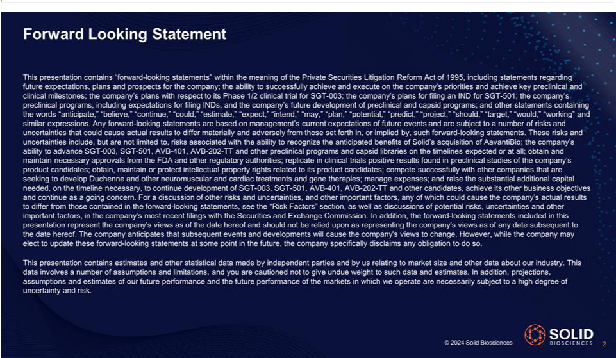

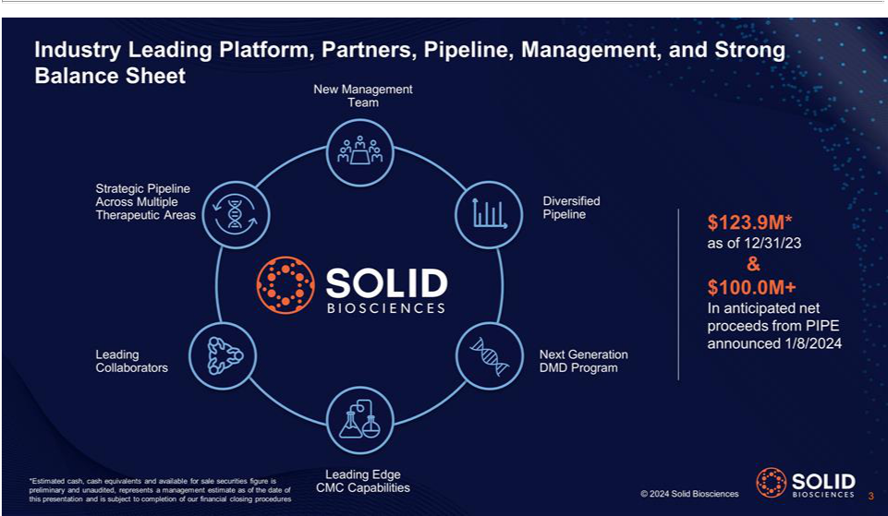

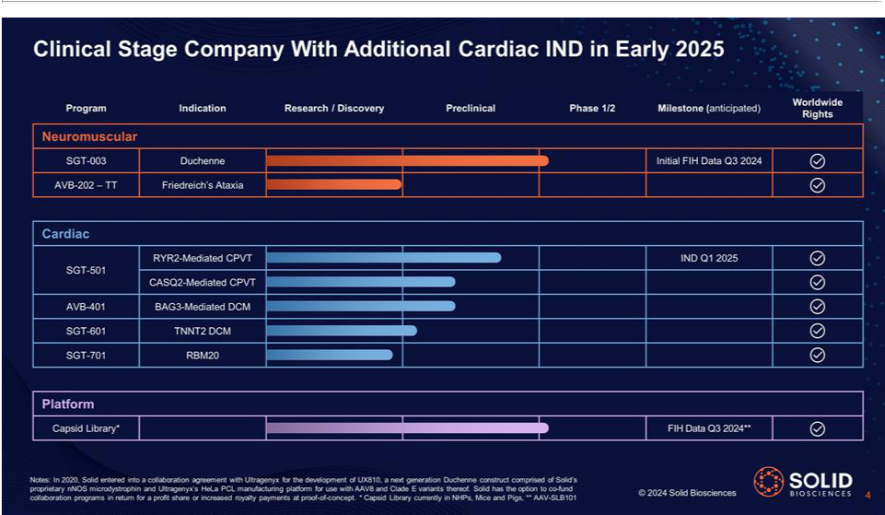



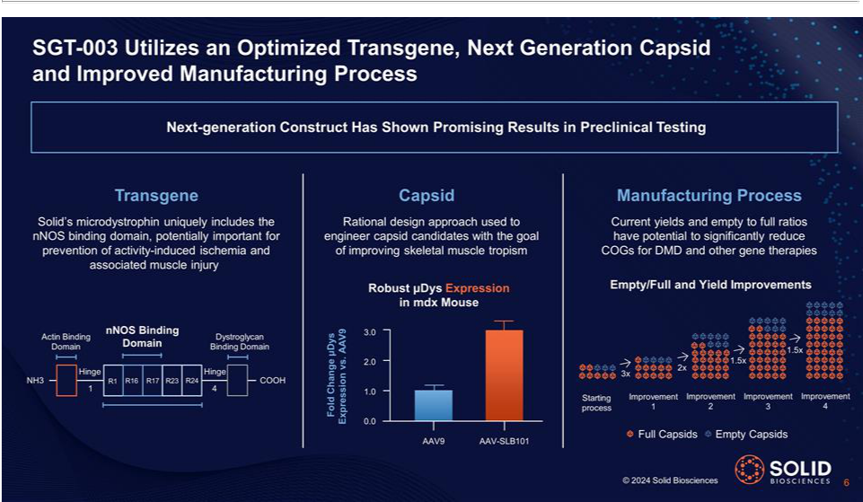

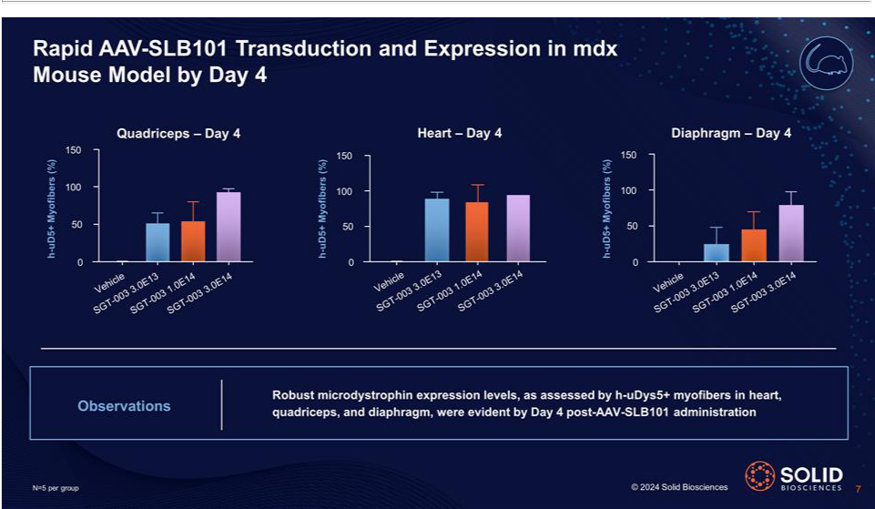

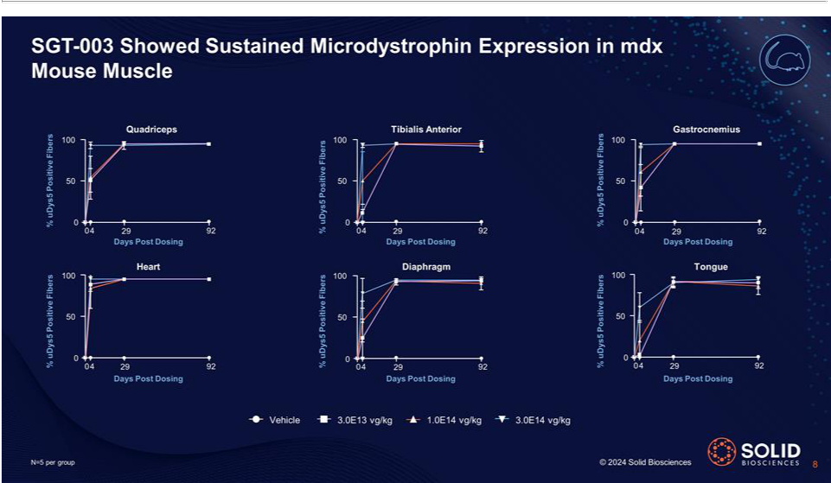

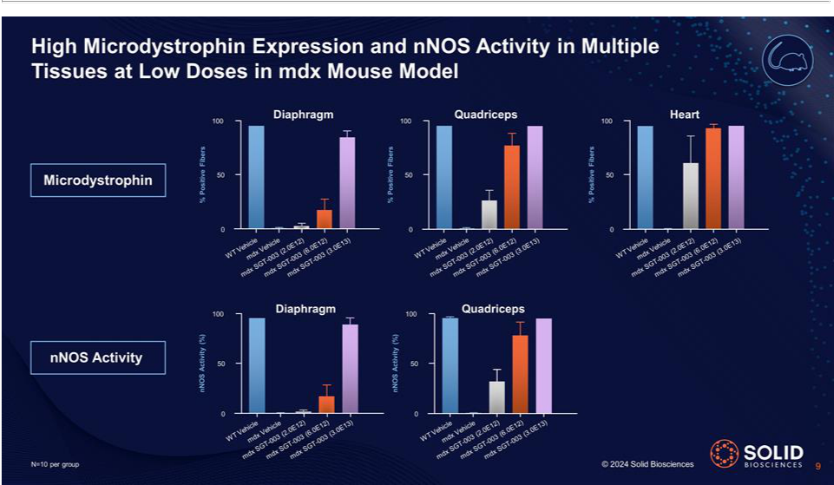

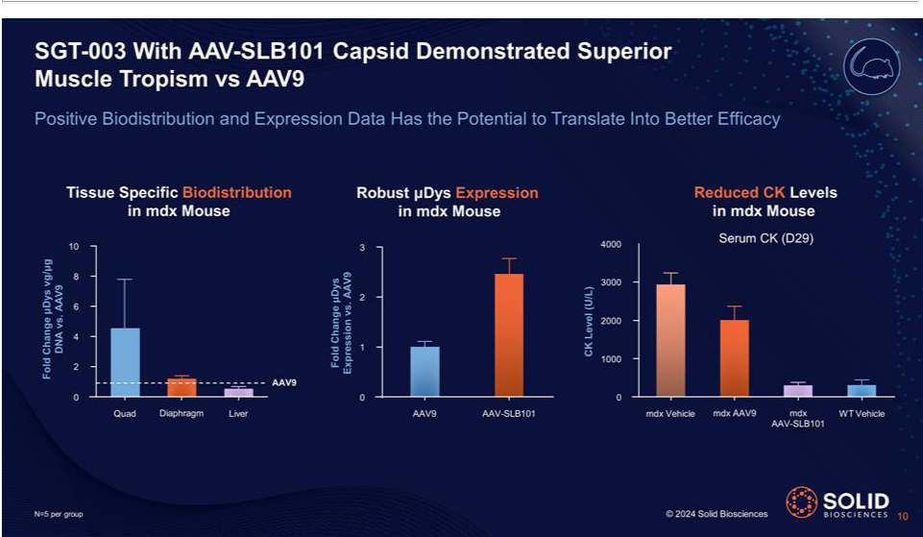

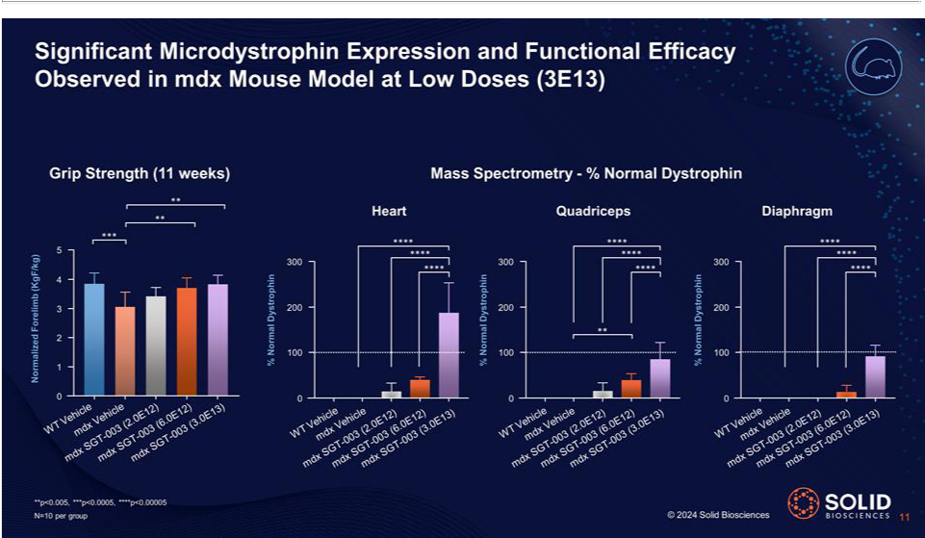

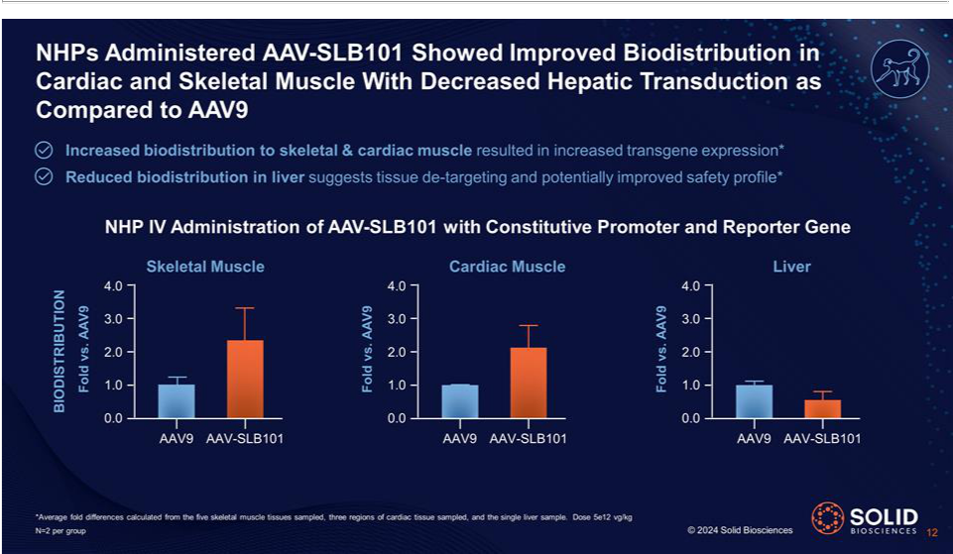

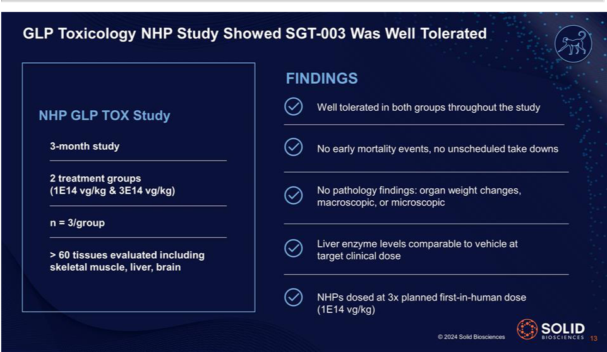

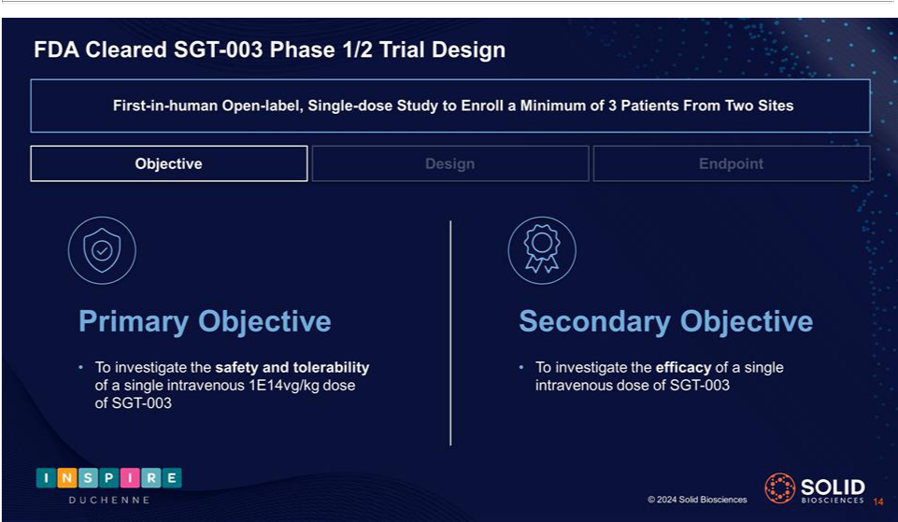

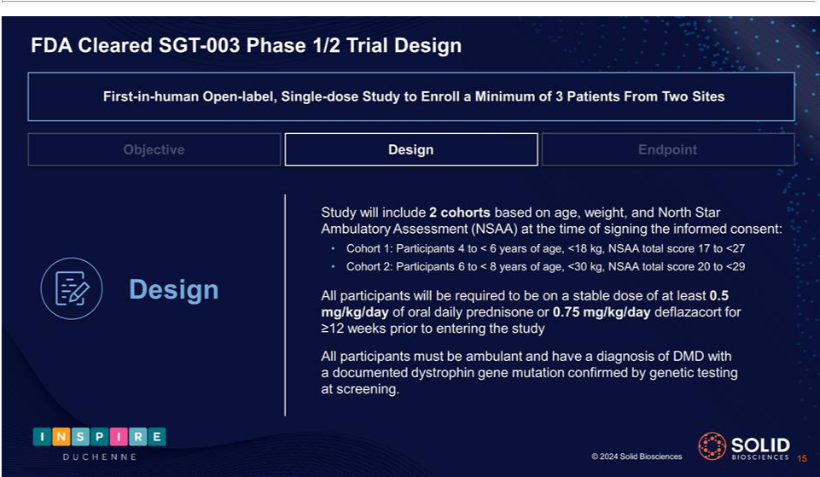

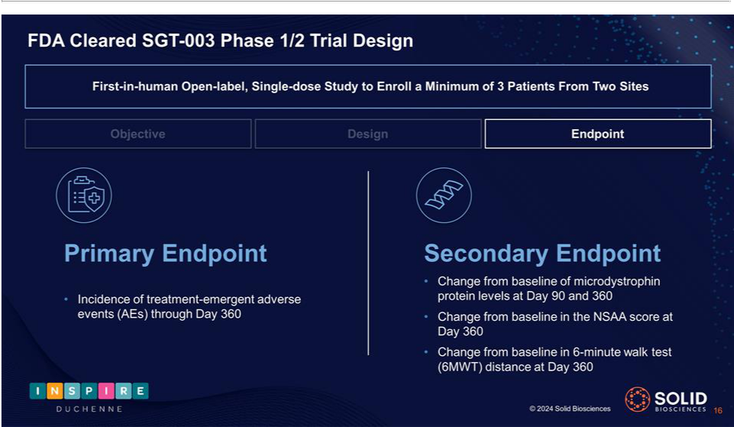

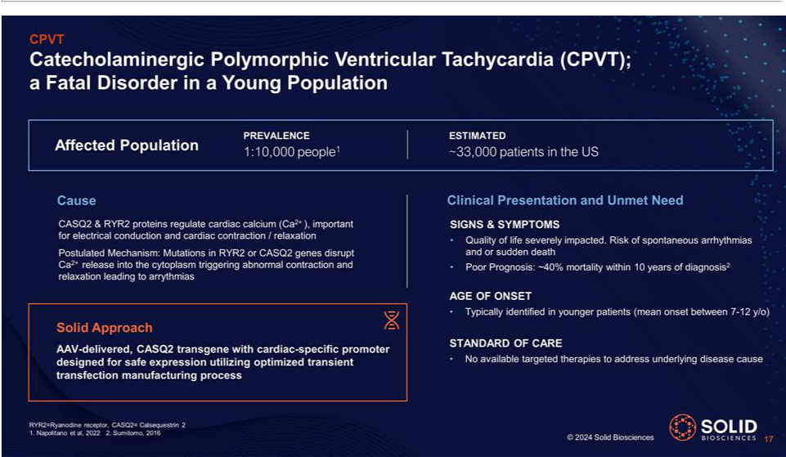

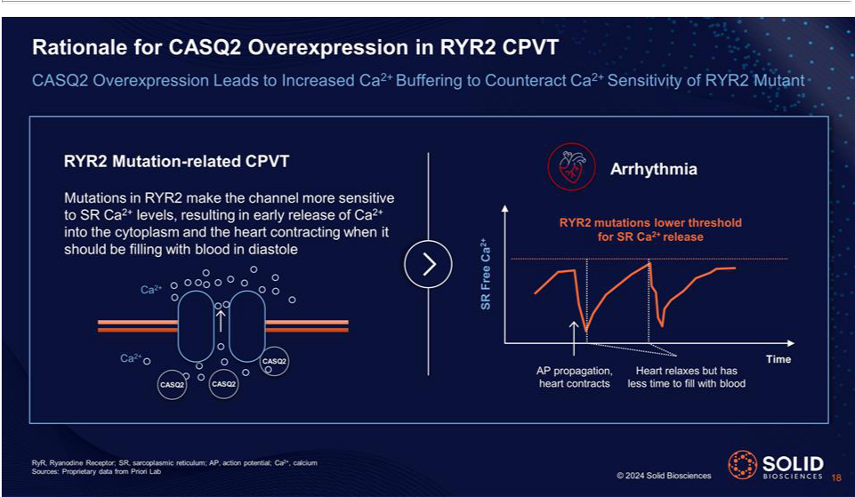

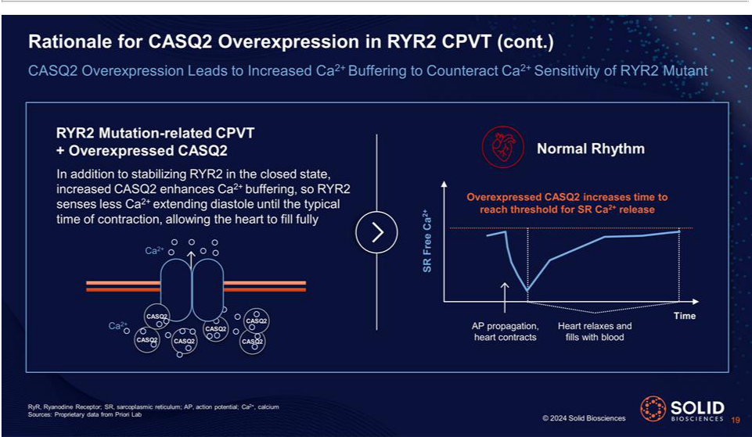

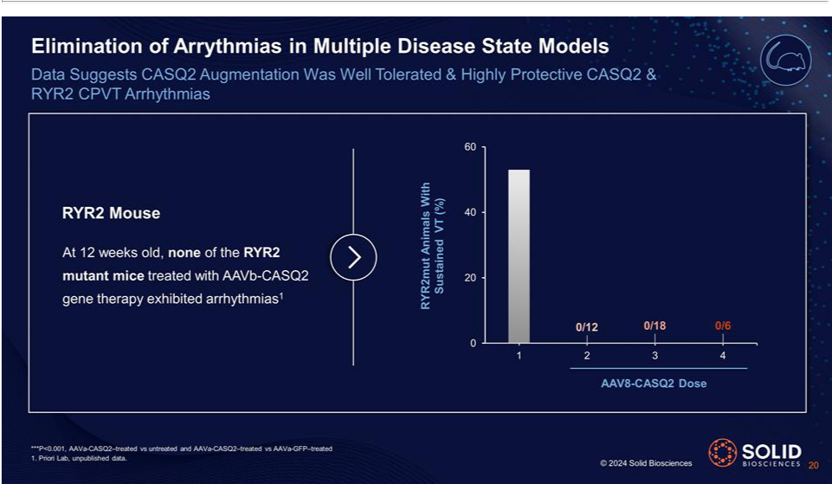

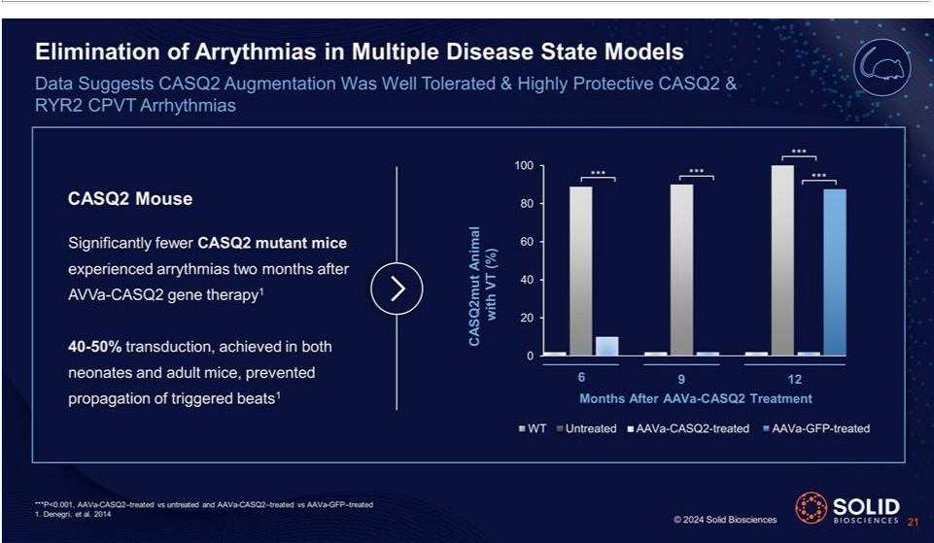

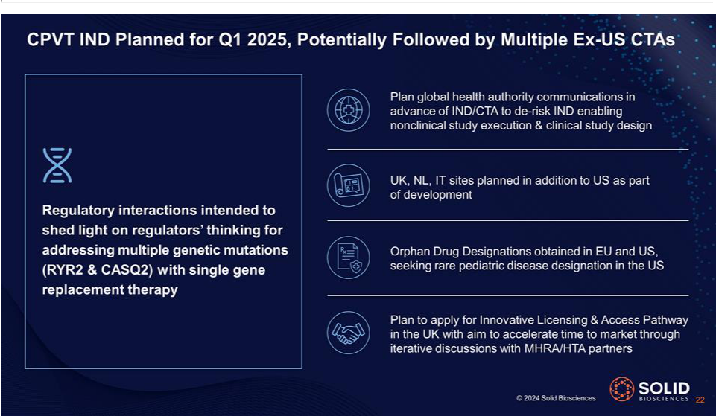

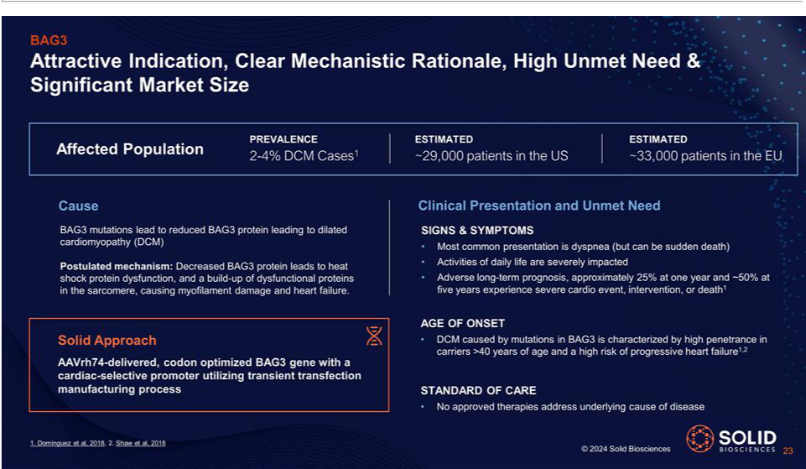

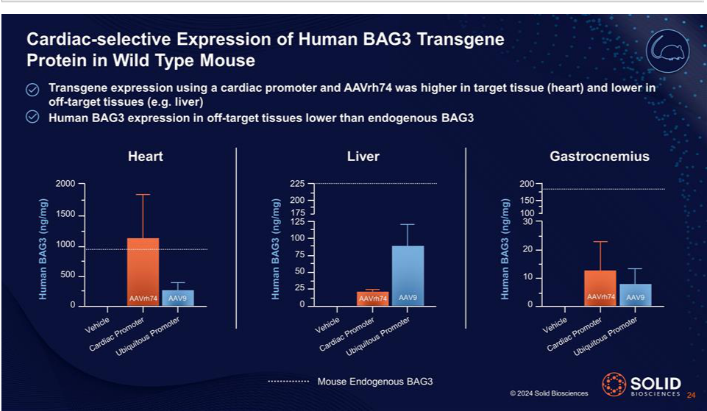

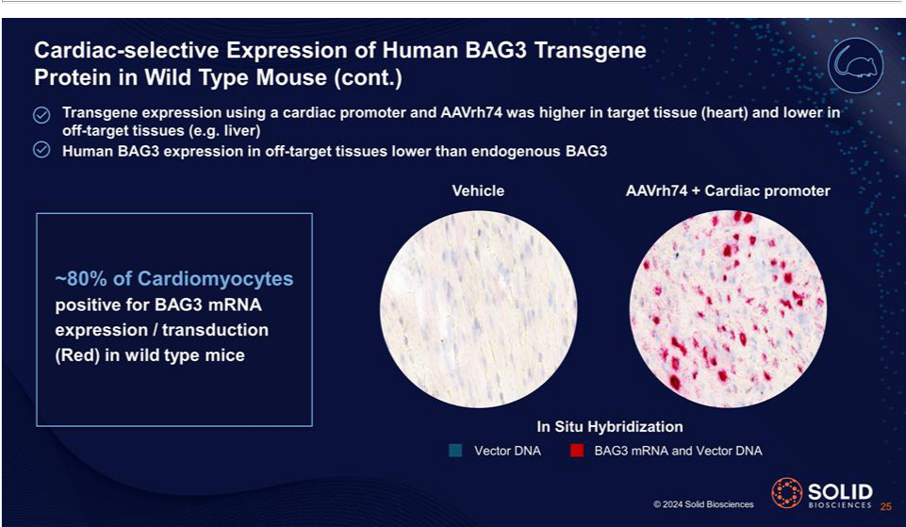

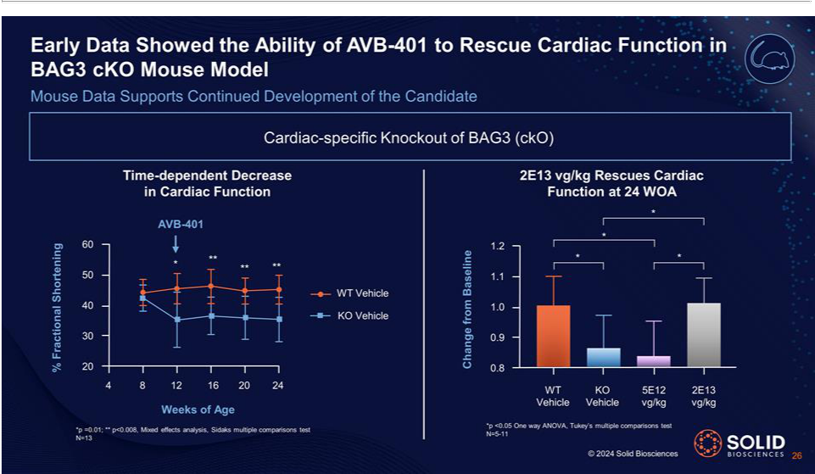



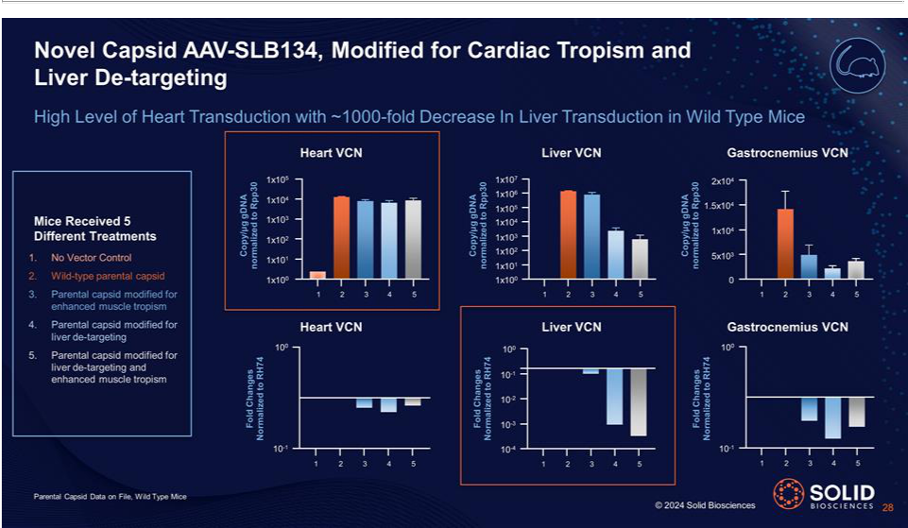

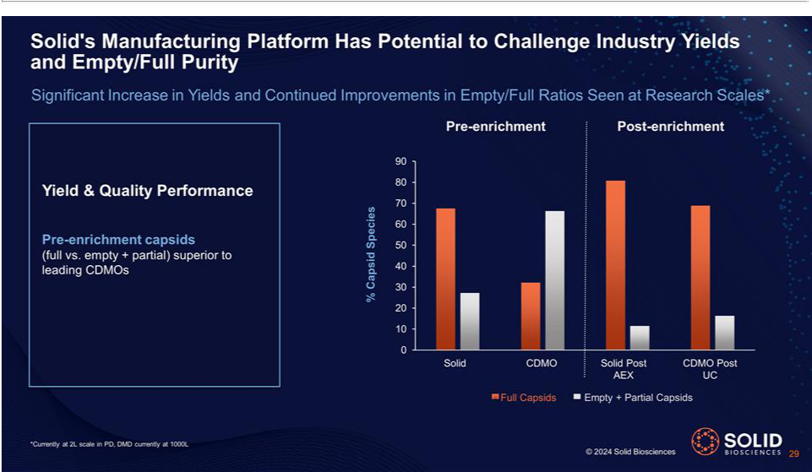

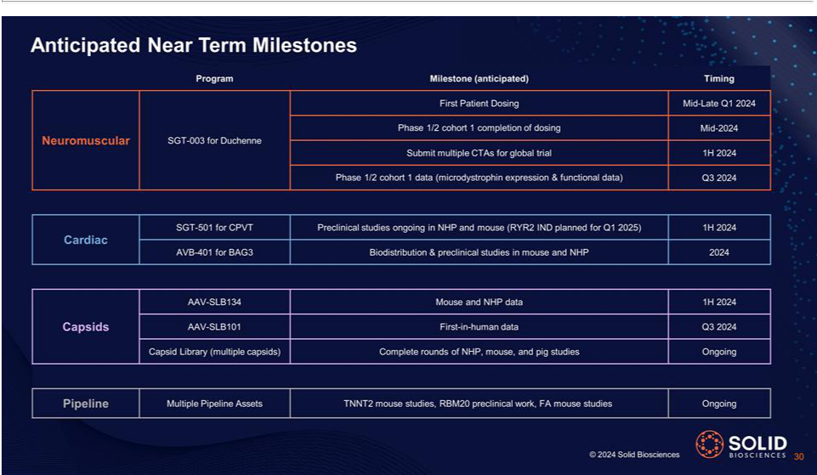

Exhibit 99.2

Solid Biosciences Announces $109 Million Private Placement

Charlestown, MA – January 8, 2024 - Solid Biosciences Inc. (Nasdaq: SLDB), a life sciences company developing precision genetic medicines for neuromuscular and cardiac diseases, today announced that it has entered into a securities purchase agreement with a select group of institutional accredited investors for an approximately $108.9 million private placement, which is expected to close on or about January 11, 2024, subject to the satisfaction of customary closing conditions. The private placement is being conducted in accordance with applicable Nasdaq rules and was priced to satisfy the “Minimum Price” requirement (as defined in the Nasdaq rules).

The private placement includes new and existing investors, including Perceptive Advisors, Adage Capital Partners LP, Deerfield Management Company, Invus, Janus Henderson Investors, Vestal Point Capital, LP, Bain Capital Life Sciences, RA Capital Management and an undisclosed life sciences investor, among others.

Citigroup and Cantor acted as joint lead placement agents to the Company in connection with the private placement.

In the private placement, the Company is selling 16,973,103 shares of common stock at a price of $5.53 per share and, in lieu of common stock, pre-funded warrants to purchase up to 2,712,478 shares of common stock at a price of $5.529 per pre-funded warrant. Each pre-funded warrant will have an exercise price of $0.001 per share, will be exercisable immediately and will be exercisable until exercised in full.

The Company expects to use net proceeds from the private placement to fund ongoing pipeline development programs, business development activities, and for working capital and other general corporate purposes.

The securities to be sold in the private placement have not been registered under the Securities Act of 1933, as amended (the “Securities Act”), or any state or other applicable jurisdiction’s securities laws, and may not be offered or sold in the United States absent registration or an applicable exemption from the registration requirements of the Securities Act and applicable state or other jurisdictions’ securities laws. The Company has agreed to file a registration statement with the U.S. Securities and Exchange Commission (the “SEC”) registering the resale of the shares of common stock issued in the private placement and the shares of common stock issuable upon the exercise of the pre-funded warrants issued in the private placement no later than the 30th day after the closing of the private placement.

This press release shall not constitute an offer to sell or the solicitation of an offer to buy these securities, nor shall there be any offer, solicitation or sale of these securities in any jurisdiction in which such offer, solicitation or sale would be unlawful. Any offering of the securities under the resale registration statement will only be made by means of a prospectus.

About Solid Biosciences

Solid Biosciences is a life sciences company focused on advancing a portfolio of gene therapy candidates and neuromuscular and cardiac programs, including SGT-003, for the treatment of Duchenne muscular dystrophy (Duchenne), SGT-501 for the treatment of catecholaminergic polymorphic ventricular tachycardia (CPVT), AVB-401 for the treatment of BAG3-mediated dilated cardiomyopathy, AVB-202-TT for the treatment of Friedreich’s ataxia, and additional assets for the treatment of fatal cardiac diseases. Solid is advancing its diverse pipeline across rare neuromuscular and cardiac diseases, bringing together experts in science, technology, disease management, and care. Patient-focused and founded by those directly impacted, Solid’s mandate is to improve the daily lives of patients living with these devastating diseases.

Cautionary Note Regarding Forward-Looking Statements

This press release contains “forward-looking statements” within the meaning of the Private Securities Litigation Reform Act of 1995, including statements regarding the anticipated closing of the private placement; the anticipated use of proceeds from the private placement; the filing of a registration statement to register the resale of the shares and pre-funded warrant shares to be issued and sold in the private placement; future expectations, plans and

prospects for the Company; and other statements containing the words “anticipate,” “believe,” “continue,” “could,” “estimate,” “expect,” “intend,” “may,” “plan,” “potential,” “predict,” “project,” “should,” “target,” “would,” “working” and similar expressions. Any forward-looking statements are based on management’s current expectations of future events and are subject to a number of risks and uncertainties that could cause actual results to differ materially and adversely from those set forth in, or implied by, such forward-looking statements. These risks and uncertainties include, but are not limited to: whether the conditions for the closing of the private placement will be satisfied; risks associated with the ability to recognize the anticipated benefits of the Company’s acquisition of AavantiBio; the Company’s ability to advance SGT-003, SGT-501, AVB-401, AVB-202-TT and other preclinical programs and capsid libraries on the timelines expected or at all; obtain and maintain necessary approvals from the FDA and other regulatory authorities; replicate in clinical trials positive results found in preclinical studies of the Company’s product candidates; obtain, maintain or protect intellectual property rights related to its product candidates; compete successfully with other companies that are seeking to develop Duchenne and other neuromuscular and cardiac treatments and gene therapies, manage expenses; and raise the substantial additional capital needed, on the timeline necessary, to continue development of SGT-003, SGT-501, AVB-401, AVB-202-TT and other candidates, achieve its other business objectives and continue as a going concern. For a discussion of other risks and uncertainties, and other important factors, any of which could cause the Company’s actual results to differ from those contained in the forward-looking statements, see the “Risk Factors” section, as well as discussions of potential risks, uncertainties and other important factors, in the Company’s most recent filings with the SEC. In addition, the forward-looking statements included in this press release represent the Company’s views as of the date hereof and should not be relied upon as representing the Company’s views as of any date subsequent to the date hereof. The Company anticipates that subsequent events and developments will cause the Company’s views to change. However, while the Company may elect to update these forward-looking statements at some point in the future, the Company specifically disclaims any obligation to do so.

Solid Biosciences Contact:

Leah Monteiro

VP, Investor Relations and Communications

617-766-3430

lmonteiro@solidbio.com

